TECHNICAL DECISION MEMO

TaxTrack Confidence-Scored Extraction and Focused Re-read Workflow
  - Feasibility analysis, corrected decision logic, and implementation recommendation
Decision: Proceed to a controlled pilot after redesigning the confidence gates
Scope: Gemini field extraction, TIN/Name masterfile validation, rescue, and review
Date: 30 July 2026
Status: GO for prototype and shadow mode; NO-GO for production automation as currently drawn

Executive decision
VERDICT: The workflow is technically feasible and fits the direction of the existing TaxTrack architecture. It is not safe to deploy exactly as shown. The 95% extraction threshold must be a hard gate, confidence must be calibrated against labeled forms, and masterfile outcomes must remain separate from extraction certainty.
The narrative's core policy is sound: do not call a TIN or Name mismatch a legitimate form error until the system is sufficiently certain that it read the form correctly. The focused re-read and human-review branches are practical safeguards.
- Use three independent layers: read confidence, reference comparison, and final business disposition.
- Apply >= 95 as a non-compensable gate. A strong masterfile signal must never offset an uncertain read.
- Treat Gemini-provided confidence as a raw signal, not a verified probability, until it has been calibrated on TaxTrack's labeled BIR 2307 data.
- Reuse the current structured-output, crop-based signer verification, masterlist lookup, audit, and override foundations; add field-level attempts, explicit review states, and masterfile ambiguity handling.

1. Intended business rule
The requested behavior can be stated as a field-level decision policy. Every extracted field receives a read-confidence score and source evidence. Only TIN and Name fields are compared with the masterfile. A masterfile comparison may be calculated early for diagnostics, but it must remain provisional until the read-confidence gate is satisfied.
- First read. Extract the field value, its location/evidence, and a raw confidence signal.
- High confidence (C1 >= 95). Accept the transcription as trusted, subject to deterministic format and cross-field validation.
- Medium confidence (80 <= C1 < 95). Re-read only the uncertain field with a focused prompt and cropped source region.
- Low confidence (C1 < 80). Route immediately to review. Do not emit a final match or mismatch.
- Second read. If C2 >= 95, continue using the rescued value. If C2 < 95, label the extraction unresolved (the business-facing label may be 'AI can't read') and route it to human review.
- Reference decision. For a trusted TIN or Name, compare the normalized value to an available, unambiguous masterfile result. Match becomes VERIFIED_MATCH; non-match becomes CONFIRMED_MISMATCH.

2. Feasibility verdict by capability
Capability | Verdict | Current fit | Required change
Schema-constrained extraction | Feasible | The Gemini client already requests strict JSON structured output. | Extend from group-level confidence to per-field attempts and evidence.
Field-level confidence | Conditional | The contract stores confidence for period, payee, payor, tax rows, and signer groups. | Create a calibrated per-field score; do not rely on self-reported confidence alone.
Focused re-read | Feasible | A crop-based payor-signer verification flow already demonstrates the pattern. | Generalize cropping, prompts, attempt persistence, and one-rescue limits.
TIN/Name reference check | Feasible | Masterlist lookup and normalization already exist. | Add exact/ambiguous/unavailable states and stronger name-match rules.
Automated final labeling | Not safe as drawn | Current validation can turn masterlist misses directly into errors. | Insert a hard read-confidence gate and richer field dispositions.
Human review and learning | Partial | Overrides and audit foundations exist, but the diagram's queue/case loop is not a complete field workflow. | Add review cases, evidence display, reviewer outcomes, and calibration feedback.

3. Corrections required before implementation

3.1 Make 95 a hard gate, not a weighted outcome
The diagram calculates separate weighted Match Confidence and Mismatch Confidence scores. Those formulas can cross 95 even when the field read is below 95, directly contradicting the narrative.
Diagram formula | Example inputs | Composite result | Why it fails
Match: 45% read + 35% comparison + 15% masterfile + 5% consistency | Read 90; all other inputs 100 | 95.5 | It would auto-accept a masterfile match even though the read is below the required 95.
Mismatch: 55% read + 30% comparison + 10% masterfile + 5% contradiction | Read 91; all other inputs 100 | 95.05 | It would auto-confirm a mismatch even though the read is below the required 95.

RECOMMENDED RULE: Final match or mismatch = trusted read gate AND deterministic reference result. Composite scores may be retained for ranking or review prioritization, but they cannot bypass either gate.

3.2 Resolve score-definition conflicts
- The first-read formula includes 15% 'second-pass agreement,' but no second pass exists yet. Remove this term from C1 or explicitly define an independent extraction within the first operation.
- The narrative alternates between '95% pataas' and '>95%.' Standardize the bands as C >= 95, 80 <= C < 95, and C < 80 so 95 and 80 have exactly one route.
- A low-confidence read is not evidence that the form is wrong. Use UNRESOLVED_EXTRACTION or NEEDS_REVIEW internally; reserve UNREADABLE for a human-confirmed outcome.
- Schema, range, and cross-field checks are guardrails, not proof that the image was transcribed correctly. A value may be plausible and still be read incorrectly.

3.3 Separate reference problems from form problems
A trusted extracted value may fail reference comparison because the masterfile is unavailable, stale, duplicated, or missing a legitimate party. Those states must not be reported as a confirmed form mismatch. TIN and Name also require different rules: prefer exact normalized TIN matching; use Name matching as secondary evidence with explicit ambiguity handling.

4. Recommended decision flow
The corrected flow makes the extraction-confidence gate explicit and keeps reference health independent. It also prevents the system from calling a business error when the AI is still uncertain about the text.
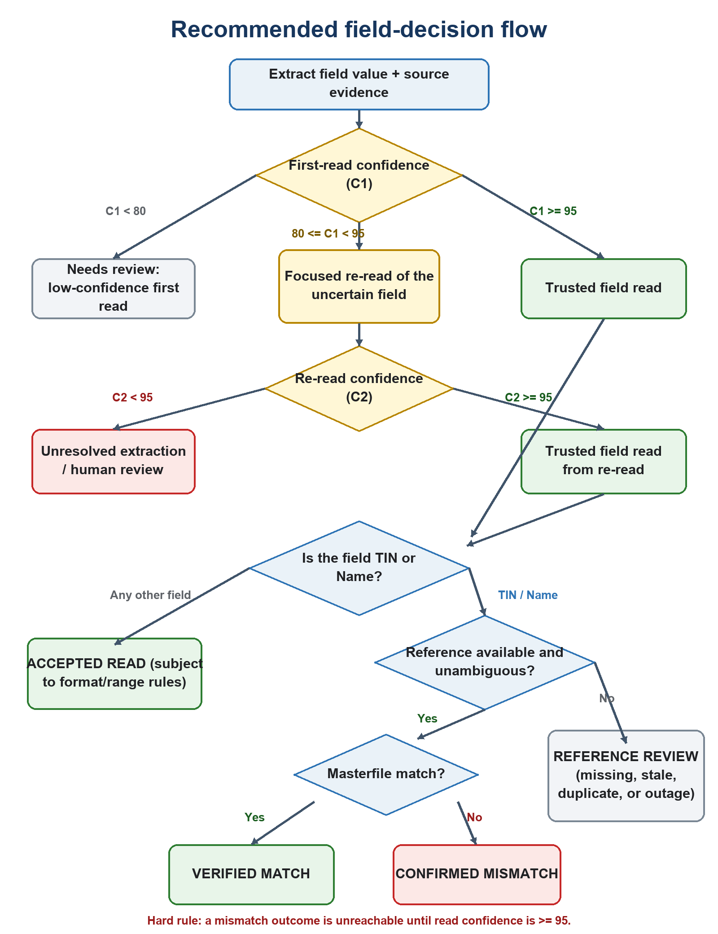
Figure 1. Corrected field-level decision flow. Mismatch is reachable only after a trusted read.

5. Authoritative decision matrix
Condition | Action | Reference step | Final disposition
C1 < 80 | Do not re-read automatically under the stated policy; create review item. | No final reference classification. | Needs review - low confidence
80 <= C1 < 95 and C2 < 95 | Stop automated classification after one focused re-read. | Any comparison remains provisional. | Unresolved extraction
80 <= C1 < 95 and C2 >= 95 | Use the rescued value as the trusted transcription. | TIN/Name only: compare with a healthy, unambiguous masterfile. | Accepted read / Verified match / Confirmed mismatch
C1 >= 95 | Use the first-read value as the trusted transcription. | TIN/Name only: compare with a healthy, unambiguous masterfile. | Accepted read / Verified match / Confirmed mismatch
Trusted TIN/Name; masterfile unavailable or ambiguous | Preserve trusted extraction, but block match/mismatch automation. | Create reference-review item. | Reference review
Trusted value; hard format or domain rule fails | Do not silently accept. Preserve the read and record the deterministic failure. | Reference check may be unnecessary. | Validation error / Needs review

5.1 What counts as a legitimate error
- C1 >= 95, the field is TIN or Name, the masterfile is available and unambiguous, and the normalized value does not match.
- 80 <= C1 < 95, C2 >= 95 after a focused re-read, and the rescued normalized value still does not match a healthy, unambiguous masterfile result.

5.2 What counts as 'AI can't read'
- C1 < 80: immediate review under the requested rule; internally label as low-confidence first read.
- 80 <= C1 < 95 and C2 < 95: unresolved after focused re-read.
If a human reviewer can read and correct the value, the final state should be HUMAN_CORRECTED rather than UNREADABLE. Use HUMAN_UNREADABLE only when the source itself cannot be read.

6. Current repository fit and required changes
The current repository already contains several building blocks. The implementation is therefore an extension of the existing worker and UI, not a greenfield system.
Area | Observed current behavior | Gap against requested workflow | Recommended change
Extraction contract | Strict structured JSON; confidence is grouped into period, payee, payor, taxRows, and signer. | No authoritative confidence/evidence record for every individual field. | Return and persist one field record per value and per attempt.
Gemini client | Whole-document extraction with provider retry; dedicated crop extraction exists for payor signer verification. | No general field-level rescue operation or field-attempt audit trail. | Generalize the crop/prompt pattern into extractField(fieldKey, crop, context).
Masterlist lookup | Uses the first nine TIN digits, then normalized Name substring search; any result becomes matched. | No explicit exact, ambiguous, duplicate, stale, or unavailable result. | Return reference status, candidate count, match method, strength, and masterfile version.
Validation | A masterlist miss contributes directly to invalid/error status. | An uncertain AI read can be treated as a business error. | Gate masterfile error classification behind calibrated read confidence.
Persistence | Certificate confidence is stored as a summary JSON; primary statuses are accepted, error, and duplicate. | The state model cannot explain field attempts and review reasons cleanly. | Add field attempts/decisions and review-case persistence, or a versioned field-decision JSON contract.
UI and review | Field confidence display, extraction retry, audit, and certificate override foundations exist. | No complete review queue that shows C1/C2, evidence crop, reference result, and final rationale. | Add evidence-first review cards and capture reviewer confirmation, correction, and unreadable outcomes.

KEY CODE IMPACT: The most important behavioral change is in certificate validation: masterlist_not_found must stop being an unconditional error and become a reference outcome evaluated only after the field-read gate.

7. Recommended implementation design

7.1 Field-attempt record
Persist enough information to reproduce every automated decision. A single overall confidence number is not sufficient for audit, rescue, or model-version monitoring.
Field group | Required attributes
Identity | documentId, certificateId, fieldKey, fieldType, attemptNo, sourcePage, sourceRegion
Extraction | rawValue, normalizedValue, rawConfidence, calibratedConfidence, evidenceExcerpt, evidenceSource
Provenance | provider, modelVersion, promptVersion, schemaVersion, createdAt, latency, token usage
Reference | referenceStatus, matchMethod, matchStrength, candidateCount, masterfileVersion, comparedAt
Decision | extractionState, finalDisposition, reasonCodes, reviewCaseId, resolvedBy, resolvedAt

7.2 Confidence is a calibrated estimate, not a prompt field
Gemini can return schema-constrained JSON and can expose output-token log probabilities on supported APIs. Those capabilities make instrumentation possible, but neither a model's self-assigned score nor token likelihood is automatically a calibrated probability that a visual field was transcribed correctly. That interpretation must be learned and tested on TaxTrack data.
- Keep raw signals separate: model self-score, token log probability where usable, source-evidence localization, image quality, deterministic format checks, form-family detection, and independent re-read agreement.
- Exclude masterfile match strength from read confidence. Reference evidence answers a different question.
- Fit and validate a calibrator per field family or use conservative empirical bands. Track calibration error and precision at the >= 95 gate.
- Make the re-read meaningfully different: isolate the field crop, include its label and expected format, use deterministic settings, and record whether C1 and C2 values agree. Repeating the same whole-document prompt produces correlated errors.

7.3 Bounded rescue execution
Allow one semantic re-read per field. Batch keyed crops when needed to bound cost and latency. Keep provider retry counts separate from semantic attempts, and persist each result for audit.

8. Primary risks and mitigations
Risk | Failure mode | Required mitigation
Uncalibrated confidence | A displayed 95 does not mean 95% field correctness. | Shadow evaluation on labeled forms; threshold calibration by field and image-quality band.
Correlated re-reads | The model confidently repeats the same mistake. | Use isolated crops, deterministic focused prompts, agreement checks, and human sampling.
Masterfile quality | Stale, duplicate, or missing records create false form errors. | Version the masterfile; expose ambiguous/unavailable states; measure reference coverage.
Name matching | Substring or alias logic causes false matches or misses. | Prefer exact TIN; use canonical Name rules and ambiguity thresholds; never take the first arbitrary hit.
Model drift | A model or prompt update shifts score behavior. | Persist model/prompt versions; rerun a frozen regression set before rollout.
Cost and latency | Many uncertain fields create an N-call rescue fan-out. | One rescue maximum, keyed crop batching, concurrency limits, and queue backpressure.
Audit and privacy | Sensitive TIN/Name data lacks decision traceability or leaks into logs. | Store bounded evidence with access control; mask logs; retain immutable attempts and reviewer actions.

9. Validation and rollout plan
- Define the truth set. Build a stratified labeled corpus across form variants, scan quality, handwriting/printing, TIN/Name formats, and genuine masterfile mismatches.
- Instrument in shadow mode. Record C1, rescue eligibility, C2, evidence, provisional reference result, and the outcome the new rules would have produced without changing production status.
- Calibrate and select thresholds. Validate the >= 95 gate separately for TIN, Name, and other high-impact fields. Optimize mismatch precision first, then automation rate.
- Pilot with mandatory human confirmation. Allow automatic routing and prioritization, but require review for would-be mismatches until false-mismatch performance meets the business target.
- Enable limited automation. Release one field family and form-quality band at a time, with drift monitoring and immediate rollback to review.
Recommended operating metrics: false-mismatch rate, mismatch precision, verified-match precision, automation rate, manual-review rate, rescue rate, rescue precision, human correction rate, reference ambiguity rate, model/prompt drift, p95 latency, and cost per processed form.

10. Production go/no-go gates
Gate | Pass condition | Decision if unmet
Hard gating | No code path can emit VERIFIED_MATCH or CONFIRMED_MISMATCH when the accepted read confidence is below 95. | NO-GO
Calibration | Threshold performance is measured on representative labeled forms with confidence intervals and approved business targets. | NO-GO
Reference integrity | Masterfile version, availability, uniqueness, match method, and ambiguity are recorded for every reference decision. | NO-GO
Auditability | C1/C2 attempts, source evidence, model/prompt versions, reason codes, and human actions are reproducible. | NO-GO
Review operations | Reviewers can see the source crop, extracted value, confidence, comparison evidence, and correct/confirm/unreadable actions. | NO-GO
Regression and drift | A frozen benchmark and ongoing monitoring detect material changes after model or prompt updates. | NO-GO

11. Final recommendation
DECISION: Proceed with a prototype and shadow-mode implementation. Do not enable automatic legitimate-error labeling from the diagram's weighted Match/Mismatch Confidence formulas. Replace them with hard gates and calibrated field confidence, then introduce production automation only after the go/no-go conditions above pass.
In short: the flow is possible. Its business principle is correct, and the repository has reusable foundations. The current diagram is an excellent orchestration sketch but not yet a safe scoring specification. The redesign is contained and implementable, with confidence calibration and masterfile governance as the two non-negotiable prerequisites.

Recommended implementation priority
- Correct the state model and hard-gate logic.
- Add field-level attempts, evidence, and a general focused re-read operation.
- Refactor masterfile lookup into match, mismatch, ambiguous, missing-reference, and unavailable outcomes.
- Run shadow-mode calibration and implement the evidence-first review queue.
- Enable limited automation only after measured precision targets are met.

Appendix A. Narrative-to-rule traceability
Source statement | Authoritative interpretation
All extracted fields receive confidence. | Persist field-level read confidence and evidence for every attempt; group-level summaries are insufficient.
95% or higher is 'goods.' | Use C >= 95 as the hard trusted-read boundary, subject to deterministic format/domain rules.
TIN or Name is compared to the masterfile. | Only trusted TIN/Name values receive a final reference disposition; other fields receive accepted/validation states.
80%-94% is re-read with a focused prompt. | Use 80 <= C1 < 95; run one field-level rescue and evaluate C2 independently.
Below 80% is for review. | Create a review item immediately and block final match/mismatch classification.
A high-confidence second mismatch is a legitimate error. | Require C2 >= 95 plus a healthy, unambiguous masterfile non-match.
Still below 95 on the second read means AI can't read. | Use UNRESOLVED_EXTRACTION before review; human review determines corrected versus truly unreadable.

Appendix B. Source sequence diagram
The diagram below is embedded for traceability. Figure 1 and the decision matrix in this memo are the recommended implementation authority where they differ from the original weighted-confidence branches.

Figure 2. Original TaxTrack confidence-score sequence diagram supplied for analysis.

Appendix C. Sources reviewed
1. Requestor-provided Tagalog/English narrative defining the confidence bands, focused re-read, masterfile comparison, legitimate-error cases, and 'AI can't read' cases (30 July 2026).
2. TaxTrack_Confidence_score.png, requestor-provided sequence diagram.
3. Current TaxTrack repository: backend/worker/src/langgraph/services/extractionContract.ts; backend/worker/src/langgraph/services/geminiClient.ts; backend/worker/src/langgraph/nodes/processCertificates.ts; backend/worker/src/langgraph/utils/payorSignerVerification.ts; backend/worker/src/db/schema.ts.
4. Google AI for Developers, Structured outputs (accessed 30 July 2026). Google structured outputs documentation
5. Google AI for Developers, GenerateContent API reference: responseLogprobs and logprobs (accessed 30 July 2026). Google GenerateContent API reference
6. Google Cloud, Document AI response structure: OCR/entity confidence and image-quality scores (accessed 30 July 2026). Google Document AI response documentation
Analytical note: statements about confidence calibration are engineering inferences from the difference between token/model signals and observed field correctness. They should be validated empirically against TaxTrack's labeled form corpus.

