Homework 1: Closed Loop Design and Testbed Construction

In this homework, you will implement testbeds for two closed loop systems, CLS 1, CLS 2.

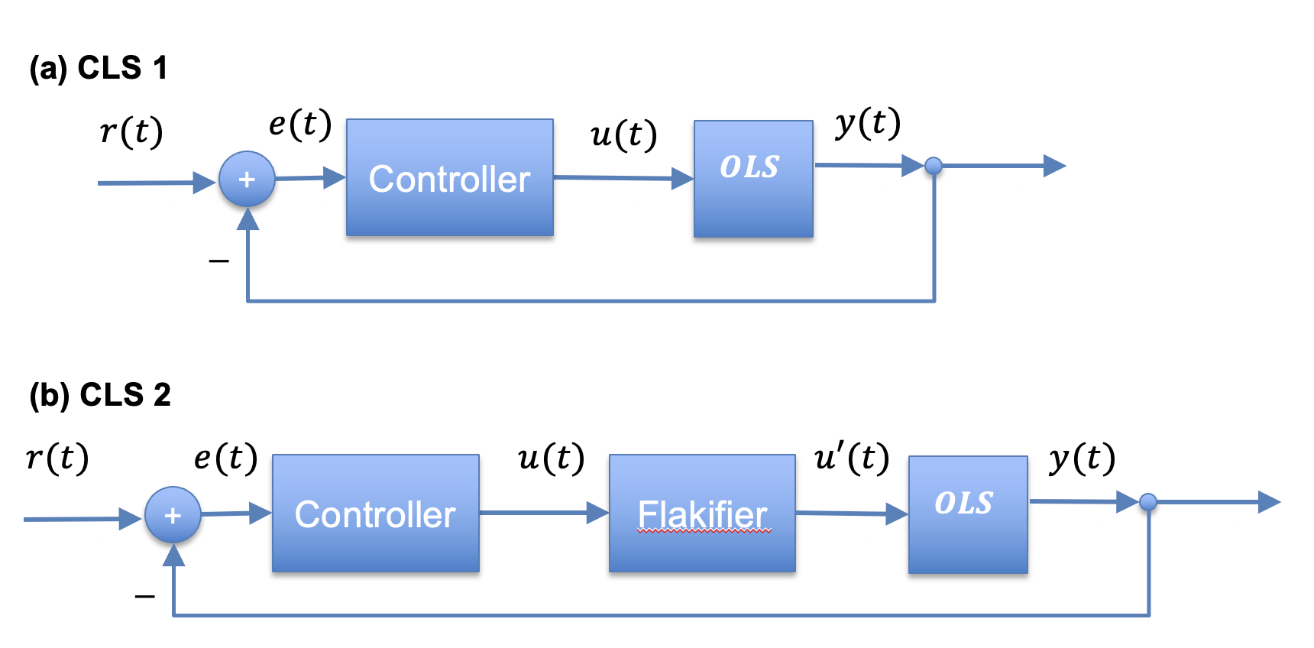

1. (10 pt) Choose an ODE model [curated BioModels.](https://www.ebi.ac.uk/biomodels/search?query=*%3A*%20AND%20curationstatus%3A%22Manually%20curated%22%20AND%20modellingapproach%3A%22ordinary%20differential%20equation%20model%22&domain=biomodels&offset=0&numResults=10)
   1. Create a notebook that runs the model using Tellurium.
   2. Find a measurement output (y(t)) that you want to control and a control input (u(t)) that can manipulate it.
   3. Specify control objectives that include one or more of the following: (i) setpoint, (ii) settling time, (iii) absence of oscillations.
2. (30 pt) Construct a closed loop system for the OLS in 1 using the CLS 1 architecture. Tune the controller to achieve your control objectives.
3. (50) Now consider the CLS 2 architecture that has an additional element, the Flakifier. The Falkifier causes u(t) signals to be randomly lost. That is, $u'(t)=u(t)$ with probability *p*, and is 0 otherwise.
   1. Implement a function that generates a Flakifier with probability *p*
   2. Implement a testbed for architecture CLS 2 using your OLS.
   3. Tune your controller for CLS 2 with *p=0.8.*
   4. Tune your controller for CLS 2 with *p=0.2*.
4. (10 pt) Summaries the challenges of tuning CLS 1, CLS 2 with p=0.8, and CLS 2 with p= 0.2.

This homework will be submitted as a Jupyter Notebook that you upload into your student folder in this [directory](https://drive.google.com/drive/folders/1v_5E8ilRBS1O4t_Y5HjKNWsaRnVqxcGg).