def add_to_cart(request, id):
product = Product.objects.get(id=id)

cart = Cart.objects.filter(
user=request.user,
product=product
).first()

if cart:
cart.quantity += 1
cart.save()
else:
Cart.objects.create(
user=request.user,
product=product,
quantity=1
)

return redirect('user:my_cart')
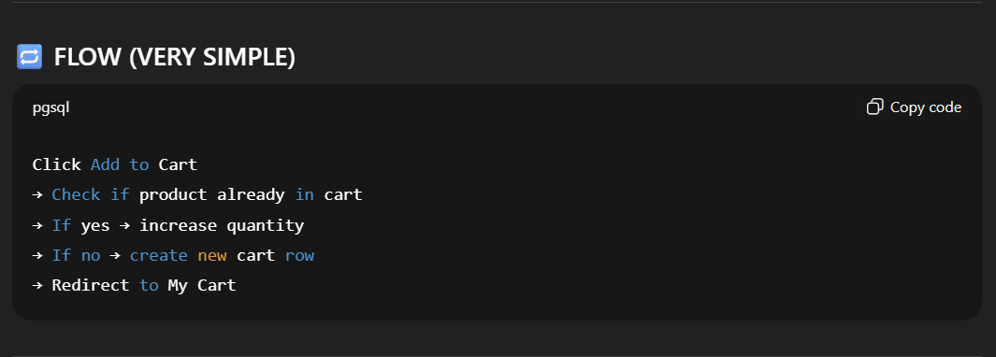

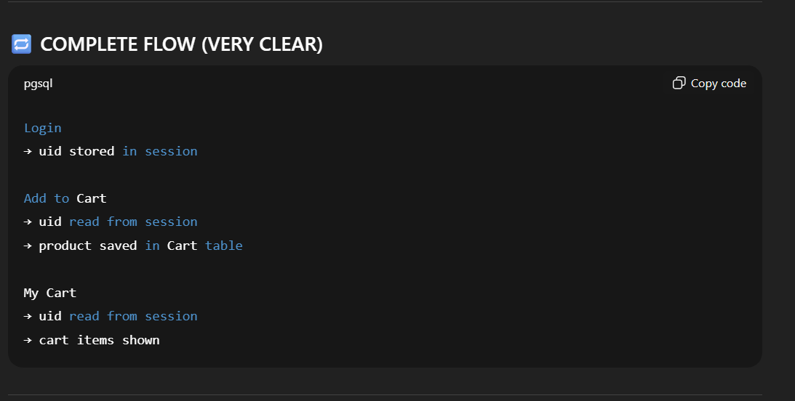

Login Form
↓
Manual Password Check
↓
User instance (Django auth model)
↓
user.id stored in session
↓
Next request
↓
session['uid'] → user.id
↓
User.objects.get(id=uid)
↓
Cart.user = User instance ✔

