**Joe Joseph** Email: [joejoseph.jj@gmail.com](mailto:joejoseph.jj@gmail.com)**|** contact: +91 9567239927 **|** Address: Ernakulam, Kerala, India **DevOps Engineer**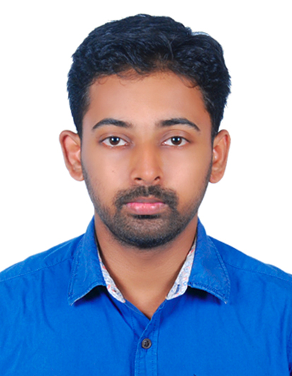

*Skilled DevOps Engineer with total 6 years of experience in supporting, automating and optimizing*

*mission critical deployments by leveraging CI/CD tools and DevOps processes*

## **WORK EXPERIENCE**

**TCS**

### DevOps Engineer in GE Health Care Project

Kochi | June 2020 – current

* worked in K8s application deployment for migration testing in OnPrem environment
* Develop automation processes to enable developers and operations team to deploy, manage, configure, scale and monitor their applications through the use of tooling or scripting reducing the time to get features in production
* Implemented and maintained Continuous Integration / Continuous Delivery systems leading to an improvement in the time to ship new feature releases. This helped to reduce a 2+hr workload to a under 20mins automated task using Jenkins, Git & bash scripting
* Developed post patching start-up bash scripts for multiple applications, which reduced the time and effort of L1 team.
* Created a log monitoring system using elastic stack for analysing input and output request by the users

### DevOps Engineer in Nissan Digital Hub project

Trivandrum | December 2018 - April 2020

* Develop automation & monitoring solutions for IoT

devices in multiple car manufacturing plants

* Implemented a containerized monitoring & alerting microservice application for engine part casting plant using python, docker, Kafka ,RabbitMQ & elastic stack
* Implemented automated application deployment for both new and existing services used by factory users, by leveraging ansible & docker compose
* Worked with Enhancement projects to support developers and Collaborate with clients to bring in new changes
* Poc on Grafana & ES for event monitoring
* Poc on Kubernetes deployments for hosting micro service applications

### DevOps Engineer in CMA Horizontal

Kochi | July 2018 - October 2018

* PoC on Elasticsearch clustering using AWS cloud with ec2 and s3 for Nio Motors project
* Poc on Docker and Jenkins

### Linux Support Engineer in UniCredit project

Kochi | November 2016 - November 2018

* Provide L1 & L2 support for a 24/7 production environment
* Automate the Daily tasks(bash scripting)
* Maintains Over Night runs in Linux platform by analysing logs and background process remotely and CA Workload automation tool
* Back up production data to storage and tape(in house tool)
* Maintain incoming tickets using service manager(HPSM)
* Coordinate with L2 support and other related vendors when there are issues with production runs  
    
  **TECHNICAL SKILLS**
* CI/CD (Jenkins, Git:github,Bitbucket)
* Linux/Bash scripting
* Docker
* Kubernetes
* Elastic stack
* Message broker: Kafka, RabbitMQ
* python scripting (modules used:

os ,sys,logging,yaml,re).   
Python test project: https:/ github.com/joseph- joe-jj/python-test

* Cloud: AWS : ec2 , s3, efs

## **SOFT SKILLS**

* Developer collaboration
* Learn and adopt new technology
* Effective communication
* Teamwork
* Time management
* Adaptability

## **EDUCATION**

**Bachelor of Science**

**Network and system Administration**

### Manonmaniam Sundaranar University

2011 - 2014

# **Accel Frontline**

### Resident Engineer

Kochi | July 2016 - November. 2016

* + Provide L1 & L2 support to Cochin Port Trust

administration department

* + Operating System Installation of Windows XP/

VISTA , Windows 7, Windows 10 & Linux distributions

* + Installation / re-installation / conﬁguration of client

speciﬁc applications

* + Isolate system & network issues , diagnose standard

software issues and report hardware issues to respective

vendor and coordinate with vendor till the issues are ﬁxed

# **AurumSoft**

### Resident Engineer

Kochi | June 2014 - June 2016

* + Provide L1 & L2 support to Geojit BNP Paribas Head Ofﬁce
  + Operating System Installation of Windows XP/VISTA ,

Windows 7, Windows 10 & Linux distributions

* + Installation / re-installation / conﬁguration of client   
    speciﬁc applications
  + Setup newly procured desktop computers, Laptops and

support the user to install necessary software

* + Isolate system issues, diagnose standard software issues

and report hardware issues to respective vendor and coordinate

with vendor till the issues are ﬁxed

* + Mail and chat Conﬁguration for MS outlook client machines
  + Handle daily Technical Support Activities

**PERSONAL PROFILE**

DoB : 07/02/1992

Gender : Male

Nationality : Indian

Marital Status : Single

Language : English , Malayalam

**DECLARATION**

I hereby declare that all the above information is correct to the best my knowledge.

Place : Kochi

Joe Joseph