1. Open MS Access
2. Make “Link to data source”

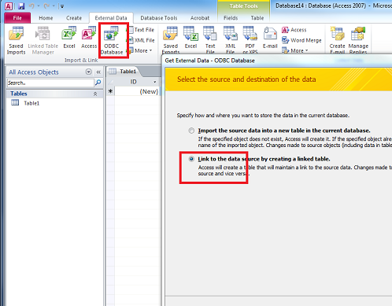

1. Create New dataSource

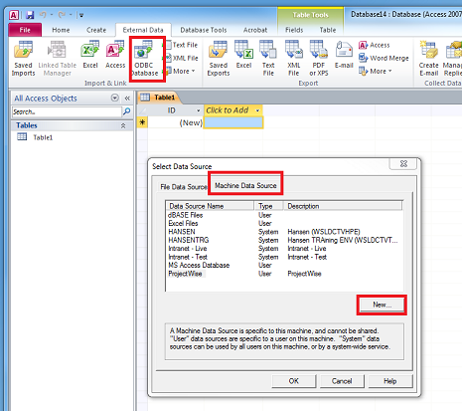

1. Make second “Link to data source”
2. Create “SQL Query”. In the Query create sql with links to two Datasources

*SELECT top 10 \**

*FROM dbo_dms_doc*

*where (o_mimetype <> 'application/pdf')*

*and (o_itemname in (*

*SELECT GISWSL_WA_PWLINK.DOC_NO*

*FROM GISWSL_WA_PWLINK*

*));*

