**Get the Prev and Current values into a stream**

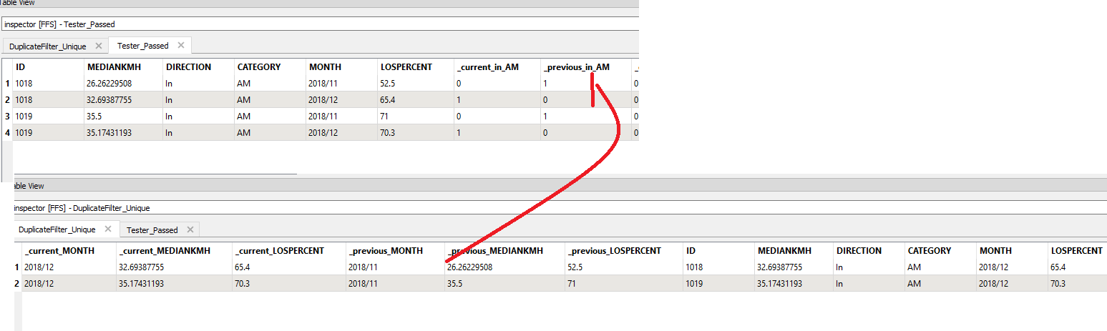

Sort by ID and Previous_In_AM

Previous month

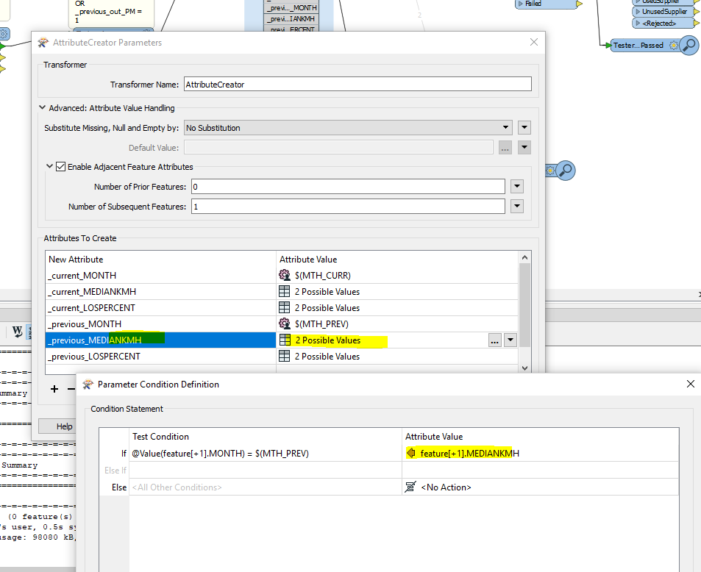

Current month

