**Set Writer in Append mode**

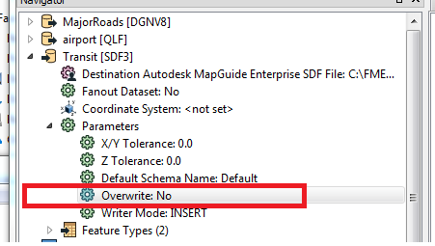

**Select a table in Writer FeatureClass**

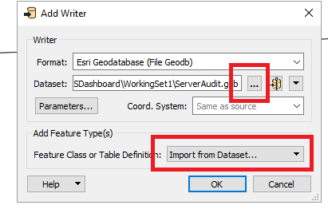

Click “OK” to prompt for table list

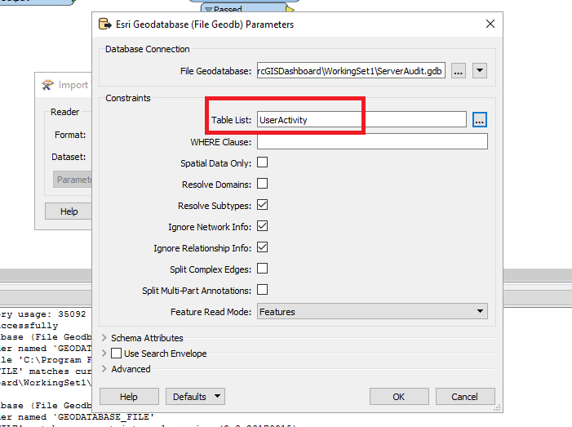

**Select a table in Reader FeatureClass**

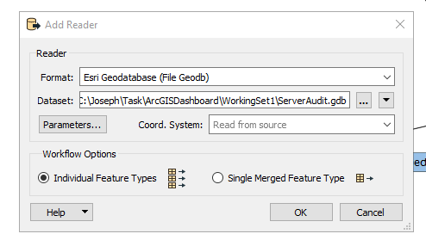

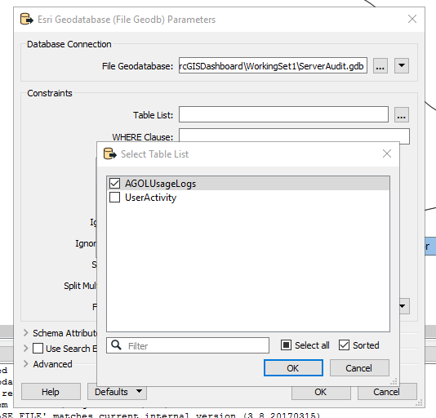

**Setting current directory path**

Eg : $(FME_MF_DIR)\Output\ServerAudit.gdb

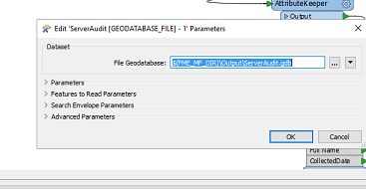

**Arithmatic evaluation**

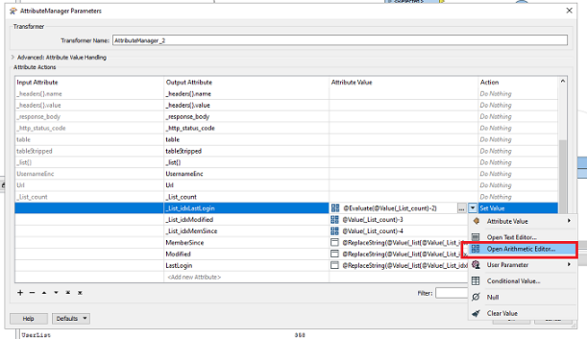

**Adding NonSDE Connections**

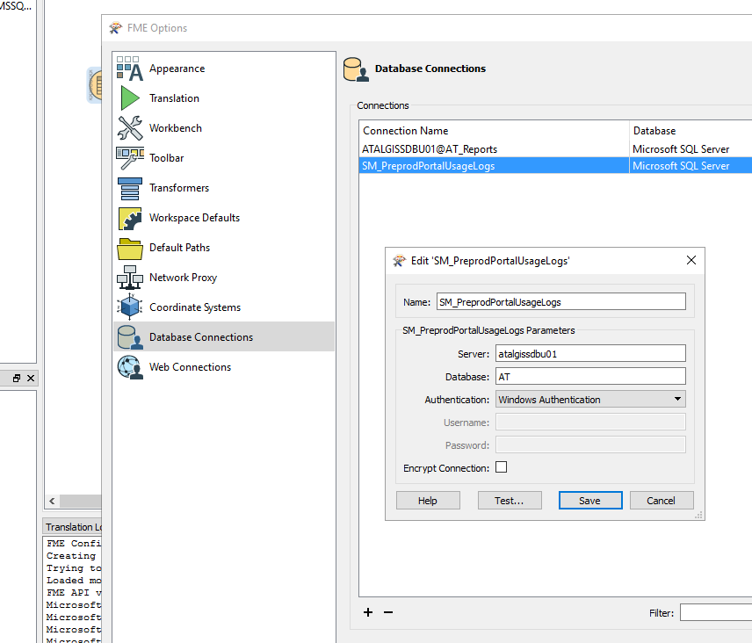

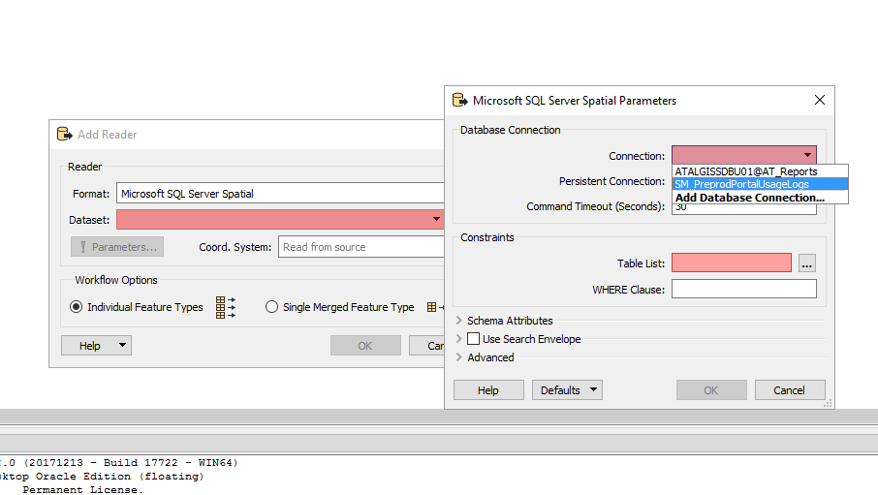

**Extract values in JSON**

Read individual components in

{"address":{"state":"WAIHEKE ISLAND", "postcode":"1081", "locality":"ONEROA", "streetName":"TUI", "streetType":"STREET","addressId":"14615516", "houseNumber1":"1","addressLine1":"1 Tui Street"},"location":{"x":175.010630000,"y":-36.783716000}}

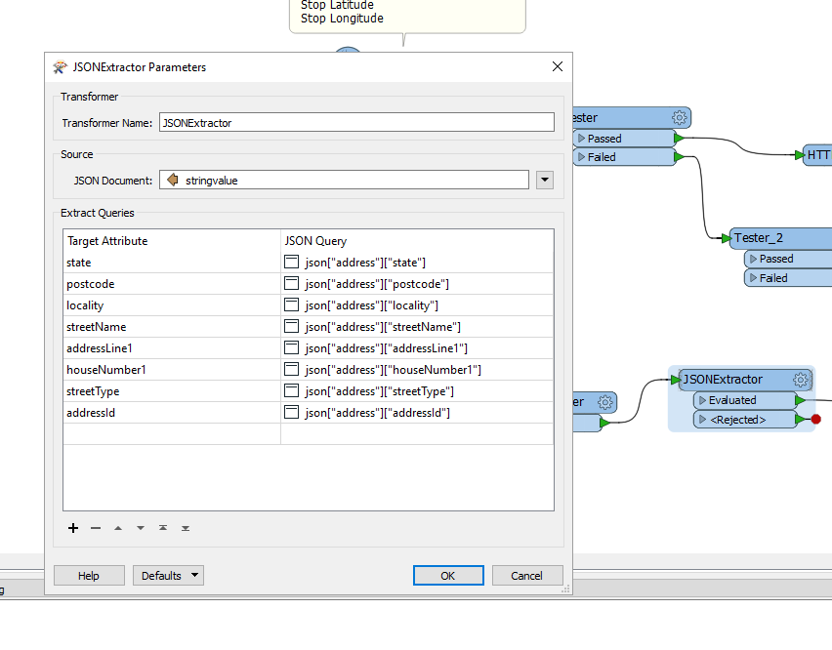

**JSON flattener expose an attribute**

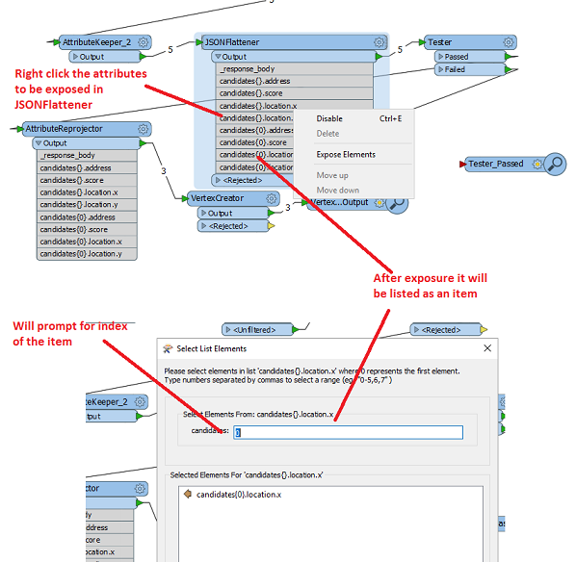

**Avoid asking template file**

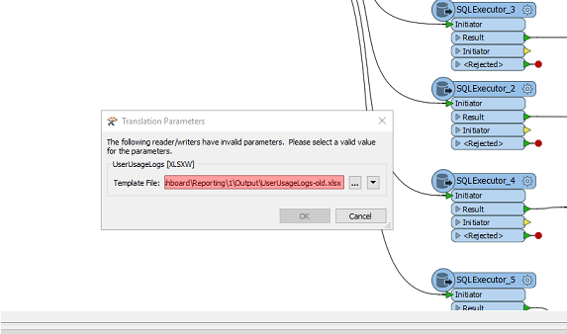

Soln:

Right click – “Edit <xyz> parameters”

Remove “template file”

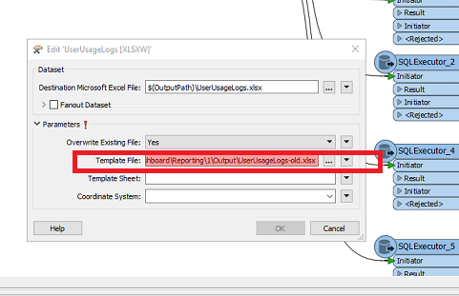

**Change parameters to a custom transformer**

In Caller

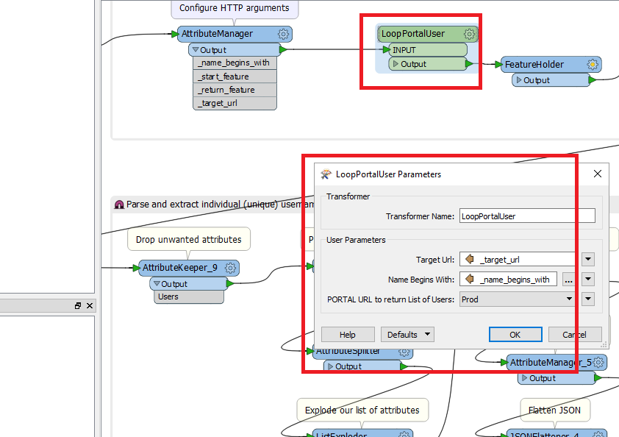

Inside custom transformer

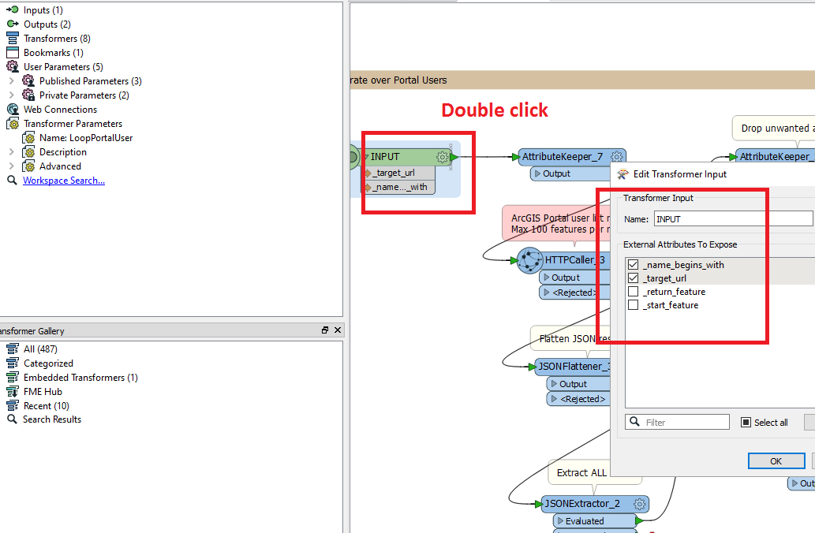

**Debug / view parameters**

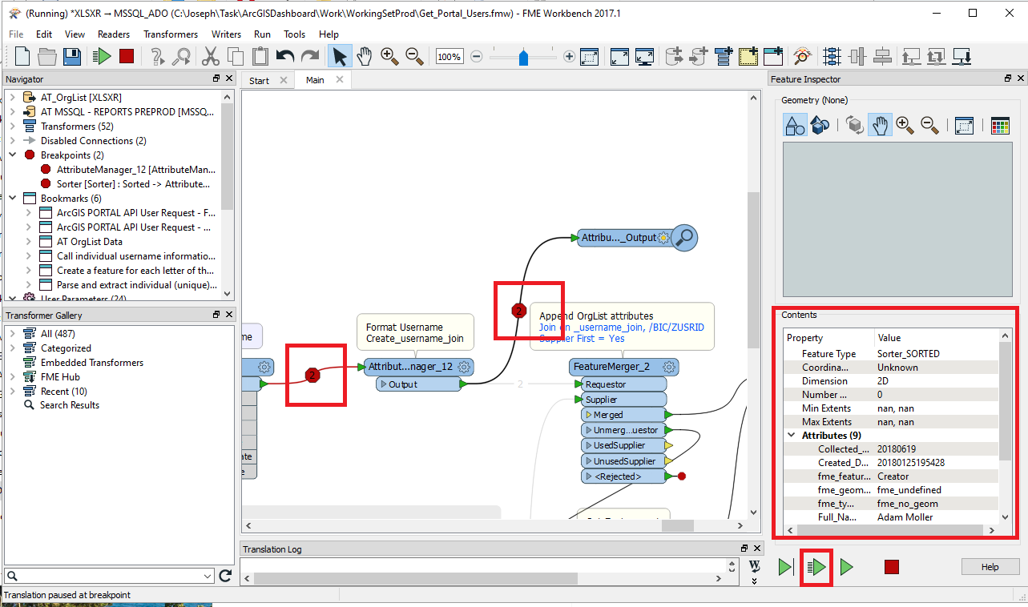

**Case statement**

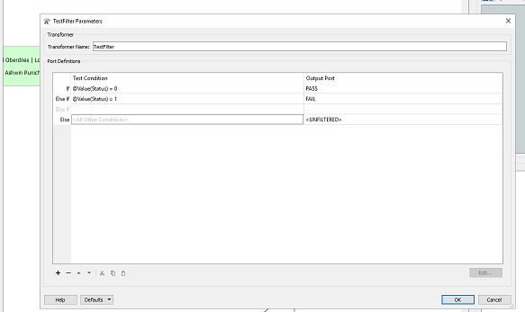

**Link Sharepoint OnPrem**

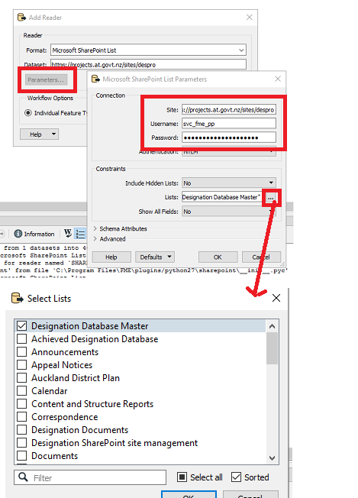

**Import connection into FME**

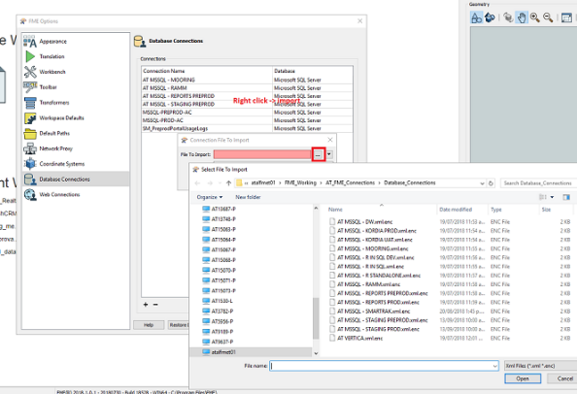

**Set priority of execution**

