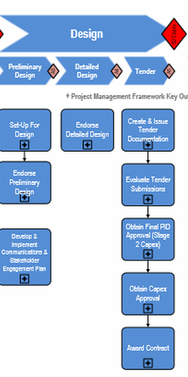

Setup for Design

Complete Options Analysis

Endorse Prelim Design

Develop And Implement Communications And Stakeholder Engagement Plan