In Excel, CONCATENATE function can convert the column list to a list in a cell separated by commas. Please do as follow:

1. Select a blank cell adjacent to the list's first data, for instance, the cell C1, and type this formula **=CONCATENATE(TRANSPOSE(A1:A7)&",")** (***A1:A7*** is the column you will convert to comma serrated list, "," indicates the separator you want to separate the list). See screenshot below:

2. Highlight the **TRANSPOSE(A1:A7)&","** in the formula, and press the **F9**key.

3. Remove curly braces **{**and ***}*** from the formula, and press the**Enter** key.

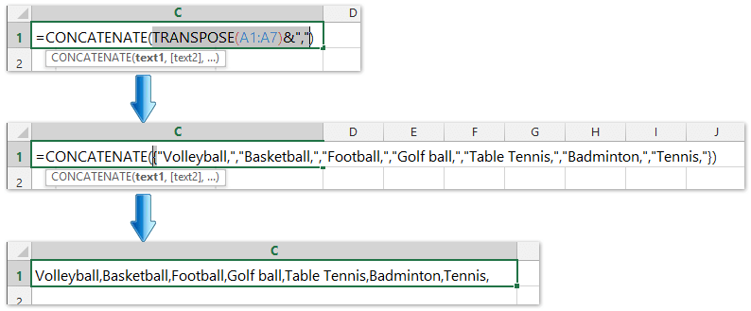

Now, you can see all values in the column list been converted a list in a cell and separated by comma. See screenshot above.