Download Microsoft Movie Maker

**Split a video**

Menu Edit -> Split

**Trim a video**

Menu Edit -> Split

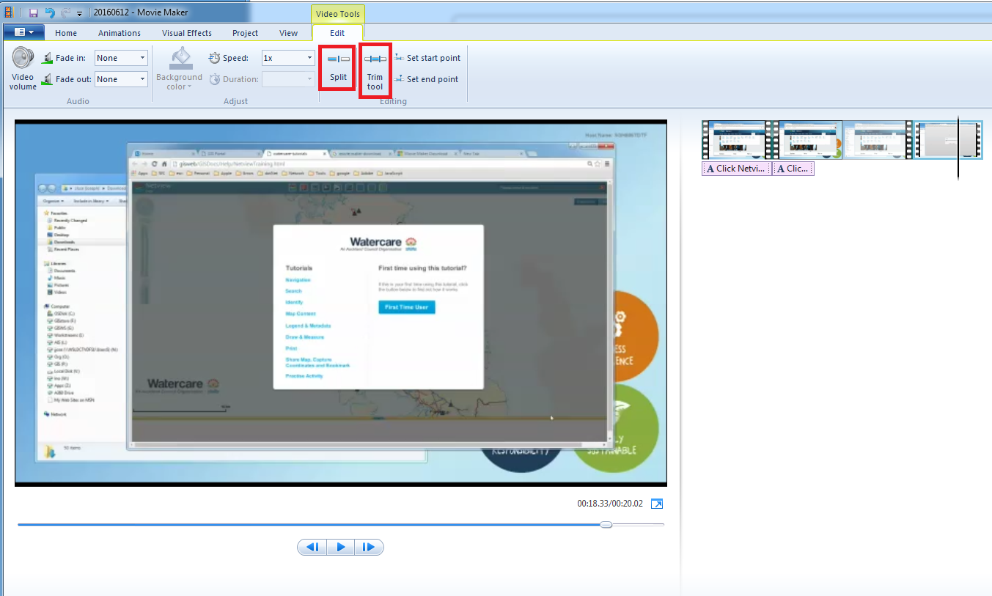

**Add starter animation**

Select Animations tab

Put cursor at start

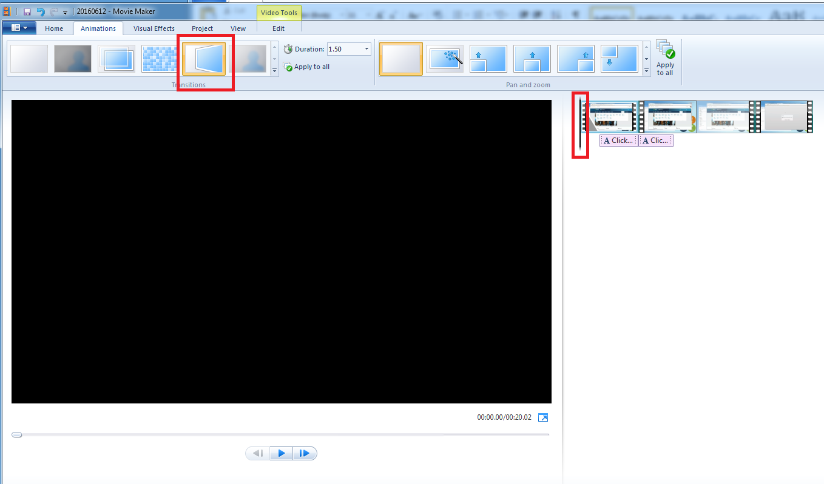

**Visual effects animation**

Put cursor at location of where effects need to come in

Select “Visual Effects”

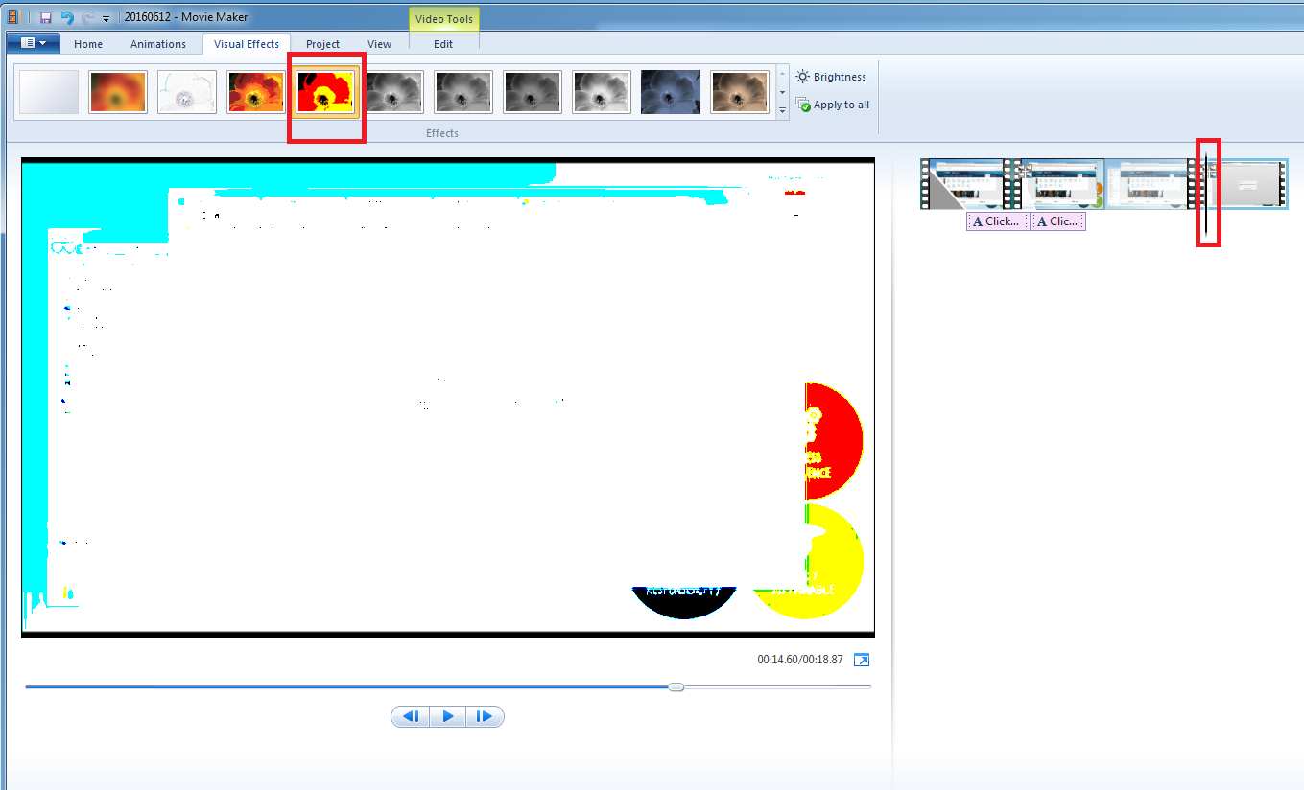

**Add notes**

Take a screencapture. Add/edit your text in screenshot and save in disk as ABC.bmp

Add it as a frame

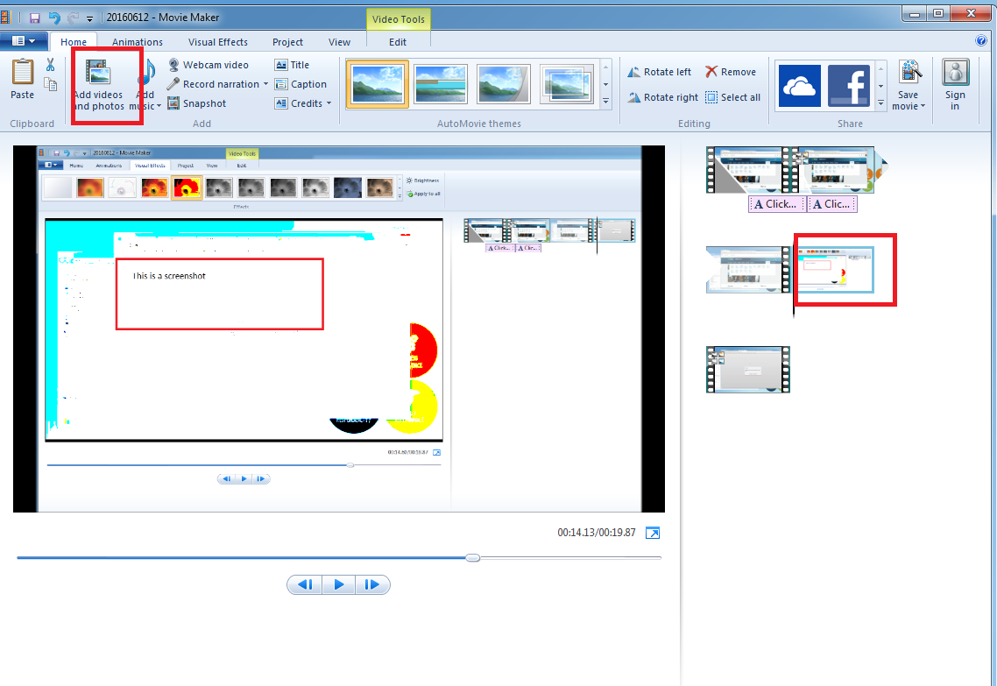

Set duration in Edit -> Duration

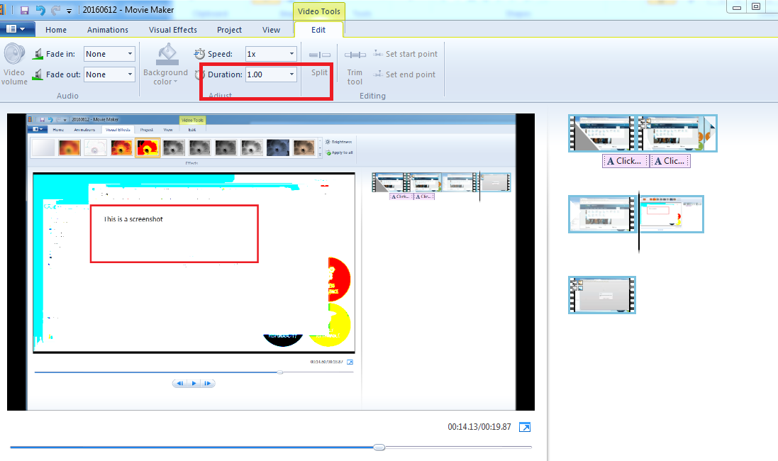

**Add animation**

Put cursor at location of where effects need to come in

Select “Animations” and required one

