REQUIREMENT

Find unique zones adjoining Carriageways

Sort each roadId and identify the zones surrounding it

1. Ramm_Car_Way make a local copy
2. FClass Ramm_Car_Way – make a UnqFldId = ObjectId
3. FClass UP_BaseZone – make a UnqFldId = ObjectId
4. FClass UP_BaseZone – Definition query “ZONE_Resolved<> 'Road [i]'”
5. Create buffer for FClass Ramm_Car_Way

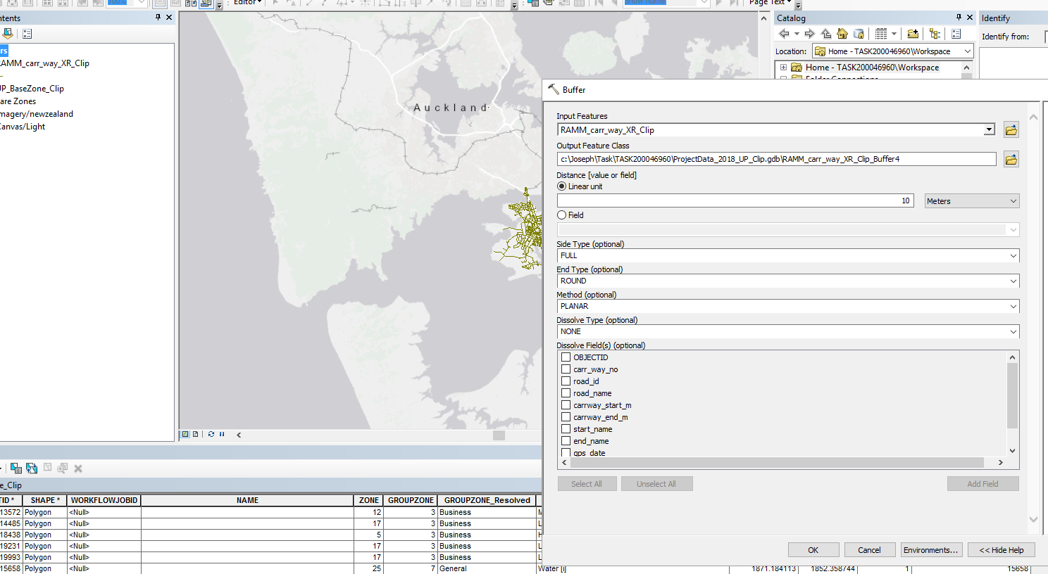

1. Create Spatial Join
   1. Between FClass Ramm_Car_Way and FClass UP_BaseZone

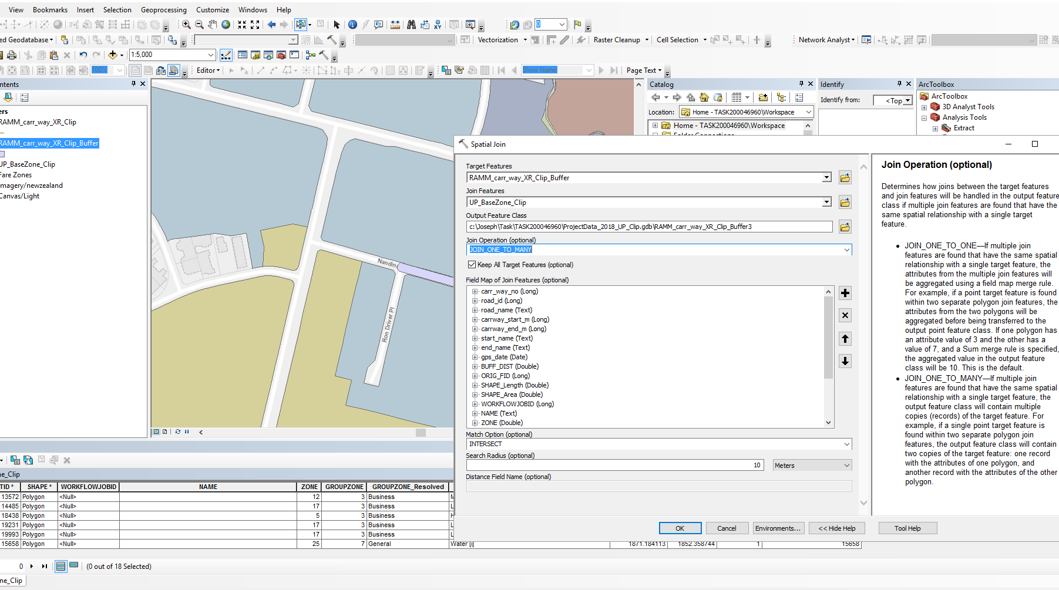

1. Validate

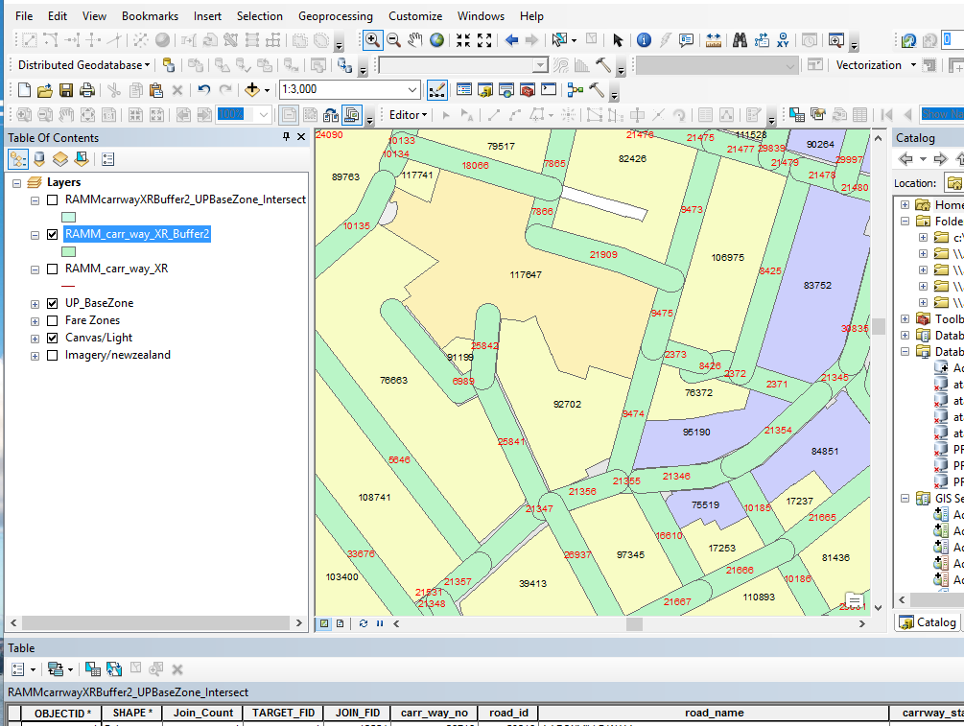

1. See where one buffer intersects which Zone

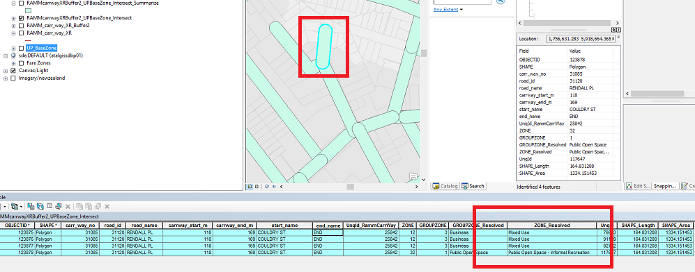

1. Find unique neighbouring zones

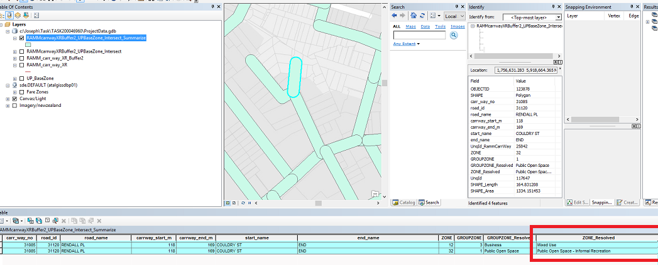

1. Export to Excel

