**ArcMap – Layer or table is not registered as versioned**

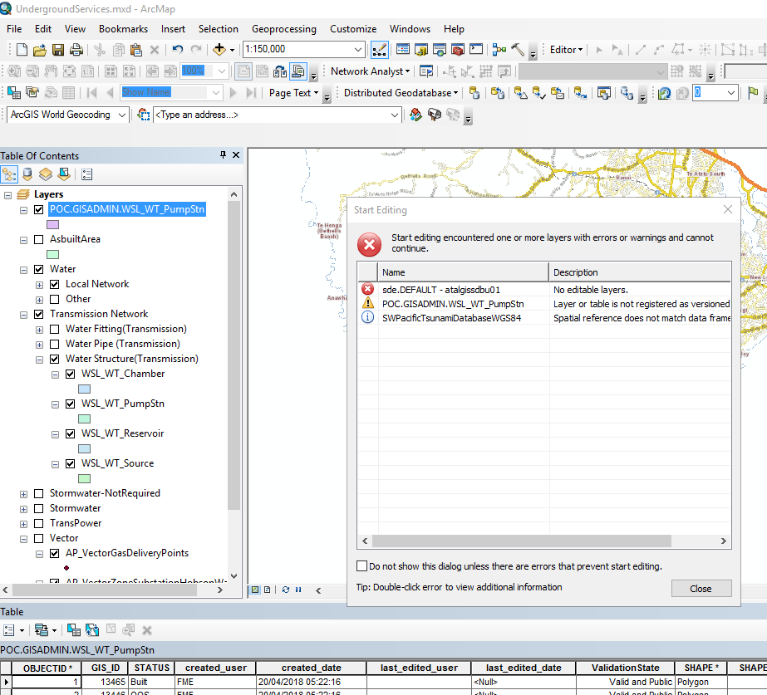

Soln Option1-

Editor -> Options -> Versioning tabl

Switch off “Edit a version…..”

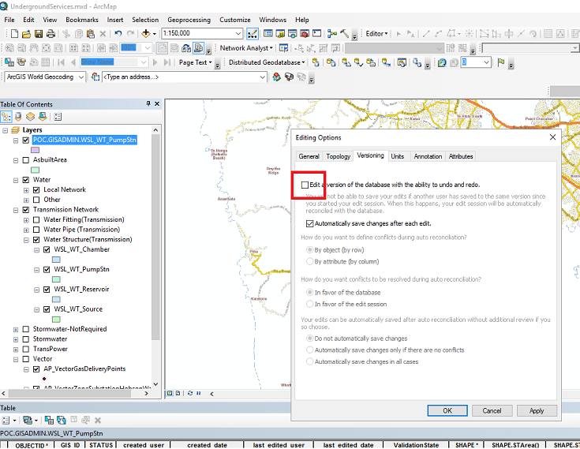

Soln Option2-

