Suggest to edit one polygon at a time, use the edit vertices button;

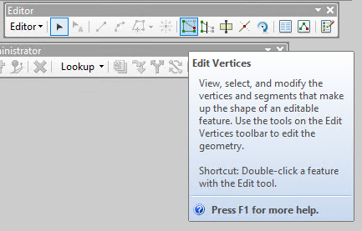

Use the edit vertices tools to delete or add vertices, you can delete multi vertices at once by drag a square to select the vertices to delete.

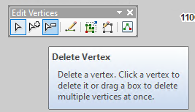

To edit the vertices precisely, use the snapping to snap to the vertices, open the snapping dialog and enable the vertex or edge to snap.

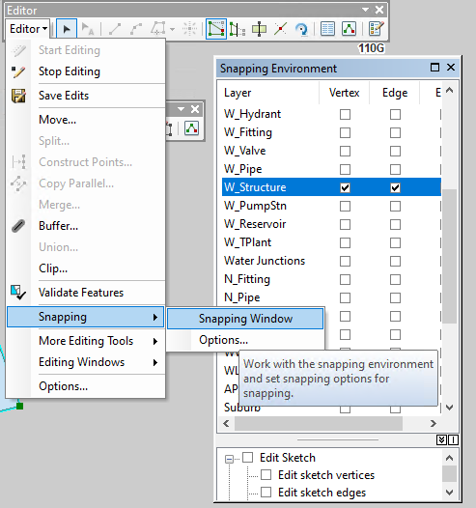

To move a vertices;

Move the cursor to the vertices and hold the mouse left button, then drag to new position.

To finish the edit, press F2 key.

Get more details in the Help

