1. Add coordination in decimal degrees
2. Add a Double type column
3. Right click “ Calculate Geometry”

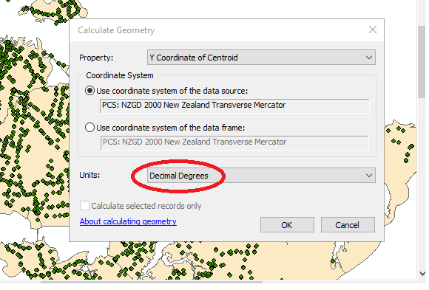

1. Find number of multi features in polygan files

Add field of integer type

With Phyton Calculate field value = !Shape!.partCount