**Roads with Borderline**

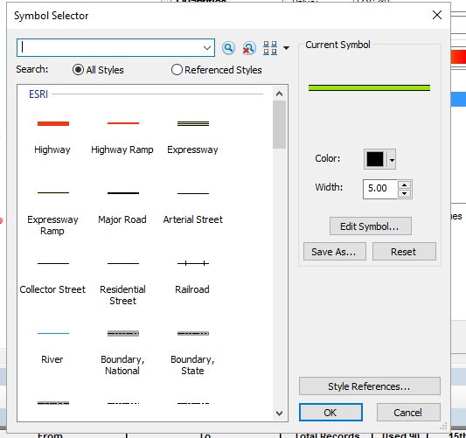

|  |  |
| --- | --- |
|  |  |
|  |  |
|  |  |
|  |  |

**Roads with In/Out Lines**

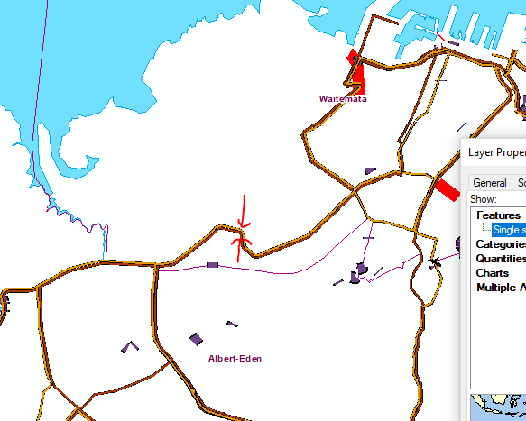

|  |  |
| --- | --- |
| Line1 |  |
|  |  |
|  |  |
| Line2 |  |
|  |  |
|  |  |