**Create equally spaced polygans across a railway lin**

1. Output sample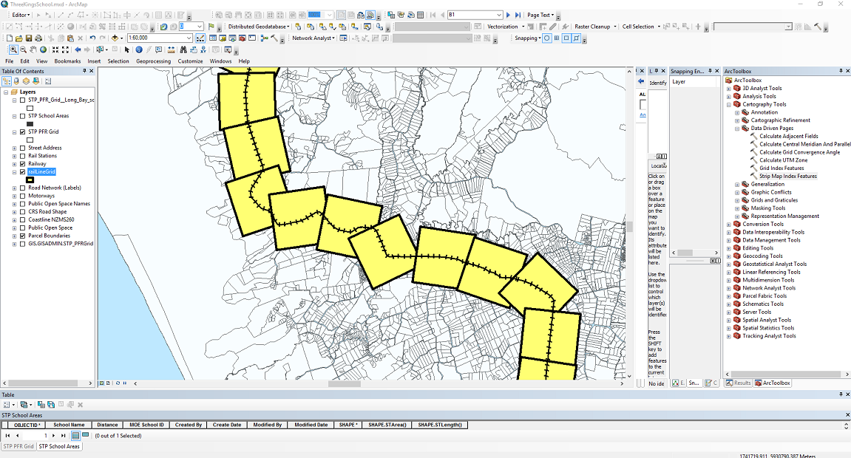
2. Goto Cartographic Tools -> Data driven Pages -> Strip Map Index Feature
3. To avoid overlap, (Percentage of overlap (optional) )

