**Enable Spatial Analysis**

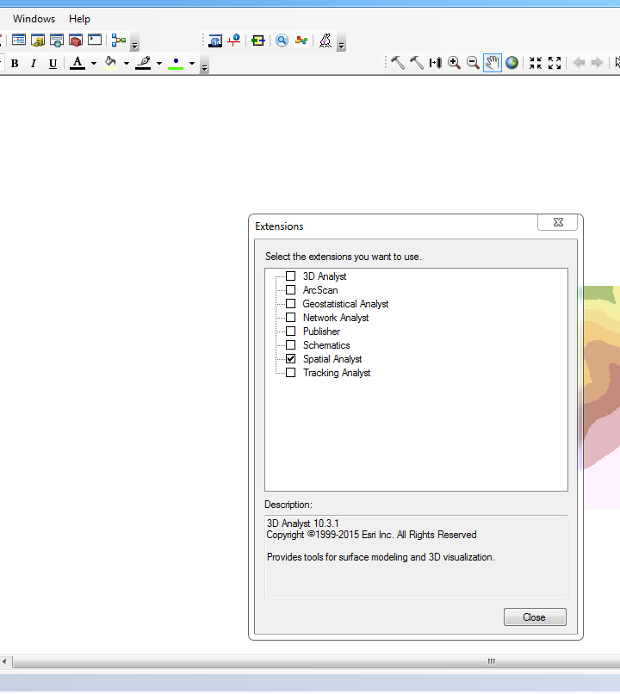

**Execute TopoToRaster Tool**

Input – Select the Contour layer

Input – Select “elevation” for field

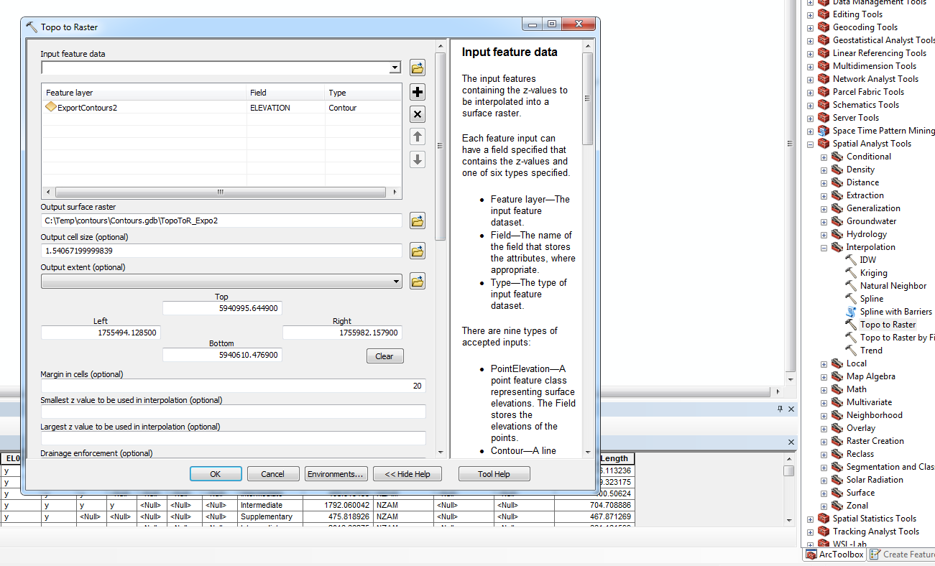

**Execute “Surface->Contour” tool**

Input raster – Output of previous step

Contour interval – Interval difference at which the new contour lines need to be created

