**<http://desktop.arcgis.com/en/arcmap/10.3/analyze/modelbuilder/integrating-model-within-a-model.htm>**

**Iterate a set of point feature classes, Collect all their values and merge them into a feature class**

1. Build a subroutine to iterate the feature classes
   1. 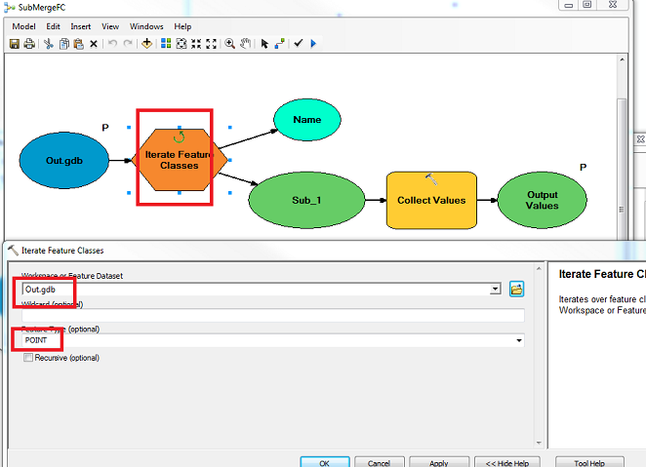
   2. Add the “Collect values” function

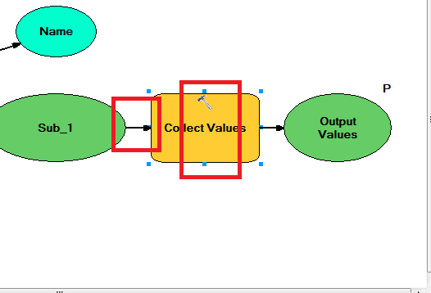

* 1. Add a link to connect the output of “Iterate FClass” to input of “Collect” values
  2. Select the “input” and “output”, right click and make them model parameters (this will make sure they work are parameters when they are included as a function)

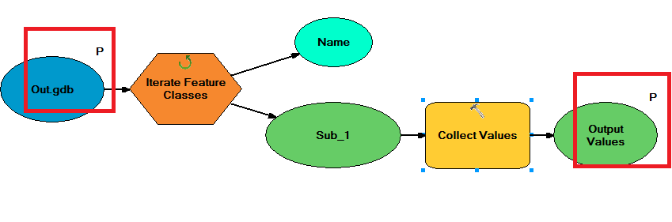

1. Build a main routine to merge the collected values
   1. Add subroutine created in previous step to main function
   2. Add the “Merge” branch function to merge all values collected in subroutine. Link them to subroutine

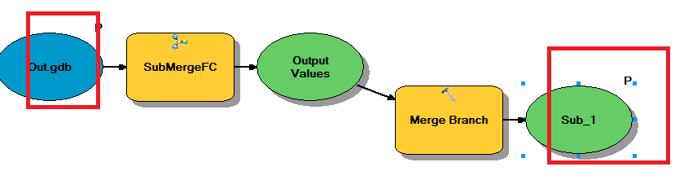

* 1. Make the input and output as model parameters

1. Run the function