<https://community.esri.com/groups/technical-support/blog/2010/08/20/setting-the-edit-and-snapping-environments-in-arcgis-10-to-the-classic-9-x-format>

**Snapping environment**

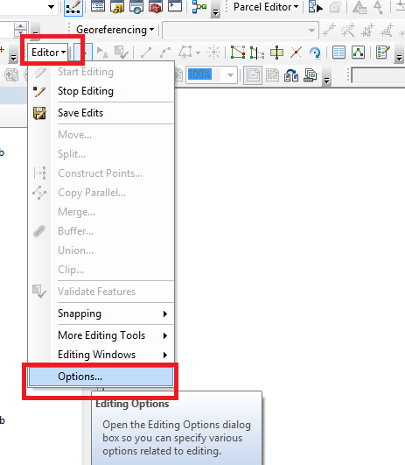

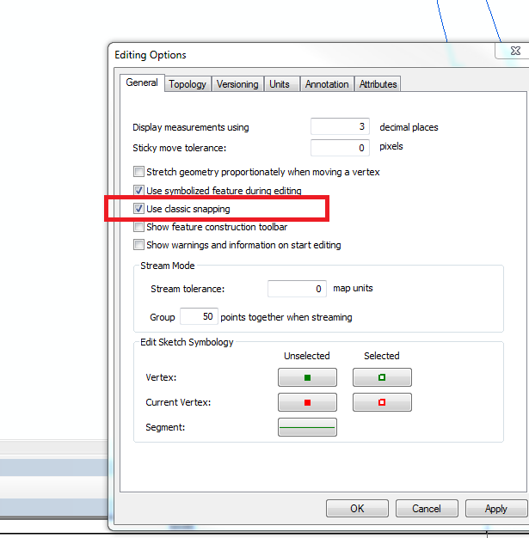

**Snapping options**

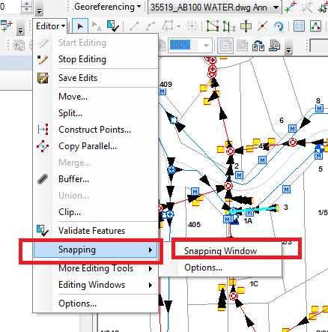

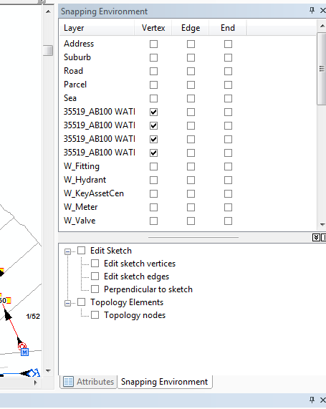

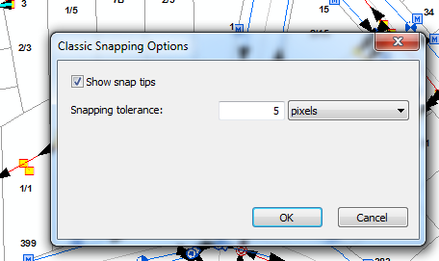

**Snapping - sketches**

Turn off classical snapping

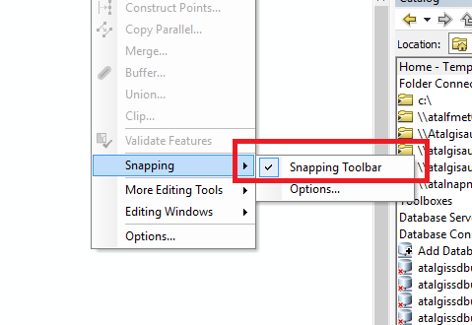

Turn on – Snap to sketch

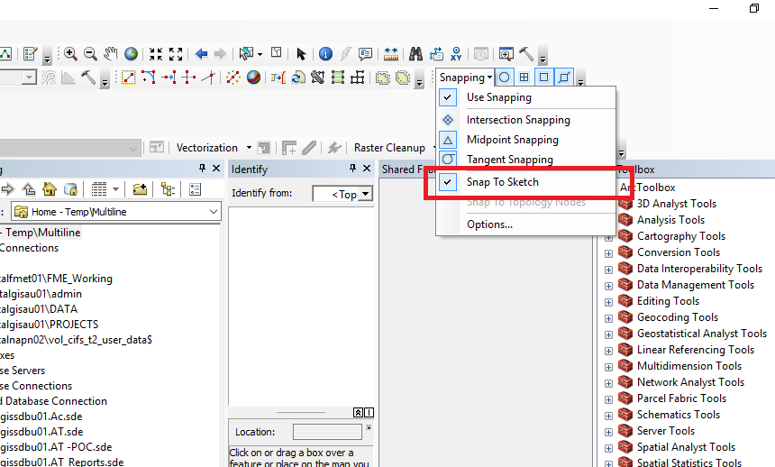

Drag the appropriate sketches

