1. Clip and extract the features required – Spatial features + Contours

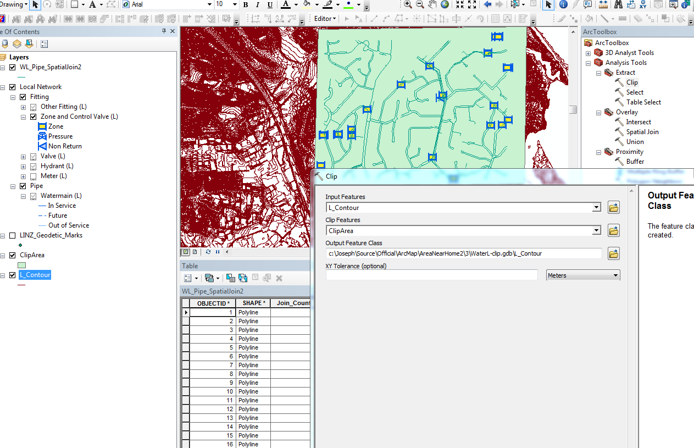

1. Create a spatial Join
   1. Target Feature – Pipe feature
   2. Join Feature – Contours

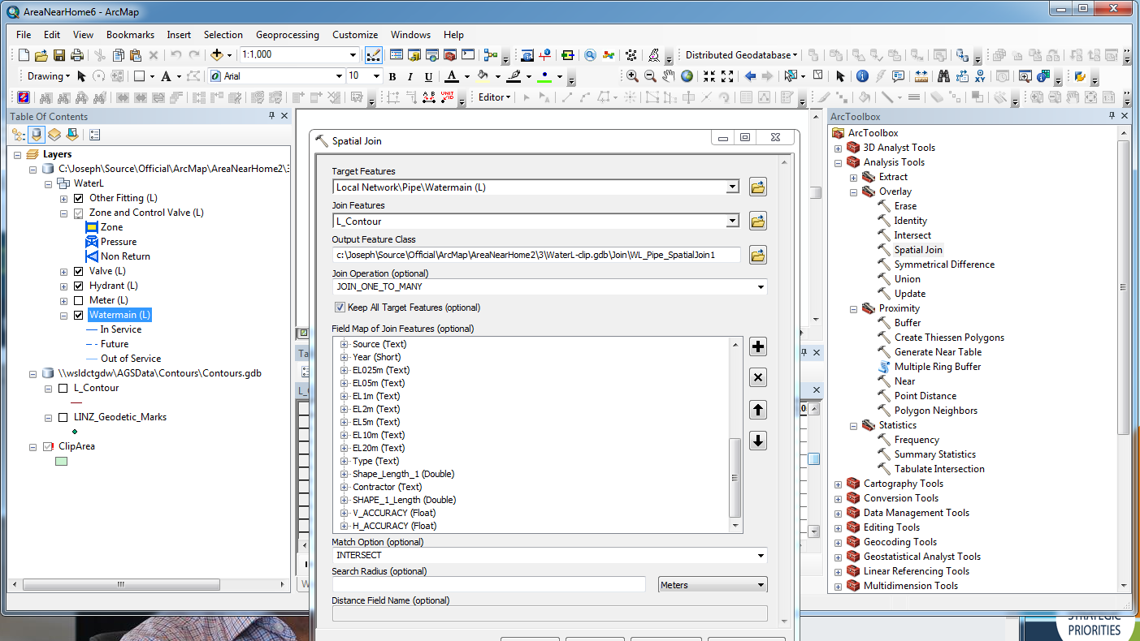

1. Open the “Joined” output table
   1. Field Target_FID = Object ID of Target Feature(=Pipe feature)
   2. Field Join_FID = ObjectID of Join Feature (=Contour feature)  
      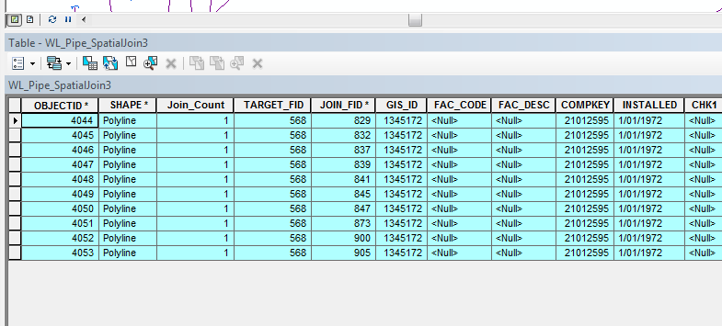
2. Create a Join between “Contours” and the “Joined” output table- WL_Pipe_SpatialJoin3
   1. Field – ObjectID
   2. Table - WL_Pipe_SpatialJoin3
   3. Join Field – Join_FID
3. In the related table – To check the number of contours interacting filter by <JoinTable>.Target_FID= ObjectID of required Pipe feature

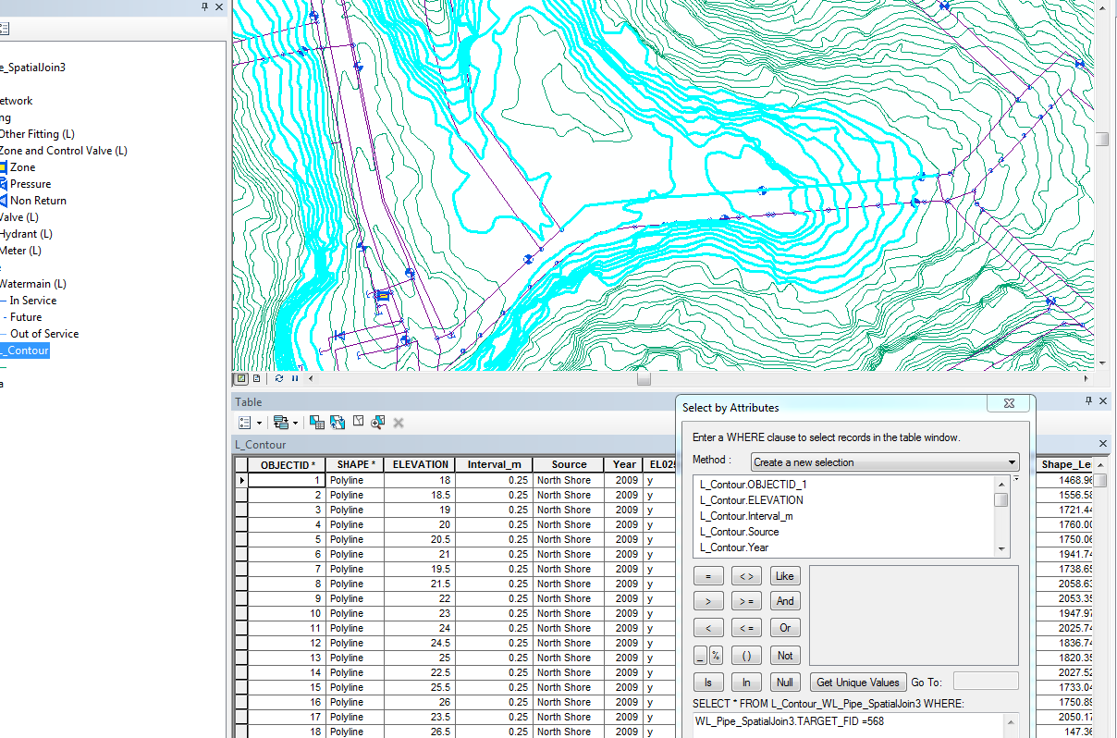

1. Export the Joined table “WL_Pipe_SpatialJoin3” to MS Access
2. MS Access function to find the Highest and Lowest values

Run the AccessSQLs

1. Export the featureclass to a standalone table “WL_Pipe_JoinAttributeOnly” with valid attributes as below

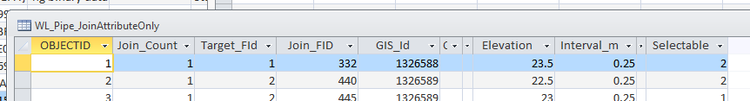

1. In the WL_Pipe Featureclass add below attributes
   1. CHKH – Highest height
   2. CHKL – Lowest height
   3. CHKHID – Id of highest contour
   4. CHKLID – Id of lowest contour
   5. Route- Direction
2. Populating Height attributes

*Ideally Joins should be done in ArcMap and values updated. At this time this function was disabled suddenly. Option B- move it to MSAccess.*

//Export the WL_Pipe feature class to Access

Run SQLs in AccessHighestValsSQLs

//Move the routed feature class from MS_Acccess to Gdb

//Populating Height attributes end

1. Move the WL_Pipe_Routed feature class from MS-Access to GDB
2. Validate if the hieghts and Ids are correct  
   *The Ids will be wrong here as Objectid are taken. A uniquie Id needs to be given for contours*

//Case 1

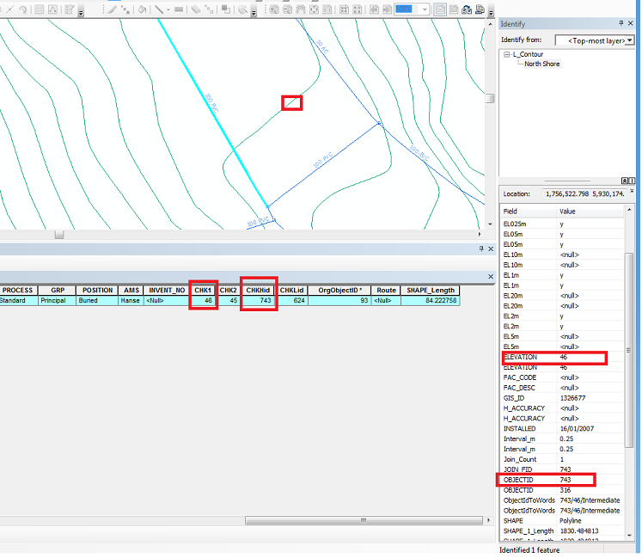

//Case 2

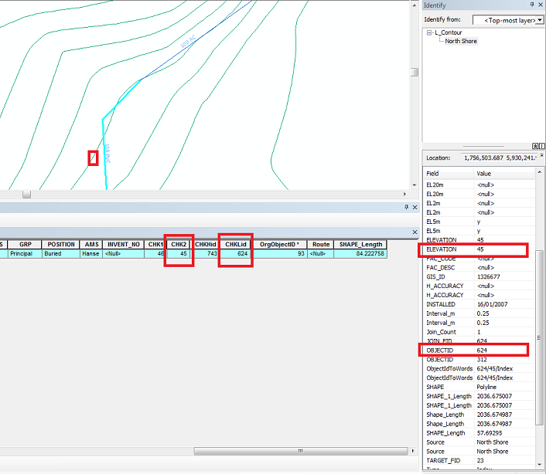

1. Update the value of Route based on value on value of CHKH and CHKL. [(CHKH>CHKL)Route = 1] [(CHKH<CHKL)Route = 0
2. Run RouteScript.txt
3. Three cases exists now
   1. CHKL missing

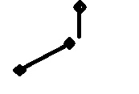

* 1. CHKH missing

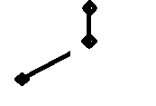

* 1. CHKH in upstream and CHKL in downstream missing

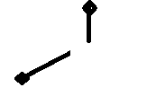

* 1. CHKH and CHKL missing in one node

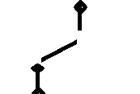

1. Create 3 attributes
   1. AgvHgt – Average of hieghts of CHKH and CHKL
   2. upAsset – Id of upstream asset
   3. DownAsset – Id of downstream asset
   4. CHKHd – derived CHKH based on up asset
   5. CHKLd – derived CHKL based on down asset
   6. CHKHf – final CHKH based on up asset
   7. CHKLd – final CHKL based on down asset
   8. upAssetd – derived Id of upstream asset
   9. DownAssetd – derived Id of downstream asset
   10. upAssetf – final Id of upstream asset
   11. DownAssetf – final Id of downstream asset

For a, b, c find the average.

1. Run AverageScript.txt
2. Setup the below layers

|  |  |  |
| --- | --- | --- |
| **Layer** | **Definition Query** |  |
| Watermain (L)-Valid | STATUS <> 'RM' AND Route IS NOT NULL |  |
| Watermain (L)-ChkHMissing | STATUS <> 'RM' AND CHKL IS NOT NULL AND CHKH IS NULL |  |
| Watermain (L)-ChkLMissing | STATUS <> 'RM' AND CHKL IS NULL AND CHKH IS NOT NULL |  |

1. For 15(b), Get CHKHd
   1. Create a spatial join ( optional Switch the target and Join)

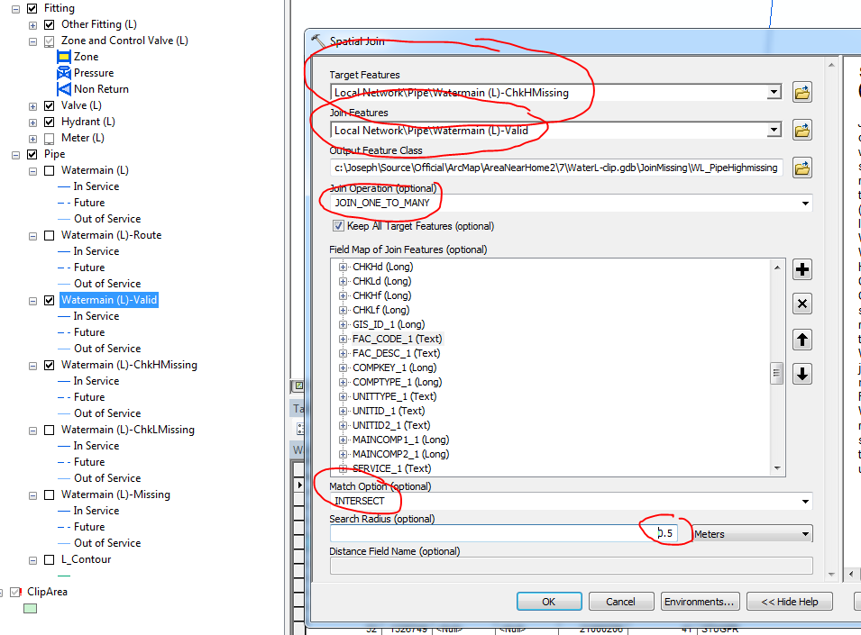

* 1. Create an attribute join on GIS_ID between Watermain (L)-ChkHMissing and WL_PipeHighMissing2
  2. Set layer “Watermain (L)-ChkHMissing” in editing mode as a joined table
  3. Use “Field Calculator”, to get derived values
     1. set CHKLf = CHKL
     2. set CHKHd = Joined table – CHKH
     3. set CHKHf = CHKHd
     4. Set AvgHgt = ( [WL_PipeRoute.CHKHf]+ [WL_PipeRoute.CHKLf])/2
     5. Set Route = 1 if (CHKHf > CHKLf) else 0

**Phyton**  
lastValue=0  
def getRoute(hVal, lVal):  
 if hVal > lVal:  
 lastValue = 1  
 else  
 lastValue = 0  
 return lastValue

getRoute( !WL_PipeRoute.CHKHf! , !WL_PipeRoute.CHKLf! )

1. For 15(a), Get CHKLd
   1. Repeat Step 18
2. For 15(c), Case not found in dataset
3. For 15(d).
   1. Spatial Join
      1. Target Features - Watermain (L)-Missing
      2. Join Features - Watermain (L)-Valid
      3. Condition – OneTomany
      4. MatchOption – Intersect
      5. Search Radius – 0.5m
      6. Run Script “calcHgtIfbothMissing.txt” along with calculate average Height at regular intervals using step 20.d. Repeat from 23a until gap reduces

*Note- Using technique will be valid for below case only. Each item to be validated*

