**Set symbology in Db**

Set one field as the RuleId

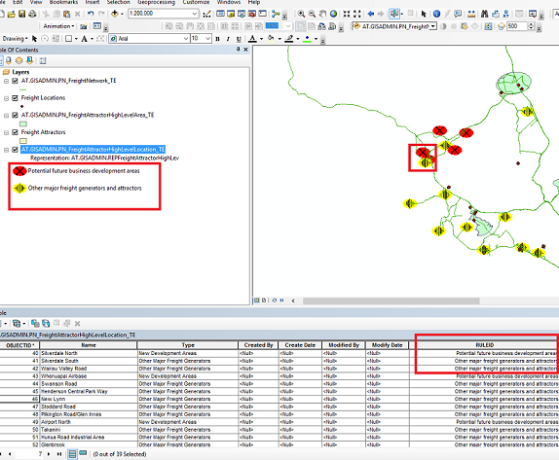

Open SDE,

1. Feature class properties
2. Set “Representations”

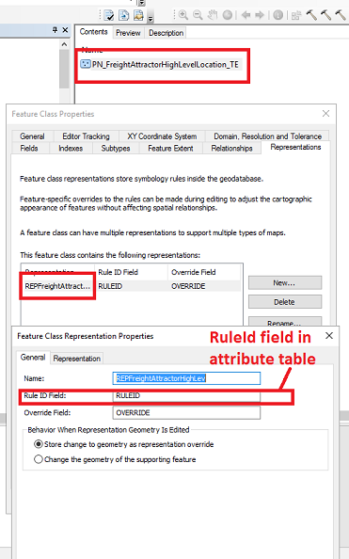

Double click the representation and set the symbol

