Enable Time on the layer

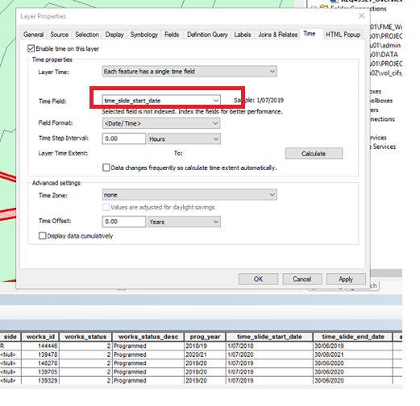

**Tools menu**

Enable – Slider

Check Options

