In the GIS Domain ,everyone might have heard about WMS,WFS and WCS at some point of time. But what exactly these words are and when to use them are the questions generally arises. Thanks to Open  Geospatial Consortium for bringing life to GIS maps with this technology. One can  create the maps from their data using desktop based GIS Tools like ESRI ArcMap  and Open Source QGIS .To bring these maps on to web and create GIS based applications, we need to publish them using Web Services .Similar to typical web applications, to share or consume the GIS data we use web services like SOAP and REST.

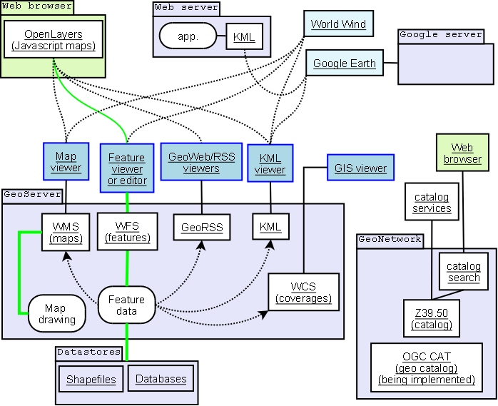

Image Source: [http://gis.stackexchange.com](http://gis.stackexchange.com/)

**Web Map Service :** To share and render the map on the browser or create a custom map based application , OGC  Web Map Service (WMS ) is used.  WMS is a simple and mostly used Map Service out there in the market.WMS will just render the Map in the form of the image. One can view the map with limited functionalities like zoom , pan within the extent of the map layer created.

**Web Feature Service:**  WFS is used  to query , update , delete  the data of the map. This is used to share the vector data or metadata of the map over the web. This protocol is mostly useful in  web based client applications developed for GIS data editing.

**Web Coverage Service :** WCS is used to Publish the raster data like satellite imagery in image or TIFF or GeoTIFF formats.  This is non-RESTful based service created using XML encoded in SOAP. If the image size  is huge, this may take time in rendering the data which can slow down the performance of the application. To enhance the speed and performance of the application , it is suggested to use compressed images.

I have covered very basic features of these web service protocols which can help the newbies in the GIS development. For further information, please refer to <http://geoserver.org/>