# map setup – offline mode

**Note : The steps below need to be followed only if the map is not downloaded onto the device or the proposed area of field work isn’t on the device. A WiFi connection should be available.**

The steps below sets up the map for offline mode.

## Prechecks

Follow the steps below

* Open the collector app
* Check if the map is downloaded onto the device
* Below is a screenshot of Collector having the field area downloaded and circled Red

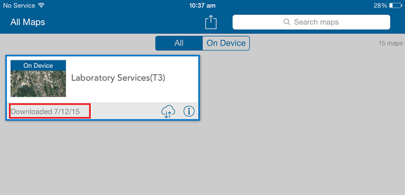

* Continue to Section 2 if it’s downloaded or else go to the next step.

## Map setup

Follow the steps below

* Open the collector app
* Check the map of interest ie Laboratory Services(T3)
* Tap the download button encircled below

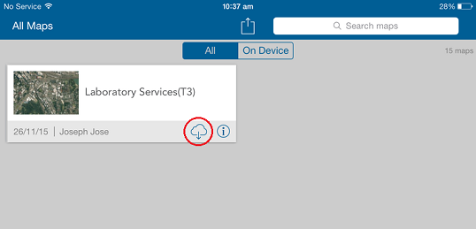

* Select your work area by zooming in to your field area on the map

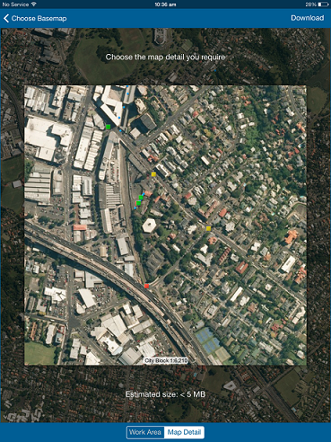

* Confirm your work area by tapping the “Map Detail” button encircled below. To reset the Area again , tap the “Work Area” again and select your area of preference.

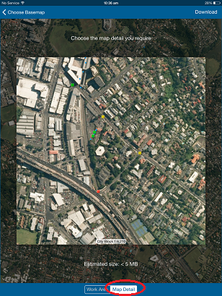

* Tap the “Download” button to start the download.

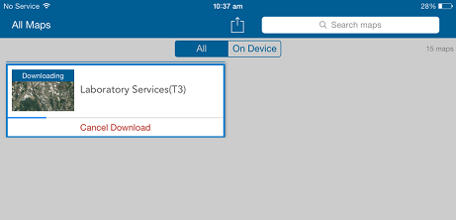

* Wait for the download to complete. On successful download, a message as in image below is displayed.  
  

# map usage and synchronizing changes

## MAP USAGE

This section details out how to use the collector app in offline mode. Follow the steps below –

* Check you have a downloaded map by info on the web page pointer as encircled below



* Tap the map pointer to open the map and start using it.

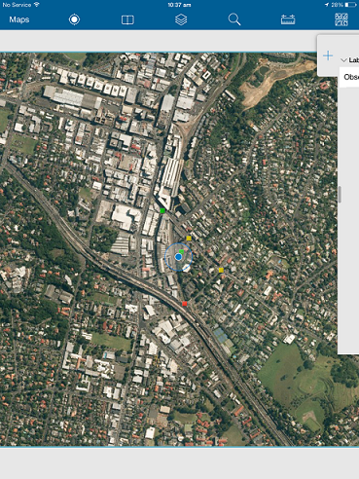

## SYNCHRONIZING CHANGES

**Note: - A Wifi connection is required to synchronize the changes.**

This section details out how to synchronize the changes. Follow the steps below –

* Check you have a downloaded map by info on the web page pointer as encircled below



* If you need a refresh of the latest data, tap the download button Wait for the refresh to complete

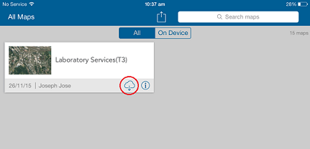

* After your field collection is complete, the collectors opening page will show the number of unsaved changes as in image below

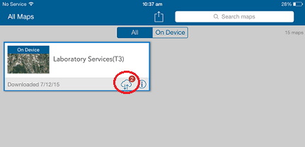

* Tap the synchronize button to post the changes into server. Wait for the upload to complete

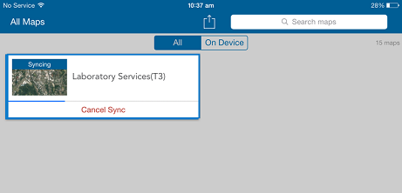

## REMOVING DOWNLOADED DATA

**Note: - A Wifi connection is required for this.**

This section details out how to delete a downloaded version. Follow the steps below –

* Tap the “On Device” button and then tap the button encircled.

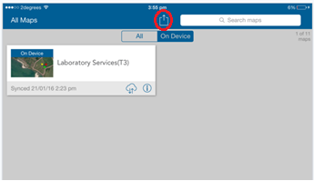

* In the popup that comes, tap the “Manage” button

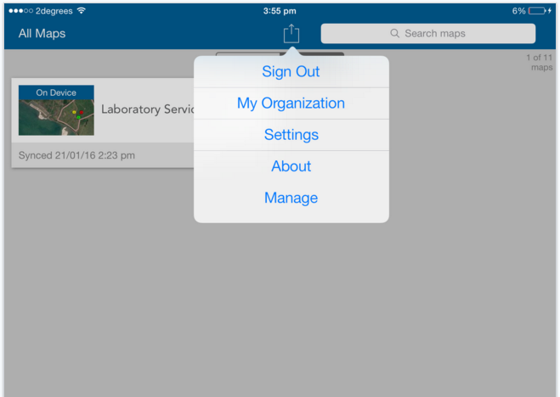

* Tap the “Remove” button for all downloaded maps that needs to be removed.

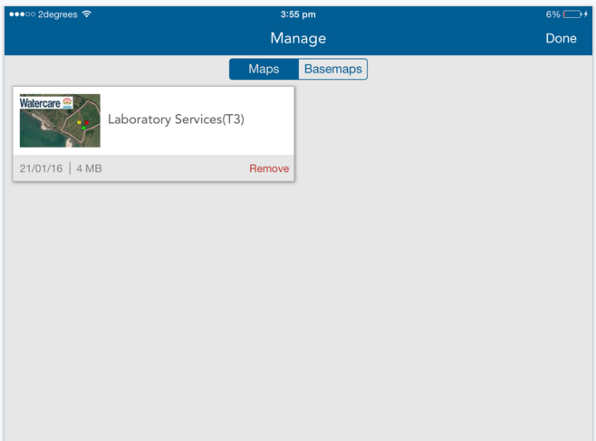

* Confirm and popups that come..