**Clip tool**

1. Set licence to Advanced editing mode
2. Create a polygan feature , add a polygan feature covering the area where features need to be extracted
3. Select Analysis Tools -> Extract -> Clip
   1. Input feature – Feature which needed to be extracted
   2. Clip Feature – Feature selected in Step 2
   3. Output Feature Class – Where the featureclasses need to be exported

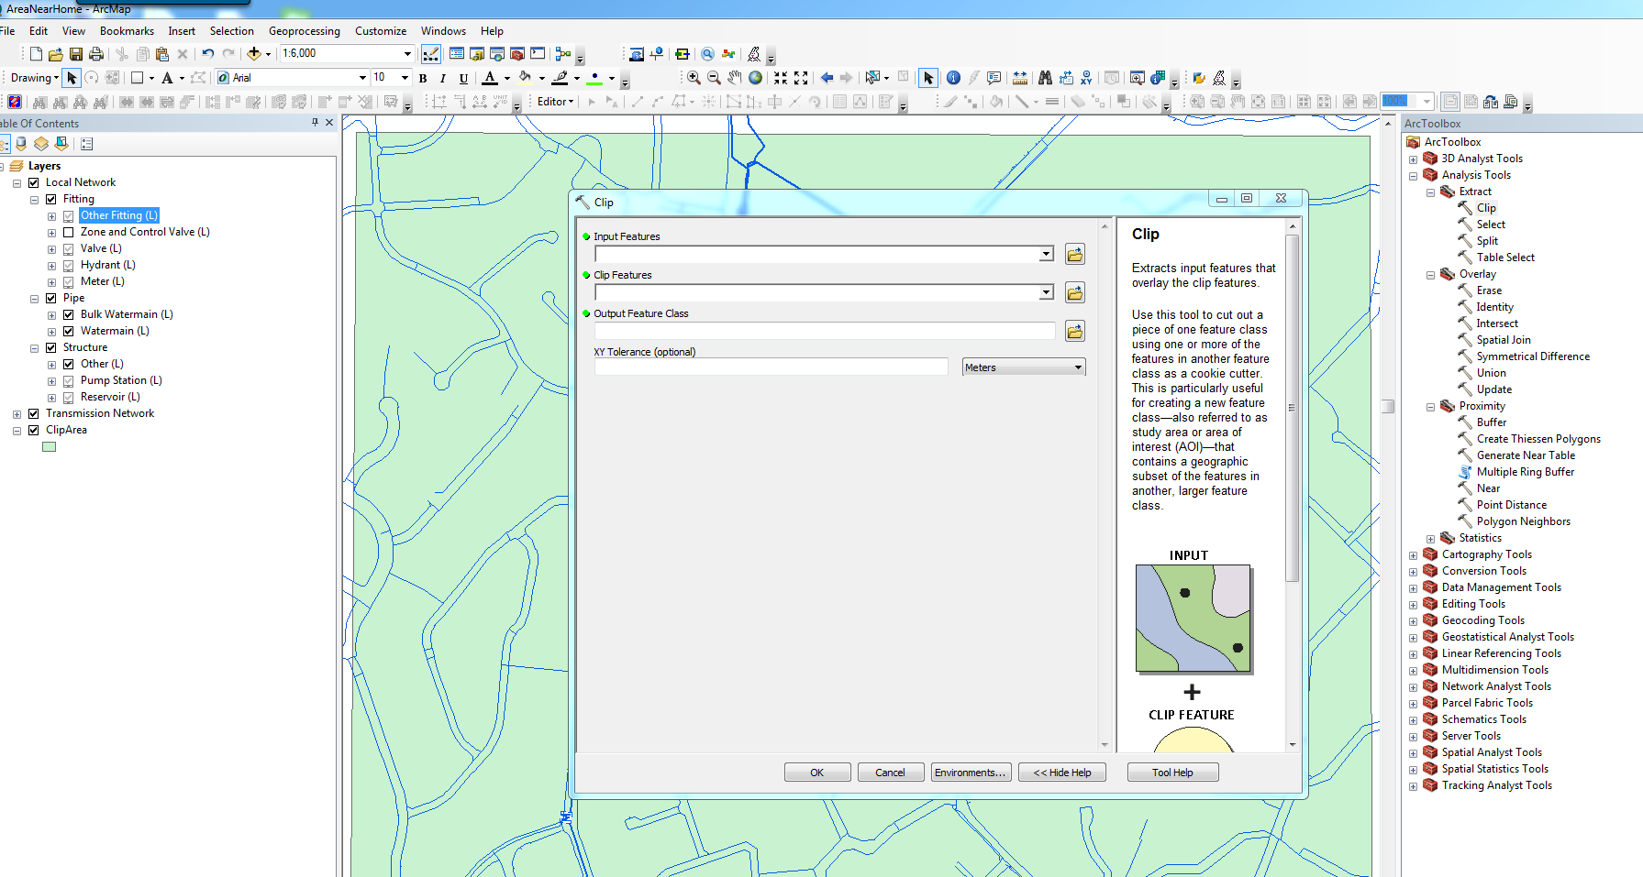

**Option2**

Enable Toolbars -> Distributed Geodatabase

1. Select <Source>
2. Select <destination>  
   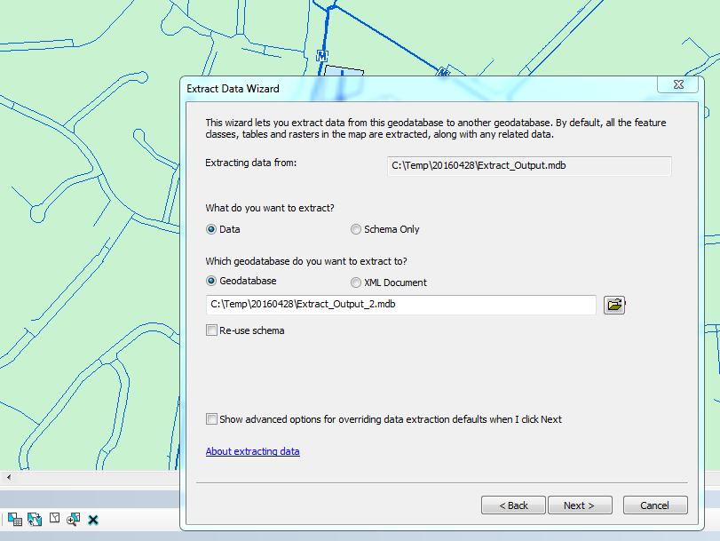

Option for a. Schema only b. Reuse schema

1. Set extent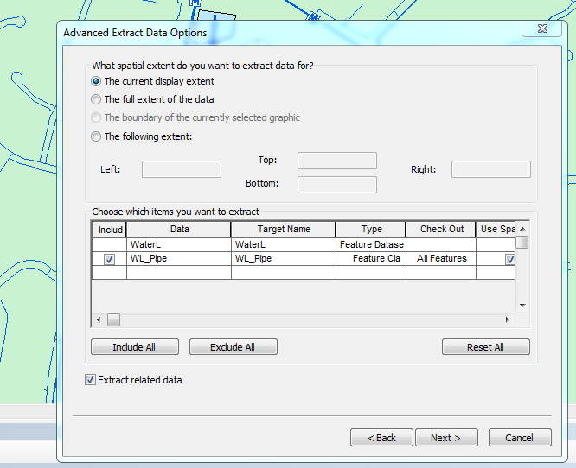
2. Click finish