1. New Feature Dataset
   1. Right click -> New -> Feature Dataset

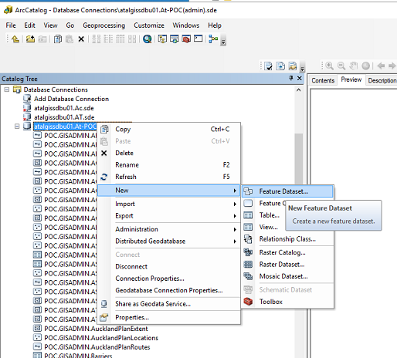

* 1. Projection

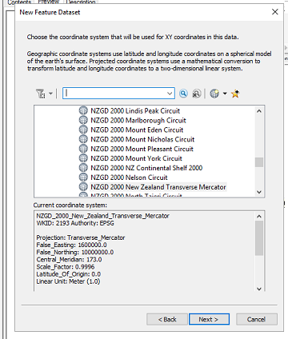

* 1. Vertical coordinate

1. New Feature Class
   1. Right click -> New -> Feature Class
   2. Projection
   3. XY Tolerance
   4. Db Storage Config
   5. Import Schema to quickly build from fgdb

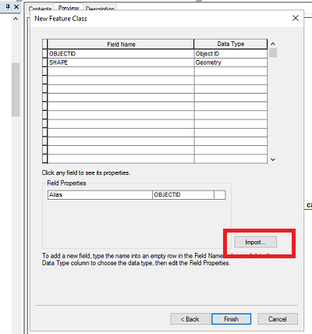

* 1. Give permissions as below

