**COMPRESS GEODb**

Right click Db -> Administration -> Compress Database

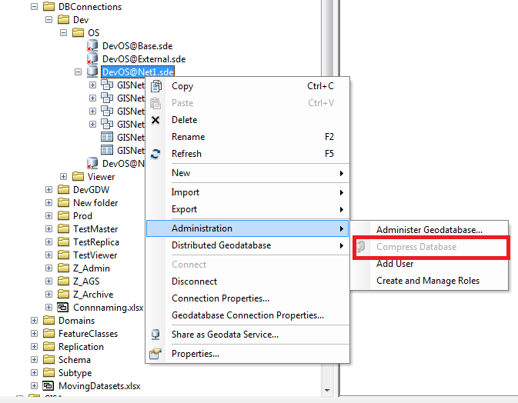

Check Compress log

