## Electoral Signage Web Editing App – Geodata Replication

1. Transfer Objects File Geodatabase to On Premise Enterprise Geodatabase

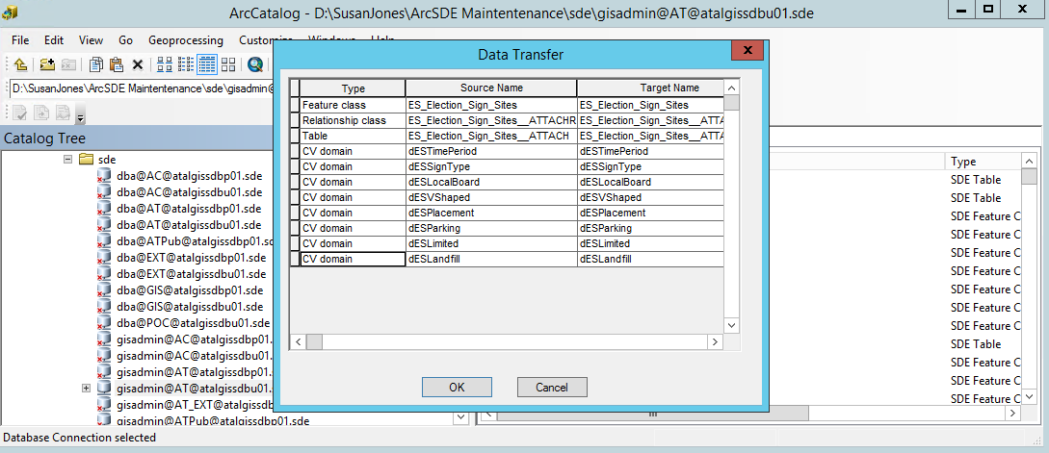

1. Add Globalid Fields to both On Premise and Azure Geodatabases
2. Register as Versioned
3. Create Replica

* Replica name **Azure_ParentToChild_ElectoralSignage**

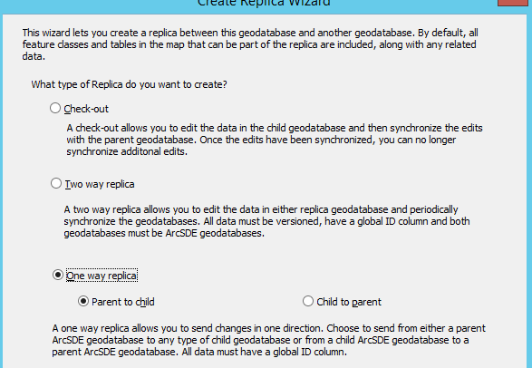

* *Select* **Register existing data only**
* *Save* in **geodata** database in **Pre Production Azure** Instance

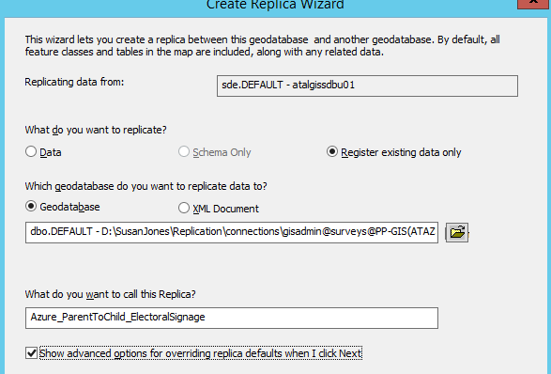

* *Select* **Simple model of replication**

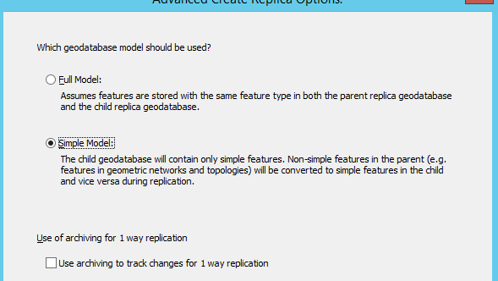

* *Confirm* the **Advanced Create Replica Options**

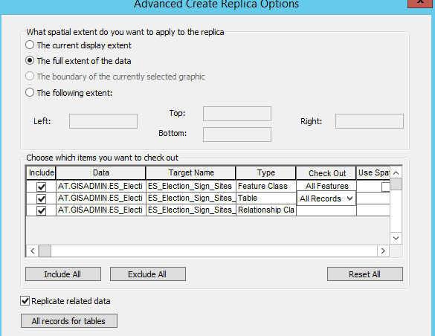

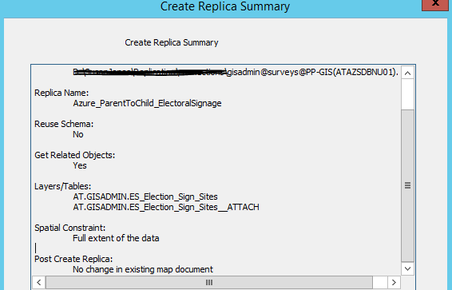

1. Confirm the replica created successfully

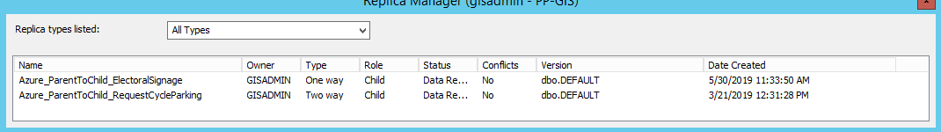

1. Test 1-way synchronisation

