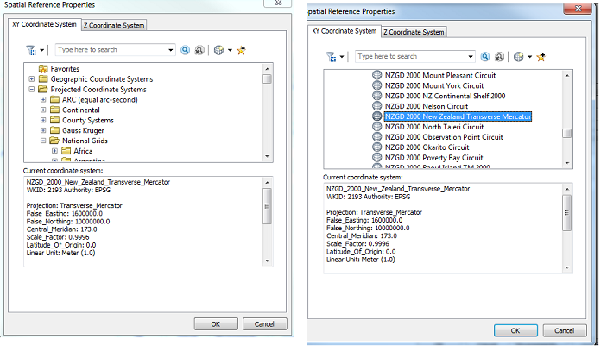

**Auckland bounds**

|  |  |  |
| --- | --- | --- |
|  | decimal degree |  |
|  | Long | Lat |
| Min | 174.1618408 | -37.29266255 |
| Max | 175.5506487 | -35.90041935 |