**Open phyton window**

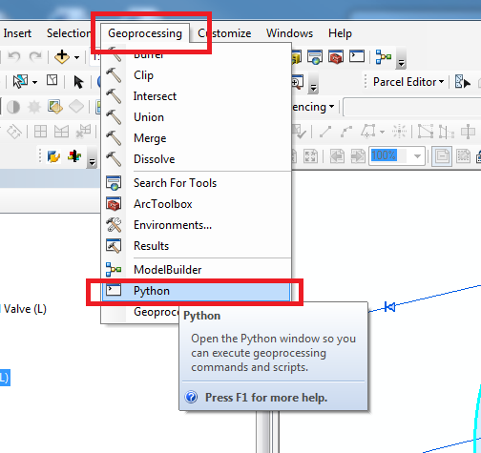

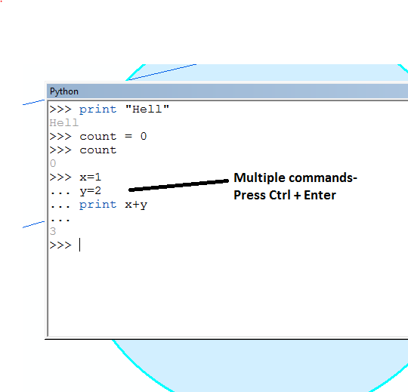

**List all selected features in a layer**

>>> for row in arcpy.SearchCursor("Reservoir (L)"):

... print row.FAC_DESC, row.COMPKEY

**Running multiple commands**

for row in arcpy.SearchCursor("Pump (T)"):

... print row.Equip_ID

... for row in arcpy.SearchCursor("Reservoir (L)"):

... print row.Fac_Desc, row.Compkey

**Make selection for a condition**

arcpy.SelectLayerByAttribute_management("Pump (T)", "NEW_SELECTION", "FAC_CODE='WPFHL'")