1. Open another tab in the web browser and navigate to AGOL Assistant.
   1. <https://ago-assistant.esri.com>
2. Click the Log in to Portal for ArcGIS button
   1. 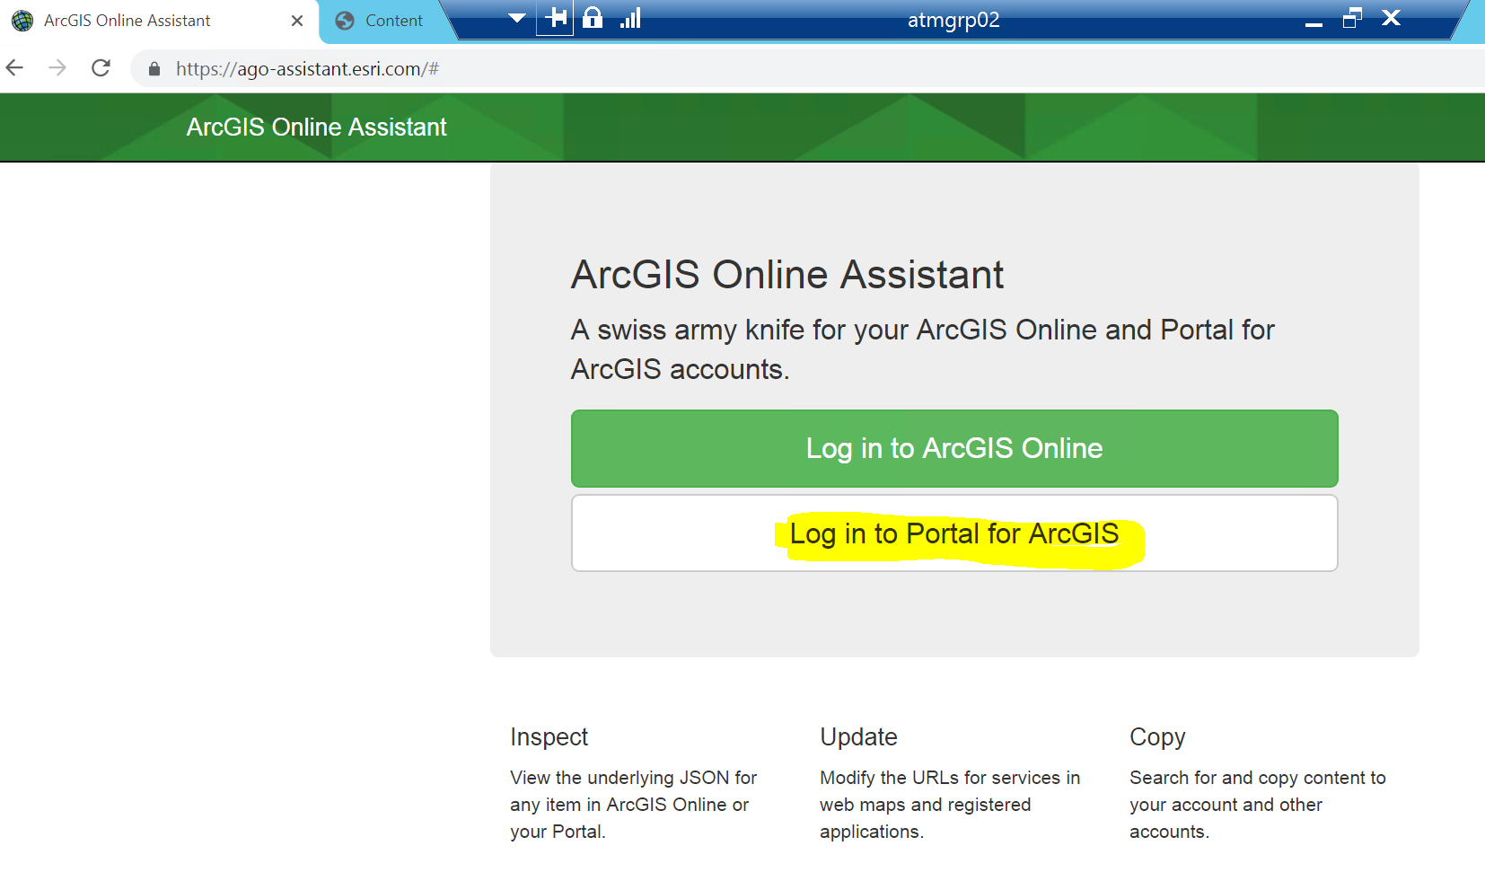
3. Type in the ArcGIS for Portal URL
   1. 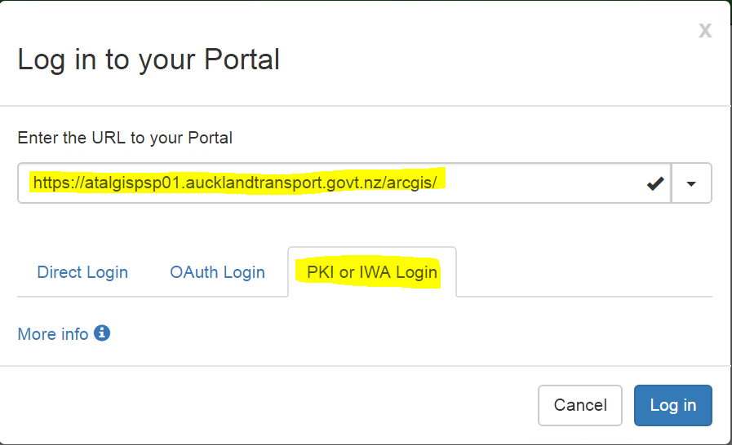
      1. Be certain to not include the last slash in the url as it will fill when you click on the tab, i.e. <https://atalgispsp01.aucklandtransport.govt.nz/arcgis>
      2. If the server is set to run through Web Adaptor, use the Web Adaptor URL. i.e. <https://maps.at.govt.nz/arcgis>
   2. Click on the PHI or IWA Login tab since our portals are set for federation and single sign on.
4. Click Log In.
   1. 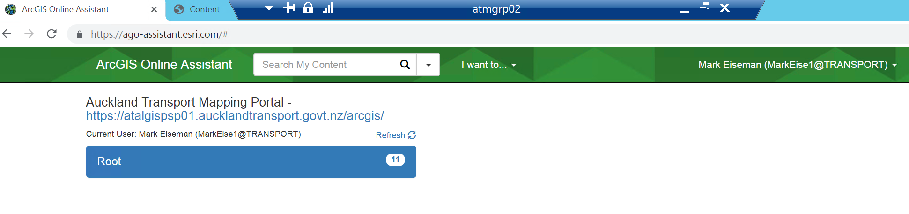
5. If all of your content is in the Root folder it should look like this. If you have organized into subfolder, it may look similar to this.
   1. 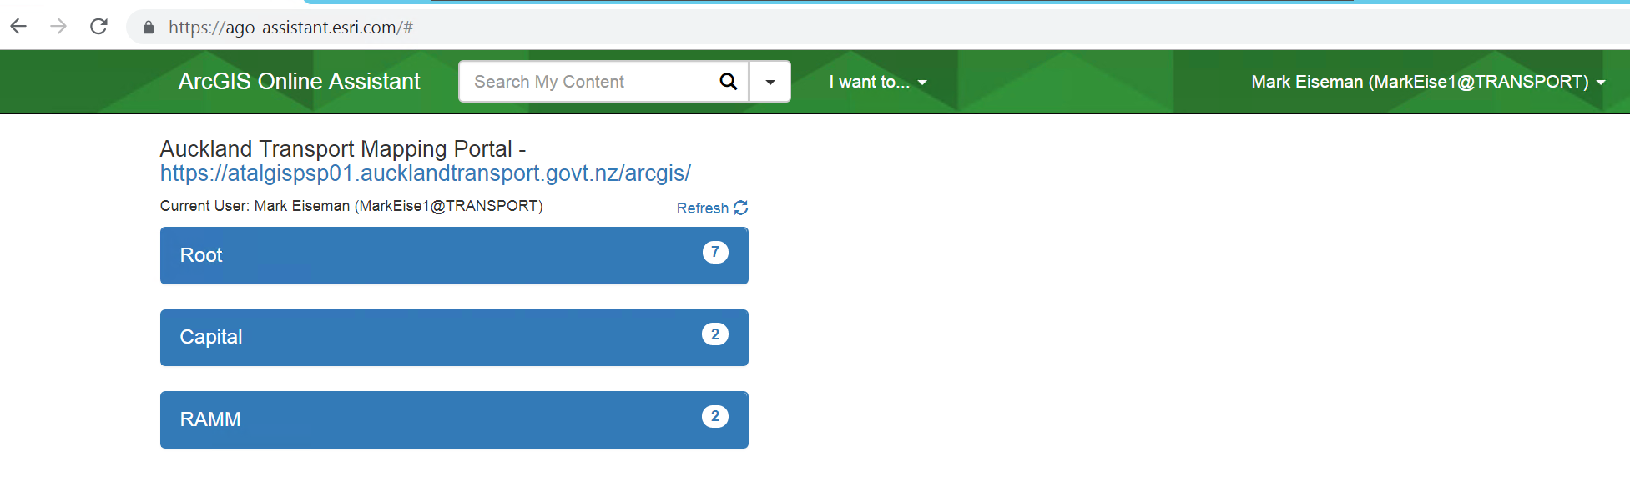
6. Click on the folder title with the content that you want to modify. The contents will cascade down.
   1. 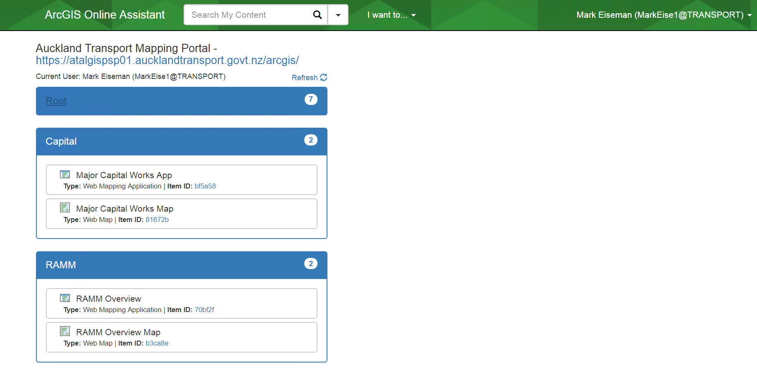
7. Click on the I Want To… button and select Update the URLs of Services in a Web Map. The eligible items on the left will turn blue.
   1. 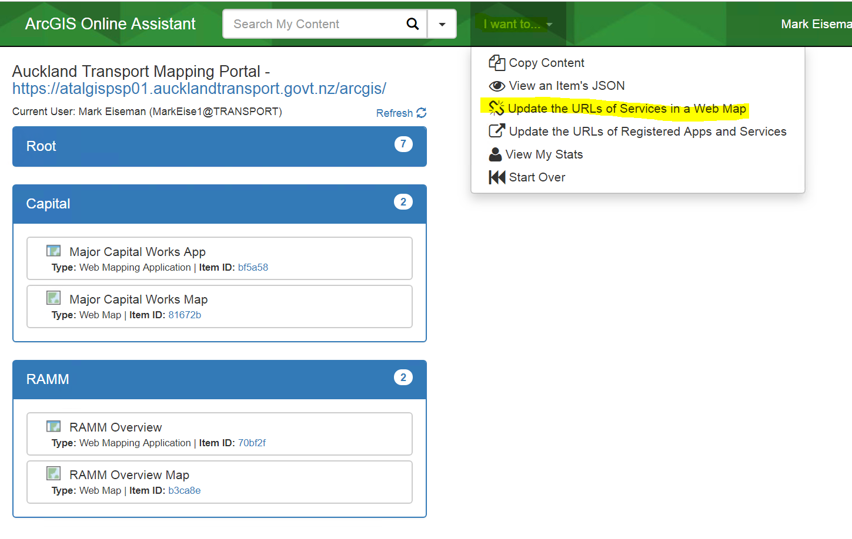
   2. 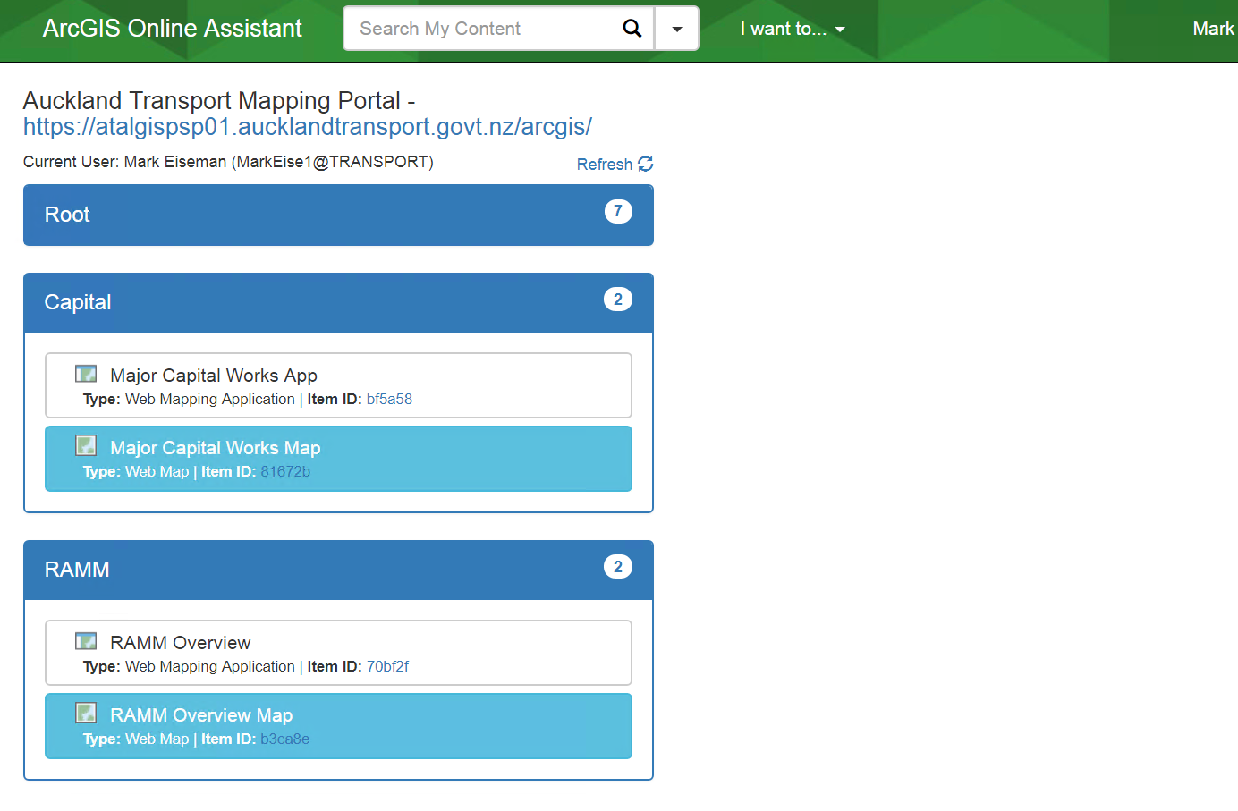
8. Select a Web Map and the referenced URLs will appear on the right.
   1. 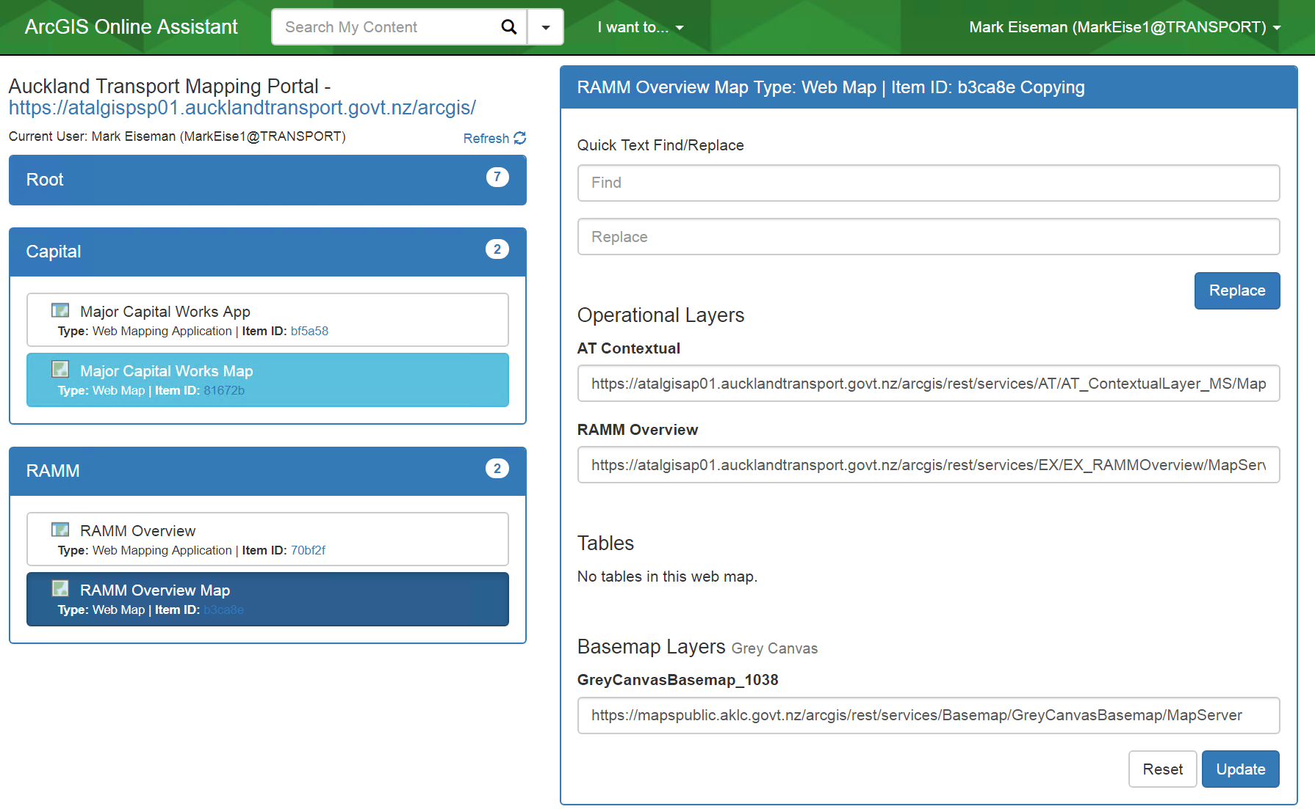
9. Replace the URL found in the Basemap Layers section with the correct URL found at the beginning of this document or other REST basemap service.
   1. 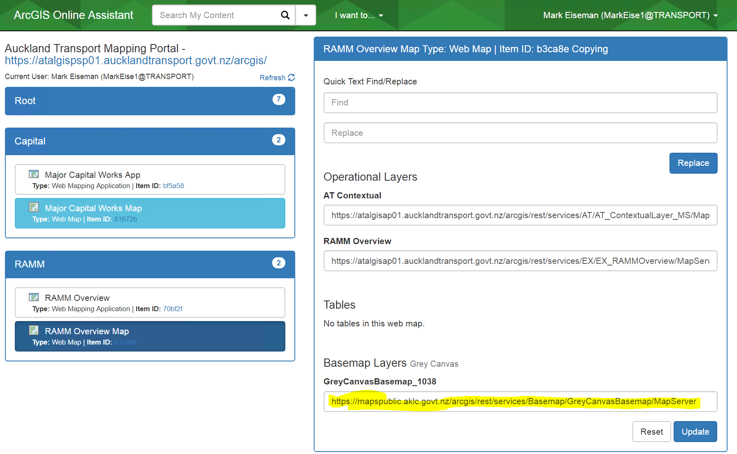
   2. 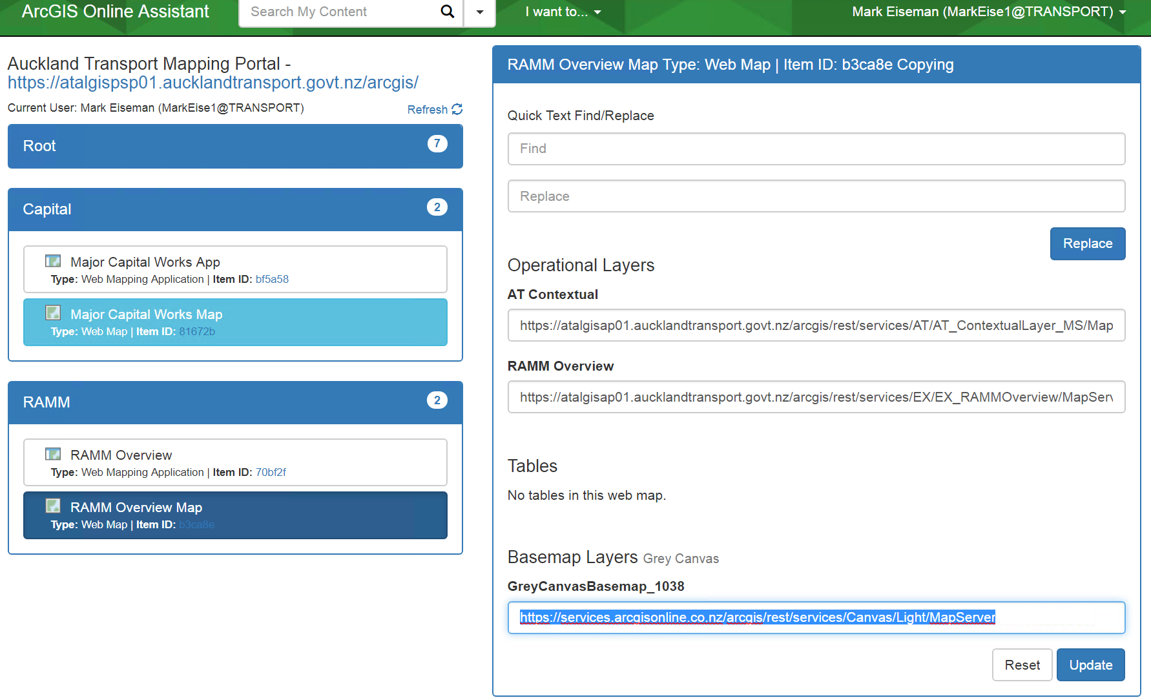
10. Click Update. This change now makes it possible to open the map in Map Viewer and Web App Builder without the basemap error message or removing other content layers.