change on-screen icon size

hello,

but I really want to make my on-screen icons bigger.

I found where to change the size of the image within the icon, but not the icon itself, it gets overwritten from the 'Inline style'

this is in ~\jimu.js\css\jimu.css

[Robert Scheitlin, GISP](https://geonet.esri.com/people/rscheitlin) Champion[**Jan 22, 2016 2:33 PM**](https://geonet.esri.com/thread/171233#comment-582649)

**Correct Answer**

Dave,

  The hard coding of the 40px comes from the LayoutMnager.js in the jimu folder (see line 21-24):

1. _createPreloadWidgetIcon: function(widgetConfig){
2. var iconDijit = new OnScreenWidgetIcon({
3. panelManager: this.panelManager,
4. widgetManager: this.widgetManager,
5. widgetConfig: widgetConfig,
6. configId: widgetConfig.id,
7. map: this.map
8. });
10. if(widgetConfig.position.relativeTo === 'map'){
11. html.place(iconDijit.domNode, this.mapId);
12. }else{
13. html.place(iconDijit.domNode, this.id);
14. }
15. //icon position doesn't use width/height in config
16. html.setStyle(iconDijit.domNode, utils.getPositionStyle({
17. top: widgetConfig.position.top,
18. left: widgetConfig.position.left,
19. right: widgetConfig.position.right,
20. bottom: widgetConfig.position.bottom,
21. /*width: 40,
22. height: 40*/
23. width: 105,
24. height: 105
25. }));
26. iconDijit.startup();
28. if(!this.openAtStartWidget && widgetConfig.openAtStart){
29. iconDijit.switchToOpen();
30. this.openAtStartWidget = widgetConfig.name;
31. }
33. this.preloadWidgetIcons.push(iconDijit);
34. return iconDijit;
35. },

[Dave Orlando](https://geonet.esri.com/people/D.Orlando)

[Dave Orlando](https://geonet.esri.com/people/D.Orlando)@ [Robert Scheitlin, GISP](https://geonet.esri.com/thread/171233#comment-582649) on [Jan 22, 2016 3:15 PM](https://geonet.esri.com/thread/171233#comment-582702)

Thanks a million, I should have seen that.

here are the four steps I took to enlarge the icon, enlarge the image within, move one over, and change the panels open position.

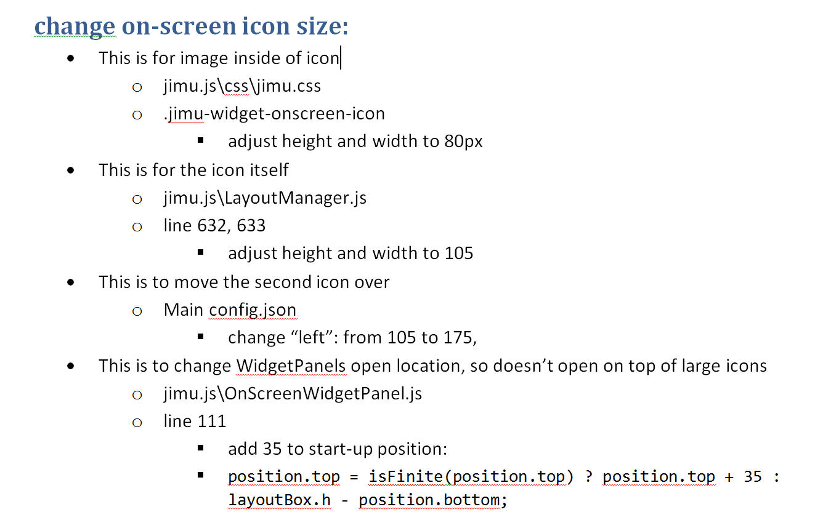

[Robert Scheitlin, GISP](https://geonet.esri.com/people/rscheitlin) Champion@ [Eoin Whelan](https://geonet.esri.com/thread/171233" \l "comment-678472" \o "Go to message) on [Apr 8, 2017 4:19 PM](https://geonet.esri.com/thread/171233#comment-678489)

Eoin,

   No files have changed since then. Here are the steps and files for WAB 2.4: (if just enlarging them x2)

* This is for image inside of icon
  + jimu.js/css/jimu.css
  + .jimu-widget-onscreen-icon img{  
      width: 40px;  
      height: 40px;  
      margin: 20px;  
    }
* This is for the icon itself
  + jimu.js/LayoutManager.js
  + lines 695, 696, 728 and 729
    - adjust width and height to 80.
* This is to move the second and third icons over
  + Main config.json
    - Change left to 145 and 235 to the second and third
* This is to change widget panel opening location
  + jimu.js/OnScreenWidgetPanel.js
    - _getPositionInfo function lines 324 and 328
      * Change 40 to 80