**No SLL in Local Install**

1. Option - <https://community.esri.com/t5/arcgis-web-appbuilder-questions/ssl-in-web-app-builder/td-p/243745>
2. Option
   1. When configure the app

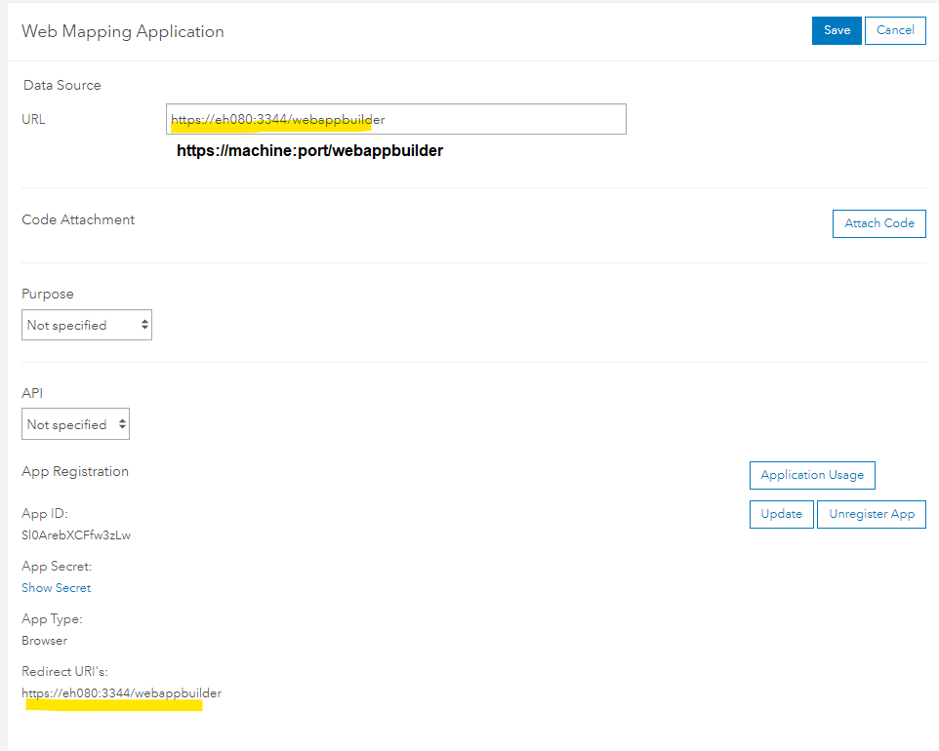

* 1. Reset startup

