Data Maintenance-Offline Editing

GIS- WSL

Version 0.1

**Ver ArcGIS Online**

Go to ArcGISOnline ->

Select HostedFeatureLayer -> Settings -> Enable Sync

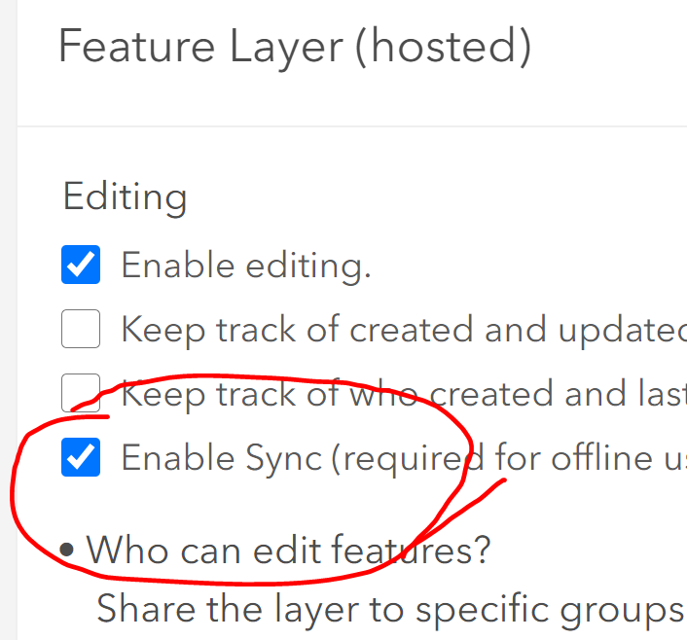

**ArcMap**

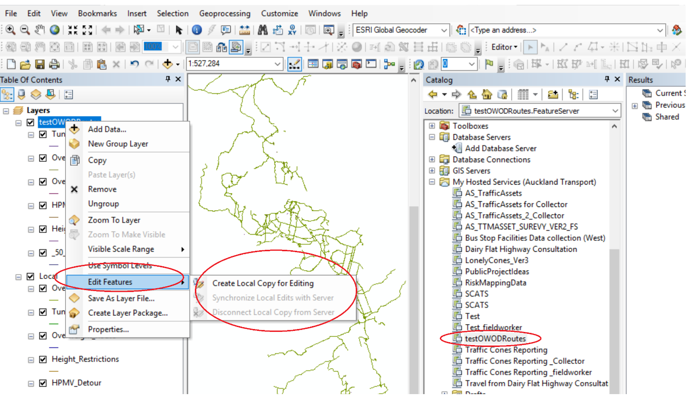

Edit Features -> Create Local copy for Editing, Synchronize, Disconnect