[aht4321](https://geonet.esri.com/people/aht4321)

Specify TimeZone for popups/attributes in arcgisonline maps

Discussion created by [aht4321](https://geonet.esri.com/people/aht4321) on 8/04/2014  
[Latest reply](https://geonet.esri.com/thread/91407#comment-675412) on 24/03/2017 by mminami-esristaff

Like • Show 0 Likes[0](https://geonet.esri.com/thread/91407)

Comment • [22](https://geonet.esri.com/thread/91407#comments)

I have created a map on our arcgisonline account... It has layer which has some attributes of the date-type.... When I click on any point of that layer, it popups the window with attributes, now all the date-time values in that popup are displayed in PST(Or some other timezone).. How can I set it to display date-time values in timezone - EST?   
How do I specify timezone in ArcGIS Online?  
  
  
thanks

Outcomes

[Helpful(5)](https://geonet.esri.com/thread/91407)

Visibility: [ArcGIS Online](https://geonet.esri.com/community/gis/web-gis/arcgisonline)9097 Views

Last modified on 8/04/2014 7:19 AM

Tags:[online](https://geonet.esri.com/community/gis/web-gis/arcgisonline/tags" \l "/?tags=online" \o "Content tagged with online)

[Content tagged with online](https://geonet.esri.com/community/gis/web-gis/arcgisonline/tags" \l "/?tags=online" \o "Content tagged with online)

[arcgis\_online](https://geonet.esri.com/community/gis/web-gis/arcgisonline/tags" \l "/?tags=arcgis_online" \o "Content tagged with arcgis_online)

[Content tagged with arcgis\_online](https://geonet.esri.com/community/gis/web-gis/arcgisonline/tags" \l "/?tags=arcgis_online" \o "Content tagged with arcgis_online)

[0](https://geonet.esri.com/thread/91407)Share

This content has been marked as final. [Show 22 comments](https://geonet.esri.com/thread/91407)

[22 Replies](https://geonet.esri.com/thread/91407)

[mminami-esristaff](https://geonet.esri.com/people/mminami-esristaff)

[mminami-esristaff](https://geonet.esri.com/people/mminami-esristaff) Employee[8/04/2014 10:39 AM](https://geonet.esri.com/thread/91407#comment-374700)

The web browser converts dates to local time.  
  
[http://doc.arcgis.com/en/arcgis-online/reference/troubleshoot.htm#anchor12](https://geonet.esri.com/external-link.jspa?url=http%3A%2F%2Fdoc.arcgis.com%2Fen%2Farcgis-online%2Freference%2Ftroubleshoot.htm%23anchor12)  
  
[http://forums.arcgis.com/threads/67212-With-popups-from-CSV-upload-Date-gets-bogus-time-stamp-Time-is-missing](https://geonet.esri.com/external-link.jspa?url=http%3A%2F%2Fforums.arcgis.com%2Fthreads%2F67212-With-popups-from-CSV-upload-Date-gets-bogus-time-stamp-Time-is-missing)  
  
Hope this helps,  
  
Mike

Like • Show 0 Likes[0](https://geonet.esri.com/thread/91407)

[Actions](https://geonet.esri.com/thread/91407)

[aht4321](https://geonet.esri.com/people/aht4321)

[aht4321](https://geonet.esri.com/people/aht4321) [8/04/2014 11:08 AM](https://geonet.esri.com/thread/91407#comment-374701)

Thanks mike, so the data in the database(Oracle) is stored as UTC and not as our local timezone time?   
  
thanks

Like • Show 0 Likes[0](https://geonet.esri.com/thread/91407)

[Actions](https://geonet.esri.com/thread/91407)

[mminami-esristaff](https://geonet.esri.com/people/mminami-esristaff)

[mminami-esristaff](https://geonet.esri.com/people/mminami-esristaff) Employee[8/04/2014 12:43 PM](https://geonet.esri.com/thread/91407#comment-374702)

Where does your data live? Is it an ArcGIS Server service? Hosted in ArcGIS ONline? We assume data stored in ArcGIS Online is in UTC.  
  
Mike

Like • Show 0 Likes[0](https://geonet.esri.com/thread/91407)

[Actions](https://geonet.esri.com/thread/91407)

[aht4321](https://geonet.esri.com/people/aht4321)

[aht4321](https://geonet.esri.com/people/aht4321) [8/04/2014 12:51 PM](https://geonet.esri.com/thread/91407#comment-374703)

I have a featureclass in Oracle 11g ArcSDE10.1...   
I have published it in our external facing server which has arcgis-server 10    
so my service is [http://gisweb.wsscwater.com/ArcGIS/rest/services/WSSC/CustomerOutreach/MapServer](https://geonet.esri.com/external-link.jspa?url=http%3A%2F%2Fgisweb.wsscwater.com%2FArcGIS%2Frest%2Fservices%2FWSSC%2FCustomerOutreach%2FMapServer)   
  
Then i created a webmap  using our ArcGIS Online account and i consume that service in that webmap...  
  
That webmap [http://wssc.maps.arcgis.com/home/webmap/viewer.html?webmap=f35adbe9b862471fb6842ae1f0fb1c40](https://geonet.esri.com/external-link.jspa?url=http%3A%2F%2Fwssc.maps.arcgis.com%2Fhome%2Fwebmap%2Fviewer.html%3Fwebmap%3Df35adbe9b862471fb6842ae1f0fb1c40) shows wrong time.. It substracts 4 hours from all our date-time values

Like • Show 0 Likes[0](https://geonet.esri.com/thread/91407)

[Actions](https://geonet.esri.com/thread/91407)

[mminami-esristaff](https://geonet.esri.com/people/mminami-esristaff)

[mminami-esristaff](https://geonet.esri.com/people/mminami-esristaff) Employee[8/04/2014 12:59 PM](https://geonet.esri.com/thread/91407#comment-374704)

Yes, this is the web browser shifting time from UTC. Are you 4 hours from UTC?  
  
In ArcMap, you can set the timezone for a layer from the Layer Properties dialog, Time tab.  
  
Mike

5 people found this helpful

Like • Show 2 Likes[2](https://geonet.esri.com/thread/91407)

[Actions](https://geonet.esri.com/thread/91407)

[](https://geonet.esri.com/people/simpsonr)

[simpsonr](https://geonet.esri.com/people/simpsonr) @ [mminami-esristaff](https://geonet.esri.com/thread/91407#comment-374704) on [18/09/2015 10:34 AM](https://geonet.esri.com/thread/91407#comment-552892)

This seems to correct the issue.  Thanks.

Like • Show 0 Likes[0](https://geonet.esri.com/thread/91407)

[Actions](https://geonet.esri.com/thread/91407)

[](https://geonet.esri.com/people/waelkat)

[waelkat](https://geonet.esri.com/people/waelkat) @ [mminami-esristaff](https://geonet.esri.com/thread/91407#comment-374704) on [27/11/2015 7:17 AM](https://geonet.esri.com/thread/91407#comment-571168)

Hello Mike,

I have a layer that has more than one date attribute (4 date attribute).

Is there a way to set the default timeZone for this attributes using ArcMap as you've suggested.

Thanx.

Like • Show 0 Likes[0](https://geonet.esri.com/thread/91407)

[Actions](https://geonet.esri.com/thread/91407)

[mminami-esristaff](https://geonet.esri.com/people/mminami-esristaff)

[mminami-esristaff](https://geonet.esri.com/people/mminami-esristaff) Employee@ [waelkat](https://geonet.esri.com/thread/91407#comment-571168) on [30/11/2015 1:06 PM](https://geonet.esri.com/thread/91407#comment-571526)

Yes, in ArcMap, you can set the time zone for the layer through the Layer Properties dialog. The dates will still display with an offset in ArcGIS Online if you are not in the same timezone the data were collected in.

Thanks,

Mike

Like • Show 0 Likes[0](https://geonet.esri.com/thread/91407)

[Actions](https://geonet.esri.com/thread/91407)

[DownerNewZealand](https://geonet.esri.com/people/DownerNewZealand)

[DownerNewZealand](https://geonet.esri.com/people/DownerNewZealand) @ [mminami-esristaff](https://geonet.esri.com/thread/91407#comment-571526) on [14/12/2015 7:47 PM](https://geonet.esri.com/thread/91407#comment-575013)

I have the same problem as Wael. While your solution corrects our data for the one date field we specify in the time tab, not the other dates. We have multiple date fields in each record (5 to be exact). Is there any way to universally update the timezone for the entire layer, not just a single field? I've attached a screenshot that shows the discrepancy of the data from the database and how is displays in our Portal.[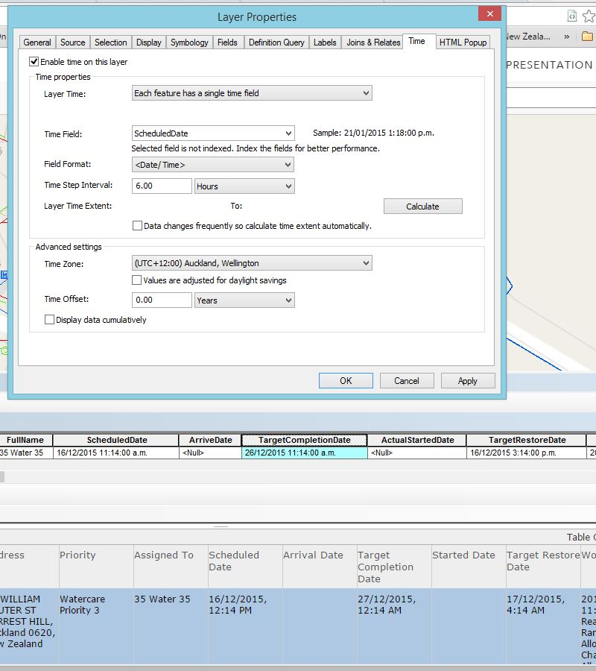](https://geonet.esri.com/servlet/JiveServlet/showImage/2-575013-156306/Capture2.JPG)

Like • Show 0 Likes[0](https://geonet.esri.com/thread/91407)

[Actions](https://geonet.esri.com/thread/91407)

[mminami-esristaff](https://geonet.esri.com/people/mminami-esristaff)

[mminami-esristaff](https://geonet.esri.com/people/mminami-esristaff) Employee@ [DownerNewZealand](https://geonet.esri.com/thread/91407#comment-575013) on [4/01/2016 4:05 PM](https://geonet.esri.com/thread/91407#comment-578254)

**I believe the time zone property affects the layer as a whole.**

**You can optionally enable time on the layer based on an individual field, which allows the features to display according to their time when you draw features** base on their time.

Mike

Like • Show 0 Likes[0](https://geonet.esri.com/thread/91407)

[Actions](https://geonet.esri.com/thread/91407)

[](https://geonet.esri.com/people/Dianazaliv)

[Dianazaliv](https://geonet.esri.com/people/Dianazaliv) @ [mminami-esristaff](https://geonet.esri.com/thread/91407#comment-374704) on [11/10/2016 12:48 PM](https://geonet.esri.com/thread/91407#comment-640255)

Hi Mike,

I have the same issue with time, it displays 4 hours behind in AGOL. I changed the time zone in Arc Map but it doesn't change anything in my web map. However I see the changes in map server.. Any ideas? THANK YOU!

AGOL:

[](https://geonet.esri.com/servlet/JiveServlet/showImage/2-640255-243402/pastedImage_1.png)

Arc Map:

[https://geonet.esri.com/servlet/JiveServlet/downloadImage/2-640255-243422/pastedImage_3.png](https://geonet.esri.com/servlet/JiveServlet/showImage/2-640255-243422/pastedImage_3.png)

[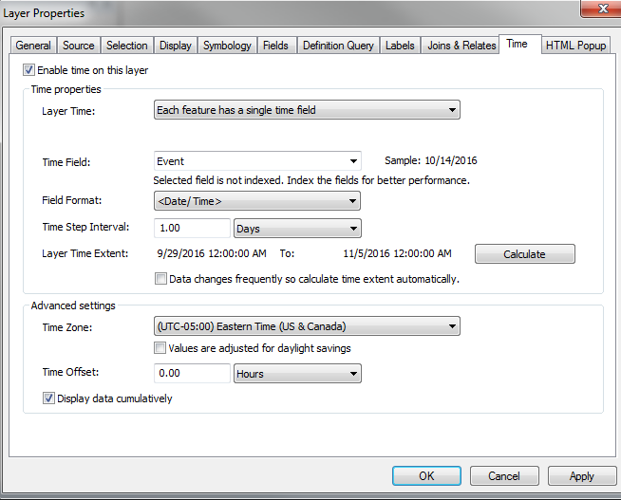](https://geonet.esri.com/servlet/JiveServlet/showImage/2-640255-243403/pastedImage_2.png)

Like • Show 0 Likes[0](https://geonet.esri.com/thread/91407)

[Actions](https://geonet.esri.com/thread/91407)

[mminami-esristaff](https://geonet.esri.com/people/mminami-esristaff)

[mminami-esristaff](https://geonet.esri.com/people/mminami-esristaff) Employee@ [Dianazaliv](https://geonet.esri.com/thread/91407#comment-640255) on [20/10/2016 10:22 AM](https://geonet.esri.com/thread/91407#comment-642109)

Where is this service running (hosted or your own server) and did you publish the service with the time zone set?

Without any time zone configuration, ArcGIS Online assumes all time is stored in UTC. Thus, when displayed in the Map Viewer of ArcGIS Online, time values will get adjusted based on your offset from UTC. To avoid this, you need to publish data (either hosted or to on premises portals) with the appropriate time zone or ensure time values are in UTC.

If you have published to your local server and you're consuming the service in ArcMap, ArcMap doesn't make the same assumption about the time zone and just displays the value stored without offset.

Hope this helps,

Mike

Like • Show 0 Likes[0](https://geonet.esri.com/thread/91407)

[Actions](https://geonet.esri.com/thread/91407)

[](https://geonet.esri.com/people/Dianazaliv)

[Dianazaliv](https://geonet.esri.com/people/Dianazaliv) @ [mminami-esristaff](https://geonet.esri.com/thread/91407#comment-642109) on [20/10/2016 10:25 AM](https://geonet.esri.com/thread/91407#comment-642137)

Thank you Mike! My mistake was that I was publishing map service. It worked when I published it as a feature server

Thanks

Like • Show 0 Likes[0](https://geonet.esri.com/thread/91407)

[Actions](https://geonet.esri.com/thread/91407)

[mminami-esristaff](https://geonet.esri.com/people/mminami-esristaff)

[mminami-esristaff](https://geonet.esri.com/people/mminami-esristaff) Employee@ [Dianazaliv](https://geonet.esri.com/thread/91407#comment-642137) on [20/10/2016 10:28 AM](https://geonet.esri.com/thread/91407#comment-642110)

Map service or feature service, that really shouldn't make a difference. Perhaps the second time when you published the feature service, you had set the time zone before publishing?

Like • Show 0 Likes[0](https://geonet.esri.com/thread/91407)

[Actions](https://geonet.esri.com/thread/91407)

[](https://geonet.esri.com/people/Dianazaliv)

[Dianazaliv](https://geonet.esri.com/people/Dianazaliv) @ [mminami-esristaff](https://geonet.esri.com/thread/91407#comment-642110) on [20/10/2016 10:30 AM](https://geonet.esri.com/thread/91407#comment-642138)

Yes. The other time I was overwriting the map service after changing the time zone

Like • Show 0 Likes[0](https://geonet.esri.com/thread/91407)

[Actions](https://geonet.esri.com/thread/91407)

[aht4321](https://geonet.esri.com/people/aht4321)

[aht4321](https://geonet.esri.com/people/aht4321) [8/04/2014 1:47 PM](https://geonet.esri.com/thread/91407#comment-374705)

Yes, this is the web browser shifting time from UTC. Are you 4 hours from UTC?  
  
In ArcMap, you can set the timezone for a layer from the Layer Properties dialog, Time tab.  
  
Mike

we are on  - USA Eastern time -New york time   
Based on DST, its UTC - 4 or 5  hrs

Like • Show 0 Likes[0](https://geonet.esri.com/thread/91407)

[Actions](https://geonet.esri.com/thread/91407)

[aht4321](https://geonet.esri.com/people/aht4321)

[aht4321](https://geonet.esri.com/people/aht4321) [9/04/2014 1:18 PM](https://geonet.esri.com/thread/91407#comment-374706)

**i found solution from esri support - to convert date values into text  
  
I found other solution - i create a view in that , convert my date-time from EST to GMT/UTC and then publish it since ARcgis online expects it in GMT/UTC**

2 people found this helpful

Like • Show 0 Likes[0](https://geonet.esri.com/thread/91407)

[Actions](https://geonet.esri.com/thread/91407)

[meblanc2](https://geonet.esri.com/people/meblanc2)

[meblanc2](https://geonet.esri.com/people/meblanc2) [18/09/2015 10:52 AM](https://geonet.esri.com/thread/91407#comment-552973)

Just saw a similar post about Time issues elsewhere and thought I'd throw this out there.  We had a similar problem with our Parcel data (sale dates) being shown as the wrong date and time. The fix for us was to go to ArcMap (10.2.2) to the Time tab in Layer Properties and enable Time.  Select the appropriate field for your date/time value and then set your local Time Zone.  Then when you publish to AGOL, you'll have the correct date and time zone.

Hope this helps.

2 people found this helpful

Like • Show 0 Likes[0](https://geonet.esri.com/thread/91407)