Data Maintenance-Bring back data

GIS- WSL

Version 0.1

**Table of contents**

1 bring data back 3

1.1 Layer “ObserverPoints” 3

1.2 Layer “WalkPaths” 5

# bring data back

The below procedures will help in bringing back data from the cloud.

## Layer “ObserverPoints”

### Select the Gdb feature layer

Click on the popup and select “Export to FGDB”

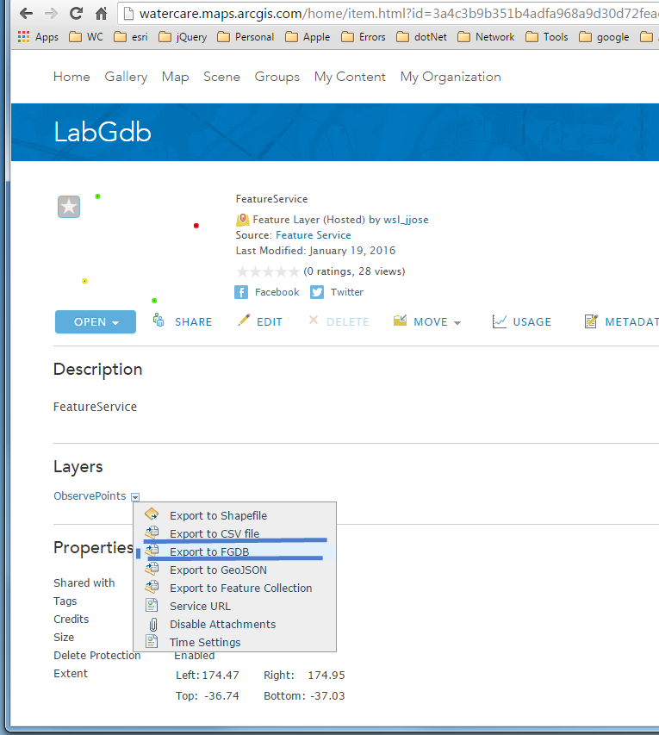

### Provide some valid values in popup

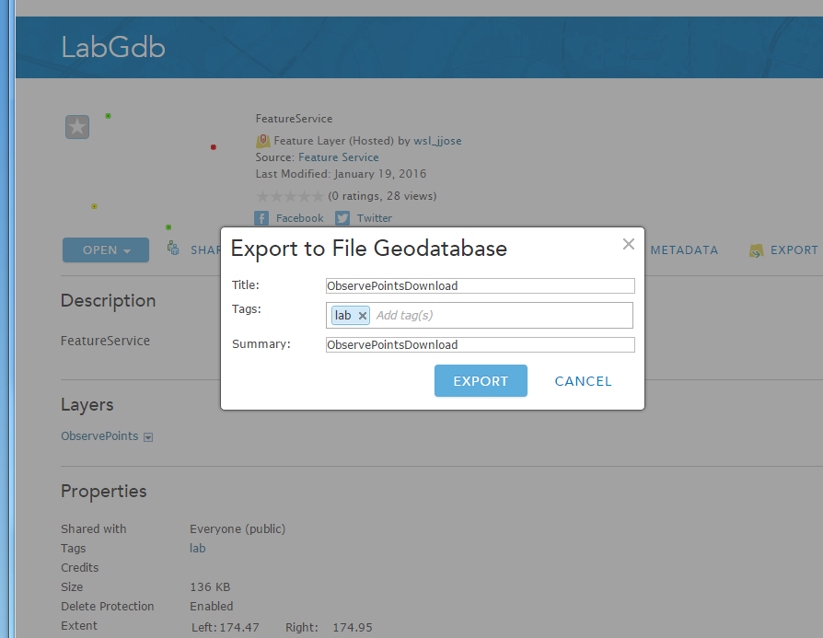

### Download the exported FGDB

Click on the download option as in image below

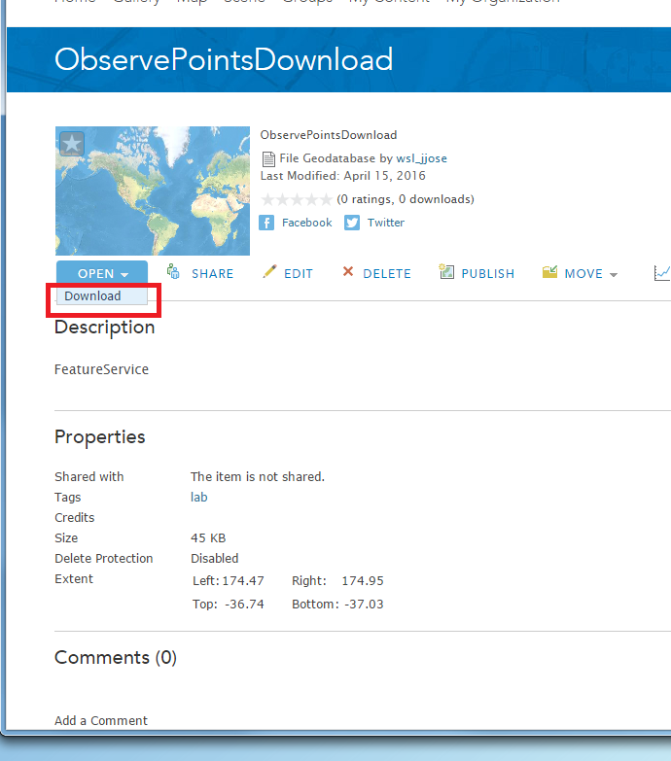

### Use the downloaded FGDB

The FGDB will be downloaded as a zip file. Extract the folder into your working folder. Remember to delete the FGDB created in AGOL.

## Layer “WalkPaths”

Repeat steps under “1.1 Layer “ObserverPoints”” using same sequence to export the features into a FGDB on your computer.