Data Maintenance-Cleanup data

GIS- WSL

Version 0.1

**Table of contents**

1 CLEAN data 3

1.1 Layer “ObserverPoints” 3

1.2 Layer “WalkPaths” 3

# CLEAN data

The below procedures are used to cleanup data when requestion

## Layer “ObserverPoints”

### Open ArcMap

* Click File -> Signin. Enter your credentials

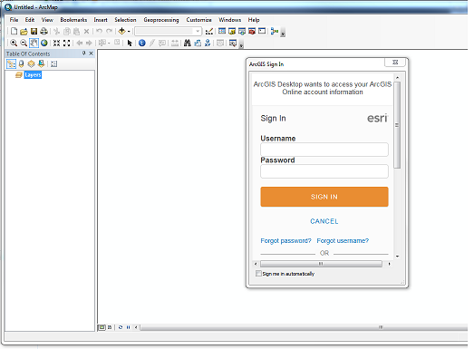

### Open the hosted data in ArcMap

* Look under Catalog-> My hosted folders and select the data in the “LabGdbT3” version
* Drag the data into ArcMap
* Right click the layer -> Select “Create Local copy for Editing”
* Start editing and delete the features. Finish editing
* Right click the layer -> Select “Synchronize local edits with Server”

## Layer “WalkPaths”

Repeat steps under “1.1 Layer “ObserverPoints”” using same sequence with the exception that the “WalkPathT3” version is selected.