**Symbol rotation exercise**

Download [the sample CSV](http://www.arcgis.com/home/item.html?id=649ea9259eb94a45b3b2ca61a31df1e9) used in this example and follow along. The CSV file includes web cam locations (dummy locations, not actual locations) as well as the direction the camera is pointing expressed as clockwise compass azimuths.

**Step 1 – Inspect the data**  
Open the file using Excel, Notepad, or some other text editor to view the contents. Note that the file contains the lat/long location, as well as Direction, which will be used to rotate the symbol.

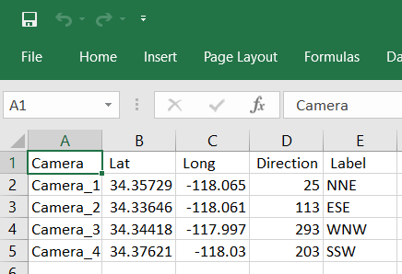

**Step 2 – Add the data to your map**  
Add the CSV data to a new map (drag and drop, or choose Add, then Add Layer from File).

**Step 3 – Change the style of the locations**When you add the CSV file in Step 2 above, Change Style automatically opens. Choose *Show location only*, then click Options.

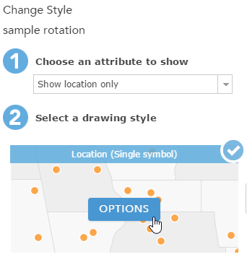

**Step 4 – Click Symbols to change symbols**

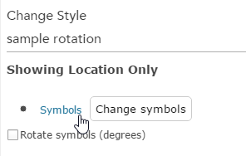

**Step 5 – Choose an arrow**  
Choose an arrow symbol from the Arrows category. Since the rotation is stored as compass directions with zero pointing north (up), choose an arrow that points up.

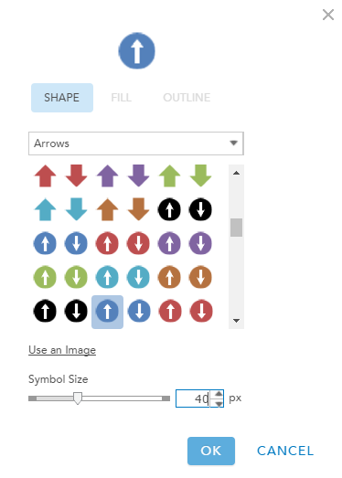

Change the symbol size as desired, then click OK.

**Step 6 – Rotate the symbol**  
Check the Rotate symbols (degrees) box, and from the dropdown choose Direction as the field containing values used for rotation. The values are already stored in the expected compass azimuth format described above, so Clockwise (the default) is the correct rotation option.

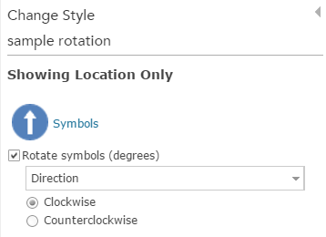

Save your style changes when finished.

**Step 7 – View the map**  
The map now displays the camera locations with the arrow rotated to show the direction of each camera.

