Using URL parameters in pop-ups

by [Bern Szukalski](https://blogs.esri.com/esri/arcgis/author/bszukalski/) on [August 24, 2016](https://blogs.esri.com/esri/arcgis/2016/08/24/url-parameters-in-pop-ups/)

* 2 1 3

URL parameters are a handy way to pass information from one web page to another. The ArcGIS Online map viewer takes the ID of the web map to open as a URL parameter, and ArcGIS Online web maps can make use of URL parameters to define things such as the basemap, layers, and extent.

In this example we’ll take a look at how to construct a string to pass information from a pop-up to another website using URL parameters from feature attributes. A custom pop-up display will be used to create the URL link to open the website using a unique attribute value.

The Map

In this example we’re working with a parcel layer in a map. The pop-up for the parcel layer is shown below, note that the field *APN* contains the unique identifier for each parcel.

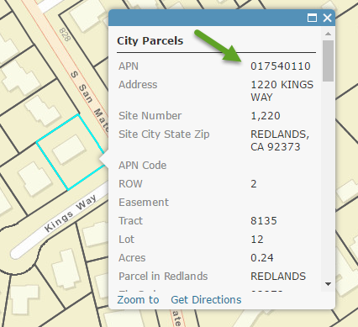

The Website

The county assessor’s website delivers detailed information for each parcel via the Property Information Management System (PIMS). The information can be retrieved by searching on the owner name, APN, or map book number. Below we’ve gotten the results for one of the parcels by entering the owner’s name.

[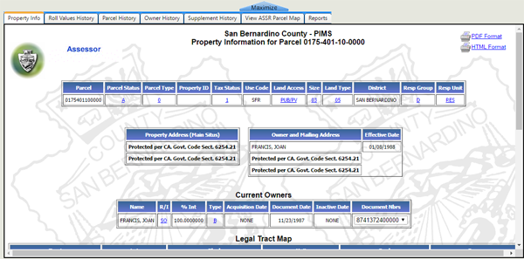](https://blogs.esri.com/esri/arcgis/files/2012/10/param-2.png)

Taking a closer look at the URL, we can see that the unique identifier (the APN) for each parcel is included as a parameter in the URL, appearing at the end after **?parcel=**

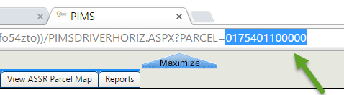

The Mission

We’d like to display the parcel information from the PIMS website from a link in the layer pop-up, retrieving the specific information for the parcel that was clicked. Currently there is no direct link in our pop-up to access the Assessor’s PIMS website, but we do have the unique parcel identifier (in the APN field) for each parcel.

The Challenge

At the PIMS website we’ve learned that the URL takes the unique identifier (APN) as a parameter to retrieve information for any given parcel. Our challenge is to construct a link that passes the contents of the APN field as a URL parameter to the PIMS website, so we can open the parcel’s information from the feature pop-up.

The How

One way to accomplish our goal is to construct a custom link in the pop-up. Follow these steps (your exact steps may differ somewhat).

**Step 1** – Click the layer options, then choose *Configure Pop-up*:

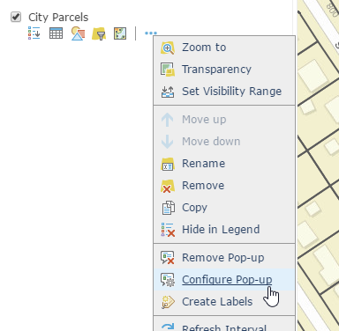

**Step 2** -From the drop-down options under Pop-up Contents, choose *A custom attribute display*:

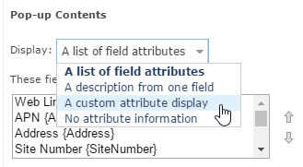

Then click *Configure*:

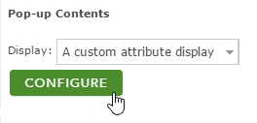

**Step 3** – Configure the custom attribute display.

Using a custom attribute display you can use a combination of rich text, attributes, and links to create a custom information pop-up. For example, below we’ve combined a string with an attribute. Attributes appear as curly braces and can be selected from the attribute drop-down (the +). In the configured pop-up these will display the value from the feature attribute when the pop-up is opened.

Here’s the custom attribute display:

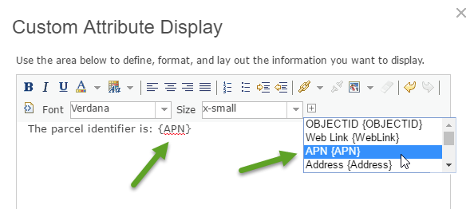

When saved, here’s what the pop-up would look like:

But we’re not yet finished. Our next task is to define a custom link that will add the APN to the URL to open the PIMS web page for each parcel.

We added the string “View PIMS Info,” selected it, then clicked *Create Link*:

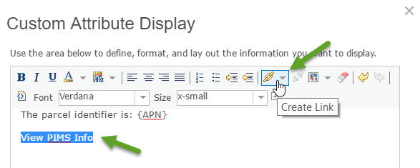

In Link Properties we copied and pasted the URL from the PIMS site, including ?parcel=, then added the field {APN} at the end. We noticed there were four extra trailing zeros that we also needed to include after the APN. Shown below is the end of the URL, with the field {APN} passed as a parameter plus the trailing zeros.

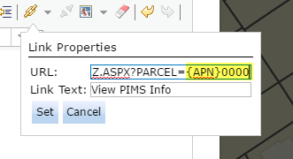

**Step 4** – Click Set to create the link, and save the pop-up.

The Result

The pop-up now looks like this, with the View PIMS Info hyperlink:

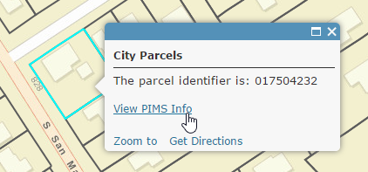

When clicked, the hyperlink opens the PIMS page for the parcel. Mission accomplished!

[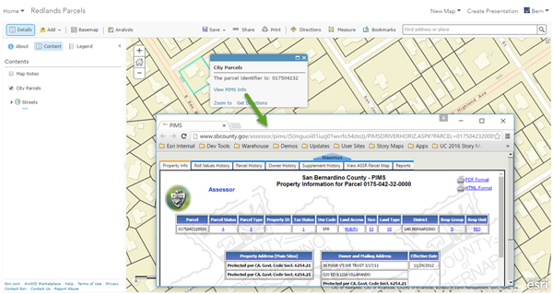](https://blogs.esri.com/esri/arcgis/files/2012/10/param-12.png)