Menu Customize -> Customize mode

Tab Commands -> UI Control -> Click New UIControl

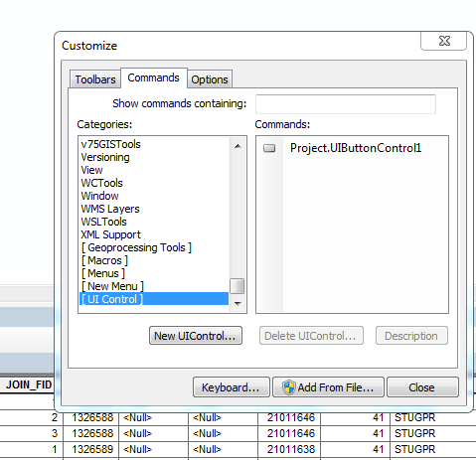

Call the main function in VBA in the “Project.UIButtonControl1”