1. Add Text Layer
2. Layer -> New gradient layer
3. Press the Alt button and hover between Gradient & Text Layer

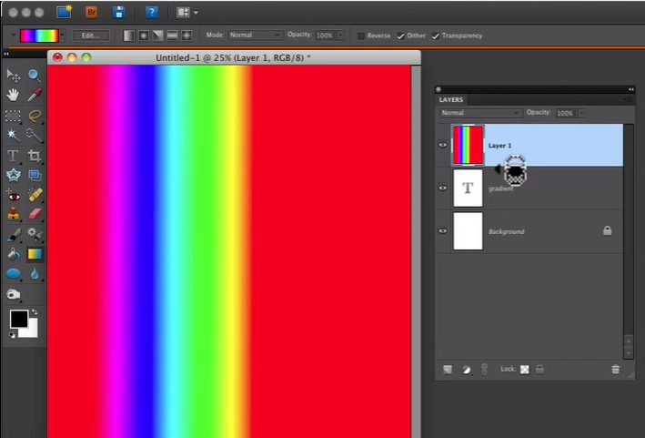

1. Click – To affect the gradient over the Text layer