Waggle dance distributions quantify collective foraging in honey bee colonies: Supplementary material

Joseph Palmer, Ash Samuelson, Elli Leadbeater and Vincent Jansen

# Waggle dance model

# Waggle dance model fit

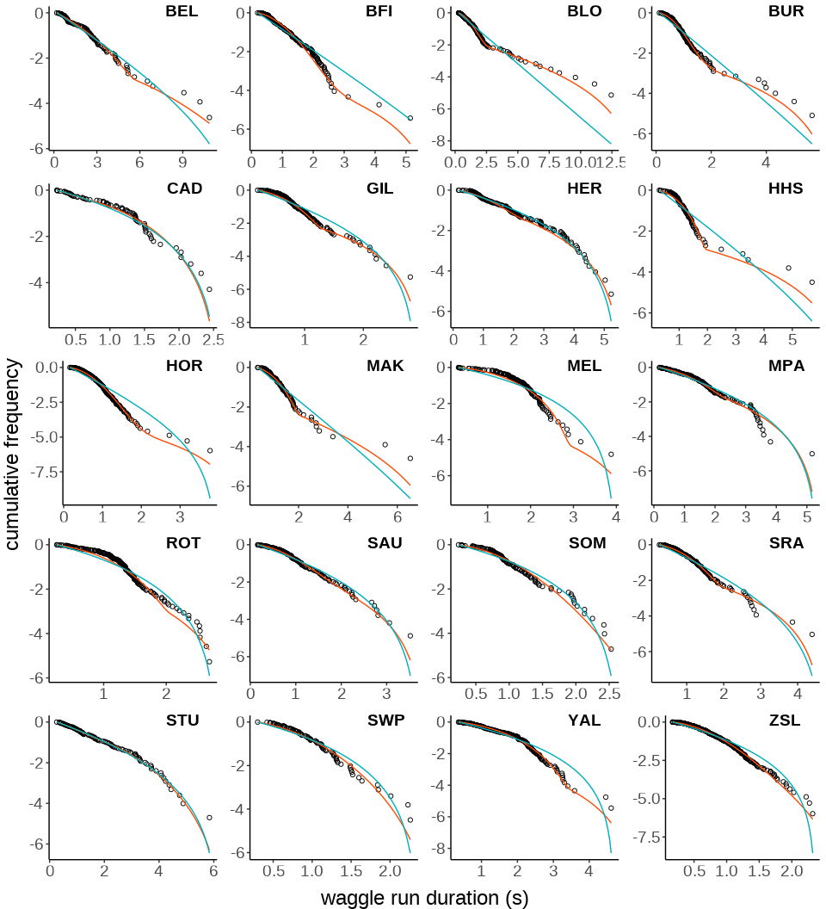

Supplementary Fig 1. log Compliment cumulative frequency distribution of waggle dance durations and fits of the collective (red line) and individual (blue line) models for all 20 sites.

Table 1. shows the results of the model fitting, including likelihood scores, parsimony measures -AIC, delta_AIC, rAIC (relative delta_AIC) and wAIC (Akaike weights)- and goodness of fit -Ks statistics (ks_statistic, ks_pvalue)- for all 20 sites.

**Table** : Fit results for the fitting of the waggle dance model to each site.

| **site** | **model** | **MLE** | **AIC** | **ΔAIC** | **rAIC** | **wAIC** | **p** | **bs** | **br** | **as** | **ar** | **D** | **p_value** |
| --- | --- | --- | --- | --- | --- | --- | --- | --- | --- | --- | --- | --- | --- |
| BEL | collective | -180.851 | 371.702 | 0.700 | 0.705 | 0.413 | 0.892 | 0.231 | 5.150 | 0.171 | 0.035 | 0.078 | 0.904 |
| BEL | individual | -183.501 | 371.002 | 0.000 | 1.000 | 0.587 | 1.000 | 4.495 |  | 0.073 |  | 0.088 | 0.812 |
| BFI | collective | -190.499 | 390.998 | 0.000 | 1.000 | 1.000 | 0.045 | 0.000 | 2.769 | 0.164 | 0.249 | 0.087 | 0.329 |
| BFI | individual | -211.297 | 426.593 | 35.596 | 0.000 | 0.000 | 1.000 | 9.470 |  | 0.100 |  | 0.183 | 0.001 |
| BLO | collective | -221.026 | 452.052 | 0.000 | 1.000 | 1.000 | 0.209 | 1.786 | 0.571 | 0.068 | 0.359 | 0.071 | 0.775 |
| BLO | individual | -237.389 | 478.778 | 26.726 | 0.000 | 0.000 | 1.000 | 5 505.000 |  | 0.000 |  | 0.112 | 0.197 |
| BUR | collective | -118.305 | 246.609 | 0.000 | 1.000 | 1.000 | 0.112 | 0.000 | 500.000 | 0.151 | 0.028 | 0.067 | 0.833 |
| BUR | individual | -143.718 | 291.435 | 44.826 | 0.000 | 0.000 | 1.000 | 10.000 |  | 0.100 |  | 0.177 | 0.013 |
| CAD | collective | -48.278 | 106.556 | 2.650 | 0.266 | 0.210 | 0.166 | 0.000 | 0.425 | 1.456 | 0.386 | 0.082 | 0.943 |
| CAD | individual | -49.953 | 103.906 | 0.000 | 1.000 | 0.790 | 1.000 | 0.000 |  | 0.385 |  | 0.110 | 0.747 |
| GIL | collective | -74.541 | 159.082 | 0.000 | 1.000 | 1.000 | 0.261 | 0.000 | 0.000 | 0.335 | 0.754 | 0.130 | 0.064 |
| GIL | individual | -102.309 | 208.618 | 49.536 | 0.000 | 0.000 | 1.000 | 2.037 |  | 0.345 |  | 0.198 | 0.001 |
| HER | collective | -235.180 | 480.360 | 0.000 | 1.000 | 0.984 | 0.638 | 0.000 | 0.000 | 0.178 | 0.429 | 0.110 | 0.230 |
| HER | individual | -242.322 | 488.644 | 8.284 | 0.016 | 0.016 | 1.000 | 0.548 |  | 0.183 |  | 0.140 | 0.072 |
| HHS | collective | -61.348 | 132.696 | 0.000 | 1.000 | 1.000 | 0.095 | 0.000 | 0.000 | 0.141 | 0.503 | 0.133 | 0.369 |
| HHS | individual | -83.749 | 171.498 | 38.802 | 0.000 | 0.000 | 1.000 | 7.095 |  | 0.125 |  | 0.244 | 0.009 |
| HOR | collective | -146.040 | 302.081 | 0.000 | 1.000 | 1.000 | 0.022 | 0.000 | 10.000 | 0.213 | 0.203 | 0.066 | 0.335 |
| HOR | individual | -213.584 | 431.168 | 129.087 | 0.000 | 0.000 | 1.000 | 4.343 |  | 0.255 |  | 0.185 | 0.000 |
| MAK | collective | -84.519 | 179.038 | 0.000 | 1.000 | 1.000 | 0.209 | 2.319 | 0.020 | 0.122 | 0.478 | 0.091 | 0.770 |
| MAK | individual | -98.025 | 200.049 | 21.012 | 0.000 | 0.000 | 1.000 | 9.168 |  | 0.096 |  | 0.192 | 0.048 |
| MEL | collective | -115.316 | 240.633 | 0.000 | 1.000 | 1.000 | 0.079 | 0.000 | 0.000 | 0.213 | 0.338 | 0.163 | 0.078 |
| MEL | individual | -135.731 | 275.462 | 34.829 | 0.000 | 0.000 | 1.000 | 0.000 |  | 0.252 |  | 0.244 | 0.001 |
| MPA | collective | -181.873 | 373.746 | 0.000 | 1.000 | 0.959 | 0.567 | 0.578 | 0.000 | 0.185 | 0.420 | 0.067 | 0.888 |
| MPA | individual | -188.038 | 380.076 | 6.330 | 0.042 | 0.041 | 1.000 | 1.474 |  | 0.187 |  | 0.100 | 0.429 |
| ROT | collective | -138.129 | 286.259 | 0.000 | 1.000 | 1.000 | 0.310 | 0.000 | 0.000 | 0.315 | 0.483 | 0.149 | 0.016 |
| ROT | individual | -153.355 | 310.710 | 24.451 | 0.000 | 0.000 | 1.000 | 0.000 |  | 0.354 |  | 0.201 | 0.002 |
| SAU | collective | -108.185 | 226.370 | 0.000 | 1.000 | 0.987 | 0.309 | 0.000 | 9.998 | 0.262 | 0.164 | 0.061 | 0.954 |
| SAU | individual | -115.503 | 235.005 | 8.635 | 0.013 | 0.013 | 1.000 | 1.489 |  | 0.271 |  | 0.129 | 0.208 |
| SOM | collective | -70.536 | 151.072 | 0.000 | 1.000 | 0.958 | 0.002 | 10.000 | 10.000 | 1.500 | 0.149 | 0.107 | 0.528 |
| SOM | individual | -76.671 | 157.343 | 6.271 | 0.043 | 0.042 | 1.000 | 0.000 |  | 0.377 |  | 0.161 | 0.080 |
| SRA | collective | -123.371 | 256.742 | 0.000 | 1.000 | 1.000 | 0.247 | 0.096 | 0.208 | 0.213 | 0.492 | 0.052 | 0.979 |
| SRA | individual | -138.114 | 280.228 | 23.486 | 0.000 | 0.000 | 1.000 | 3.002 |  | 0.213 |  | 0.143 | 0.081 |
| STU | collective | -155.700 | 321.400 | 4.319 | 0.115 | 0.103 | 0.352 | 0.000 | 1.028 | 0.521 | 0.156 | 0.045 | 1.000 |
| STU | individual | -156.540 | 317.081 | 0.000 | 1.000 | 0.897 | 1.000 | 1.347 |  | 0.161 |  | 0.055 | 0.995 |
| SWP | collective | -40.424 | 90.848 | 0.000 | 1.000 | 0.953 | 0.000 | 0.129 | 1.275 | 0.365 | 0.384 | 0.100 | 0.722 |
| SWP | individual | -46.441 | 96.882 | 6.034 | 0.049 | 0.047 | 1.000 | 0.000 |  | 0.424 |  | 0.144 | 0.277 |
| YAL | collective | -256.218 | 522.436 | 0.000 | 1.000 | 1.000 | 0.153 | 0.994 | 0.253 | 0.189 | 0.287 | 0.065 | 0.715 |
| YAL | individual | -274.067 | 552.135 | 29.699 | 0.000 | 0.000 | 1.000 | 0.590 |  | 0.213 |  | 0.095 | 0.236 |
| ZSL | collective | -150.273 | 310.546 | 0.000 | 1.000 | 1.000 | 0.052 | 0.000 | 10.000 | 0.374 | 0.200 | 0.048 | 0.710 |
| ZSL | individual | -181.734 | 367.468 | 56.921 | 0.000 | 0.000 | 1.000 | 0.965 |  | 0.424 |  | 0.122 | 0.003 |