It was a great idea to get the various developers of programming solutions for the NXT to implement your sample program. It’s an opportunity to evaluate not only the execution speed of the resultant programs but also some of the subtle differences in how the various environments manage the LCD screen.

I’ve included two different versions of your sample program.
- The first version is a straight forward exact implementation of your pseudo code. There’s four numbers to display on the NXT LCD screen and they are displayed as a column of right-justified numbers on the NXT screen.
- The second program has simply commented out the NXT LCD drawing. Drawing to the NXT screen is a relatively real-time expensive function on RobotC. Eliminating the drawing functionality decreases the execution time by a factor of five! It also makes very good sense because RobotC has comprehensive PC based debugging functionality that, in this case, can eliminate the need for drawing to the screen. The four numbers are all easily and automatically available in a debugger window on the PC.

The number of loops executed in one minute for each of the three cases is:

 | Number of Loops | Program Description
1 | 93,967 | Use of standard ‘C’ formatting for drawing to the NXT LCD. For example  nxtDrawStringAt(7, 0, “%6d”, nNumbOfLoops);  This displays the numeric value into a 6-character text string that is drawn on the NXT screen starting at point (7, 0).
2 | 411,497 | For this example, drawing to the text screen was disabled by commenting out the code.  //nxtDrawStringAt(7, 0, “%6d”, nNumbOfLoops);  RobotC has PC based debugging screens that can eliminate the need to draw values on the NXT screen. Instead all program variables are accessible on a PC Window.
3 | 32,555 | This test run is program #2 running on an RCX  RobotC is a cross-platform solution and the same programs can run on the NXT and the RCX. For the RCX, a Hitechnic legacy ultrasound sensor was used instead of the NXT’s sensor. This was a one line program change.
4 | 1,000 | This measurement is for a PC-based program controlling the NXT. The intelligence resides in the PC and the PC screen is used as the display. The PC polls the status (all sensors, all motor encoders) from the NXT and then sends motor update commands to the NXT. Using RobotC’s internal communications interface 1,000 of these cycles can be achieve per minute using a Bluetooth connection.  At present, the RobotC communications interface is not currently publicly exposed.

All NXT examples were measured with the RobotC debugger actively polling the NXT and connected via a Bluetooth connection. The RCX example used the debugger with an IR connection.

It took under 30 minutes to write and debug program #1. The size of the executable file on the NXT is 561 bytes. All RobotC executable programs have a fixed header of about 300 bytes. The variable part, i.e. the size of the compiled program, is 290 bytes.

RobotC NXT Display Function Advantages:
RobotC has expanded functionality to that found in the NXT-G firmware for drawing to the LCD screen. A few of these are illustrated in these sample programs.
- Precise format control is available so that data in columns can be easily drawn. This example uses a single column of fixed width right-justified data. Fixed width and right-justification are very complex in a NXT-G implementation.
- There is no screen flicker! RobotC redraws on top of the existing pixels one byte at a time. So that during a background screen refresh there is at most one byte in an indeterminate state. This is difficult to do in NXT-G and the most common technique will be to do a complete screen erase and repaint. Screen flicker arises because often the LCD hardware refresh is display text pixels that have been erased and not yet redrawn.
NXT-G does not provide good control over the length of strings so that if you redraw a new value of ‘99’ on top of an old value of ‘103’ then the screen shows ‘993’ where the ‘3’ is an artifact from the previous number that was not erased! That’s why a complete screen erase is required.
- The display functions have been rewritten and tuned so that they execute more than five times faster than the NXT-G firmware. The rewritten software performs display updates a byte at a time rather than NXT-G which generally works on a bit at a time.

RobotC NXT Display Function Advantages:
RobotC has a very powerful PC based debugger that in many cases eliminates the need to draw text onto the NXT LCD. Not to mention that it is easier to read data from a stationary PC window rather than from a moving robot. The enclosed screen shot shows the “standard” debugger display for the variables in this program; it’s the window label “Global Variables”. The fourth sample program substitutes the debugger display (the “Global Variables” window in the following screen shot) for drawing to the NXT LCD screen.

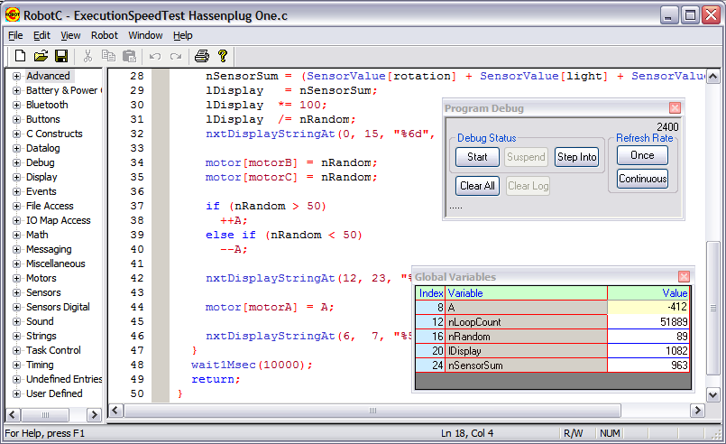

As you can see from the above window, all the program variables are nicely displayed in a simple grid. For this application to be viable, two key features are essential.
- A low debugger overhead. Critical real-time applications, like this one, should be debugged / analyzed without concern that the debugger is degrading the system performance. Overhead from running the debugger is less than 1%. All the RobotC measurements are with the debugger fully operational in its most powerful mode (i.e. breakpoint support active and enabled).
- The debugger must efficiently operate over an un-tethered Bluetooth connection; i.e. the screen must be refreshed frequently. This is a tricky problem because of the relatively slow performance of the BT messaging; i.e about 30 milliseconds to do a message transmit and acknowledgement. RobotC has optimized the BT messaging so that it was refreshing its display almost 10 times per second. Slower refresh rates, say over 500 milliseconds, are not really unacceptable.

