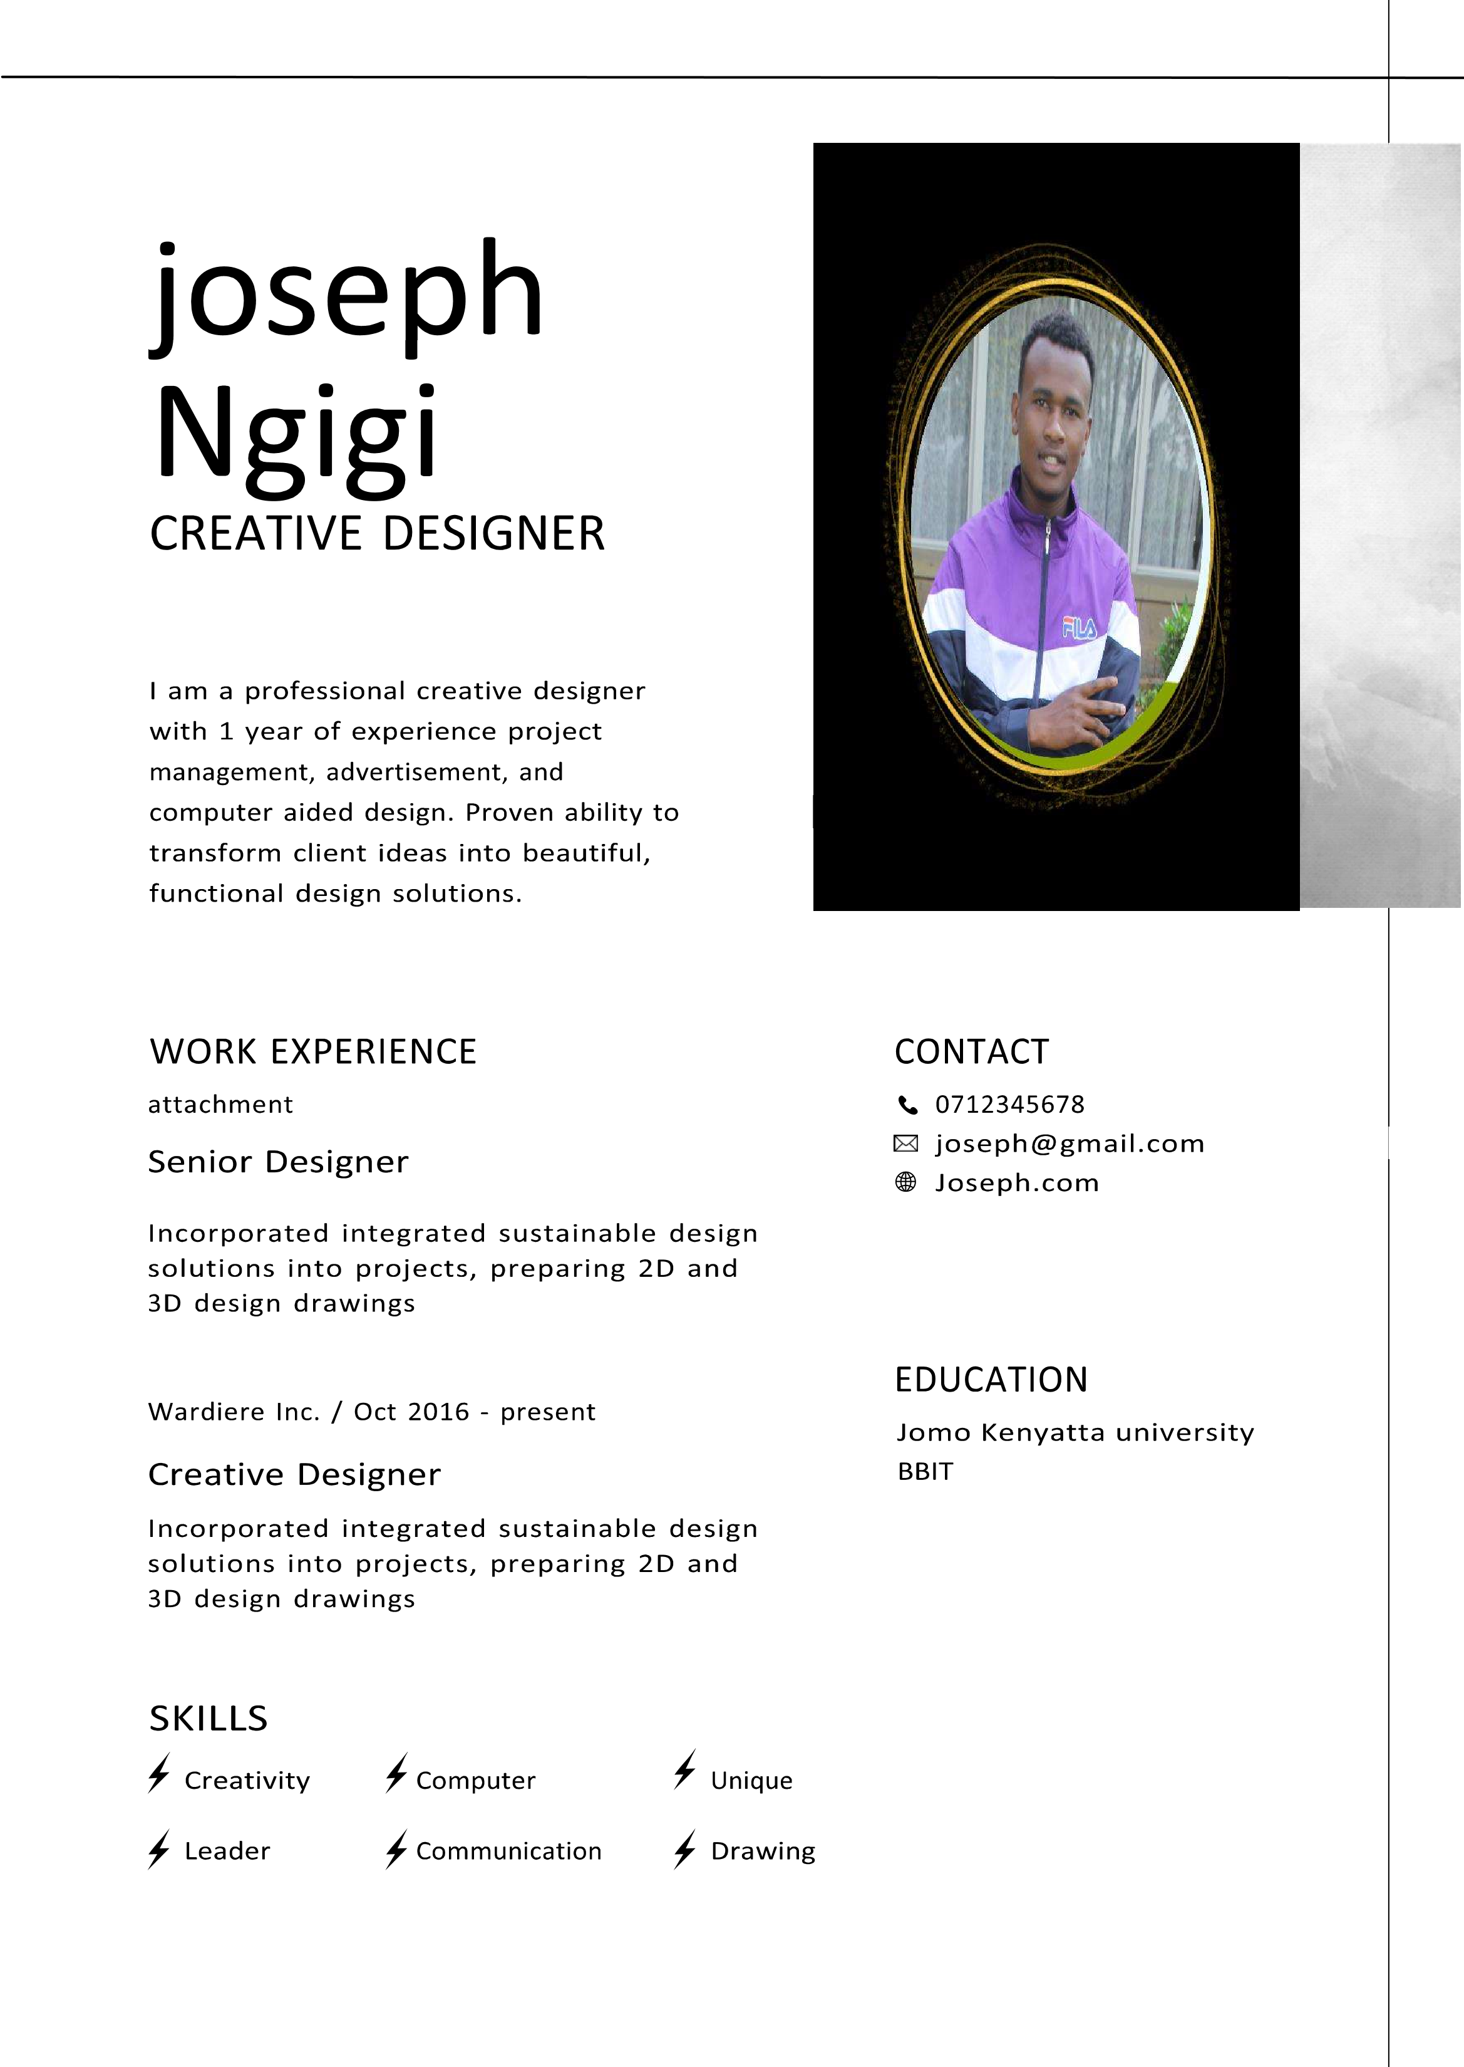

**Dear Sir or Madam,**

I am writing to express my interest in a position within your company. Your organization is known for its innovation, professionalism, and results-driven marketing strategy, which is why I am confident that I would be a valuable addition to your team. I am eager to learn more about your company and any available opportunities, and I have enclosed my resume for your consideration.

I am confident that my experience in this field will be an asset to your company. As outlined in my resume, I have a proven track record of achievements that enable me to make meaningful contributions to your organization.

I look forward to the opportunity to speak with you regarding how my skills and experience align with your company’s needs. I will reach out to arrange a suitable day and time to discuss this further. Please feel free to contact me by phone or email should you have any questions. I look forward to hearing from you.

Sincerely,  
**NGIGI**