DHCP & DNS Home Lab
Cisco Packet Tracer | Network Services Configuration
Paulson K Babu | March 2026

1. Lab Overview
This lab demonstrates the configuration and validation of DHCP (Dynamic Host Configuration Protocol) and DNS (Domain Name System) services using Cisco Packet Tracer. These are foundational network services that a SOC analyst encounters daily — understanding how IP assignment and name resolution work is critical for log analysis and network incident investigation.

Lab Tool | Cisco Packet Tracer
Lab Date | March 2026
Objective | Configure DHCP & DNS on a simulated LAN
Difficulty | Beginner — SOC Analyst Fundamentals
Analyst | Paulson K Babu (Jude)

2. Network Topology
The lab topology consists of five devices connected through a central switch, simulating a basic enterprise LAN segment:
- 2911 Router (Router0) — Default gateway for the LAN
- 2960-24TT Switch (Switch0) — Layer 2 switching for all devices
- Server-PT (Server0) — Acts as both DHCP and DNS server (Static IP: 192.168.1.10)
- PC-PT (PC0) — DHCP client, received IP: 192.168.1.100
- PC-PT (PC1) — DHCP client, received IP: 192.168.1.101

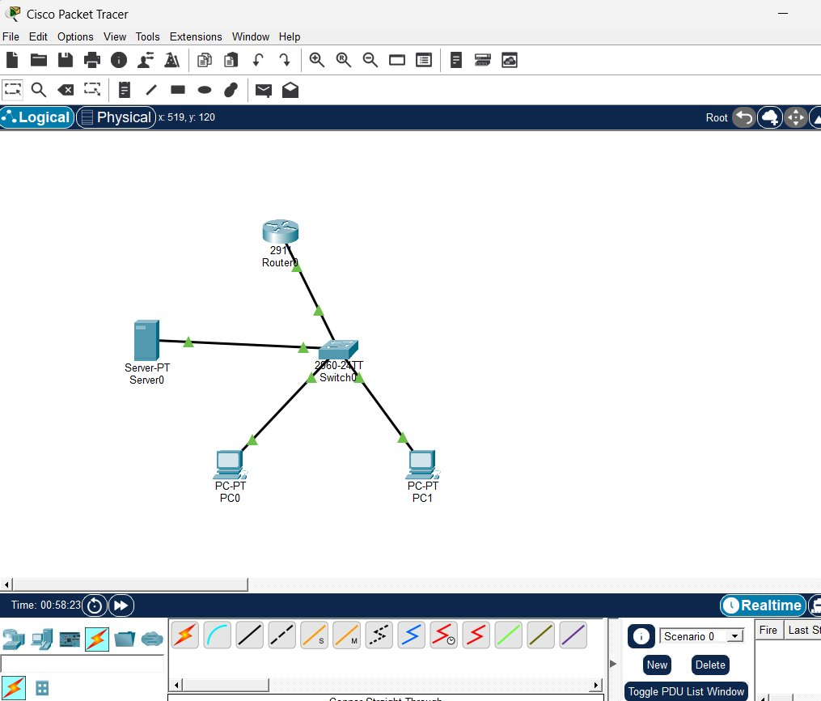
Figure 1: Network Topology — Router, Switch, Server, PC0, PC1

3. Device Configuration

3.1 Router Configuration (GigabitEthernet0/0)
The 2911 router was configured with a static IP on GigabitEthernet0/0 to act as the default gateway for the 192.168.1.0/24 network:
enable
configure terminal
interface gig0/0
ip address 192.168.1.1 255.255.255.0
no shutdown
exit

3.2 Server Static IP Configuration
The server was assigned a static IP address to ensure it always remains reachable at the same address — required since PCs use it as their DNS server.

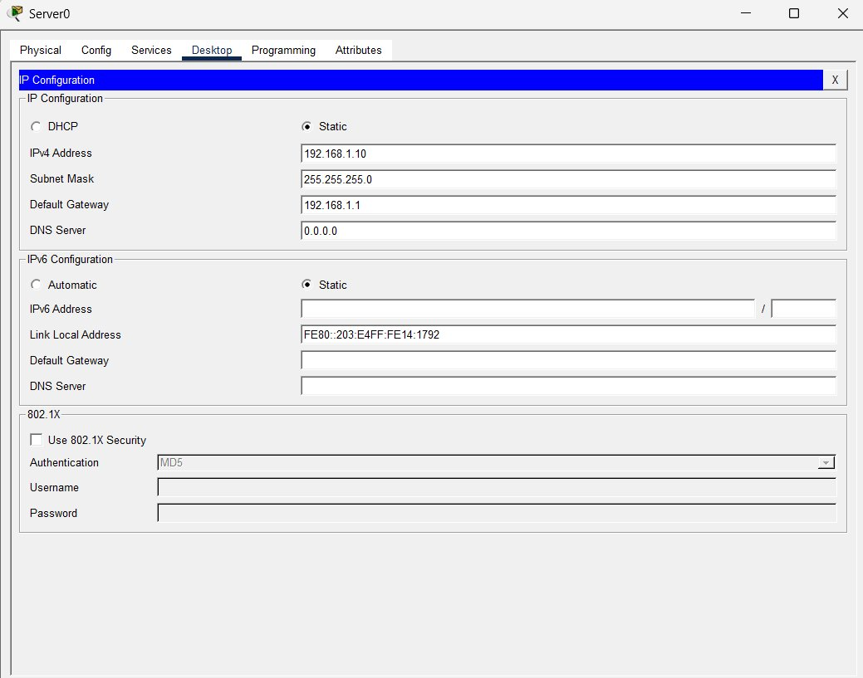
Figure 2: Server0 Static IP — 192.168.1.10 / 255.255.255.0 / Gateway 192.168.1.1

3.3 DHCP Service Configuration
The DHCP service was enabled on the server with a pool named 'serverPool'. When a PC boots and sends a DHCP Discover broadcast, the server responds with an available IP from this pool.

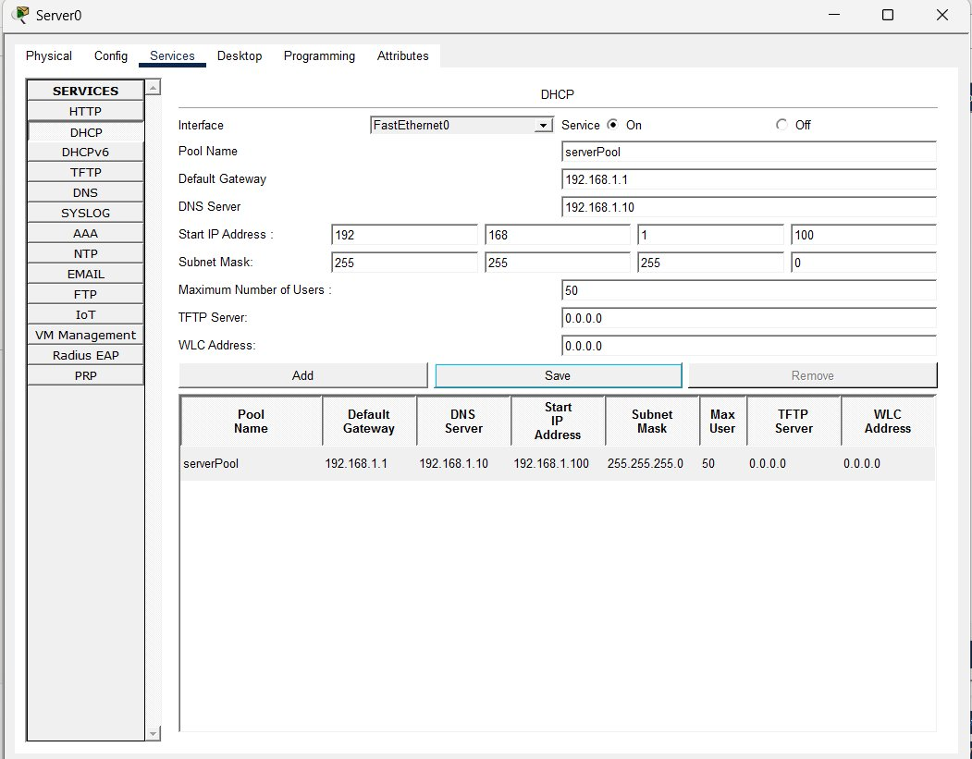
Figure 3: DHCP Pool — serverPool, Start IP 192.168.1.100, Subnet 255.255.255.0
Key DHCP parameters configured:
- Default Gateway: 192.168.1.1 (router interface — sent to clients)
- DNS Server: 192.168.1.10 (server itself — sent to clients for name resolution)
- Start IP Address: 192.168.1.100
- Subnet Mask: 255.255.255.0

3.4 DNS Service Configuration
The DNS service was enabled with an A Record mapping the hostname 'www.testlab.com' to the server's IP address 192.168.1.10. This allows PCs to resolve domain names to IP addresses.

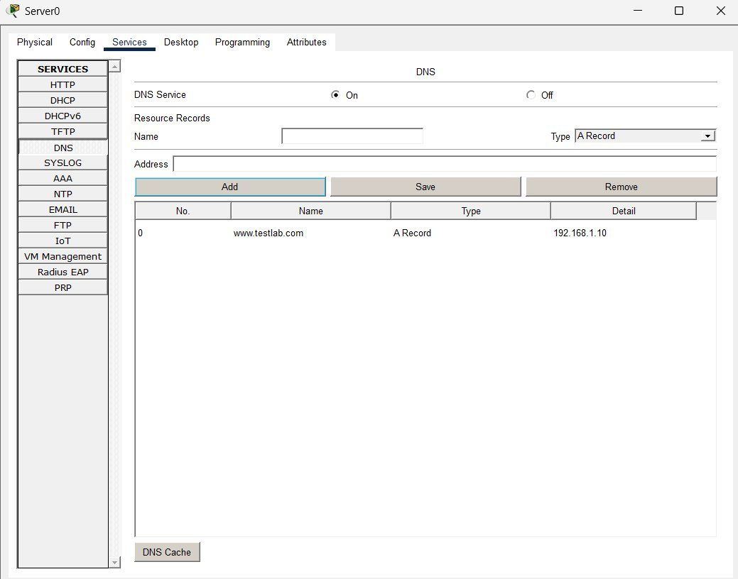
Figure 4: DNS A Record — www.testlab.com → 192.168.1.10

4. Verification & Testing

4.1 DHCP Lease Verification — PC0
PC0 was set to DHCP mode. The server successfully assigned IP 192.168.1.100 — the first address in the pool. The message 'DHCP request successful' confirms the handshake completed.
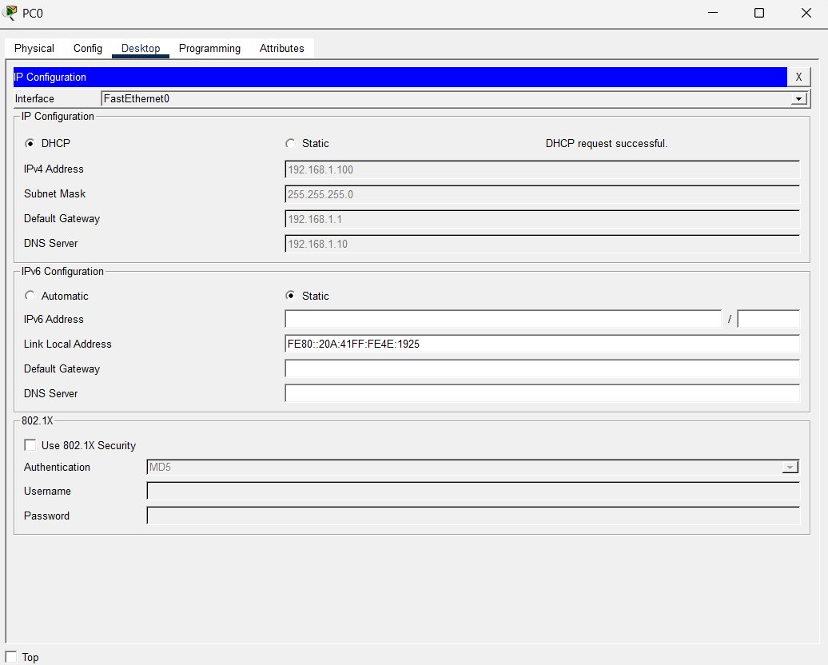
Figure 5: PC0 DHCP Assignment — 192.168.1.100 (DHCP request successful)

4.2 DHCP Lease Verification — PC1
PC1 was also set to DHCP mode and received the next available IP — 192.168.1.101 — confirming sequential address allocation from the pool.
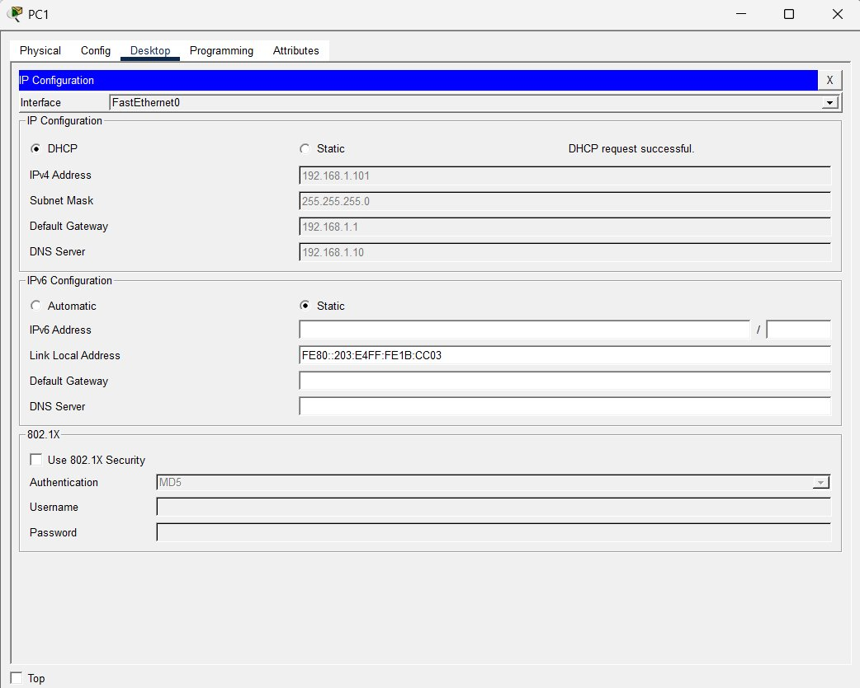
Figure 6: PC1 DHCP Assignment — 192.168.1.101 (DHCP request successful)

4.3 Connectivity & DNS Tests — PC0 Command Prompt
Three tests were run from PC0's command prompt to fully validate network connectivity and name resolution:
- ping 192.168.1.10 — Tests basic IP connectivity to the server
- nslookup www.testlab.com — Tests DNS resolution (domain to IP)
- ping www.testlab.com — Tests DNS-resolved connectivity by name

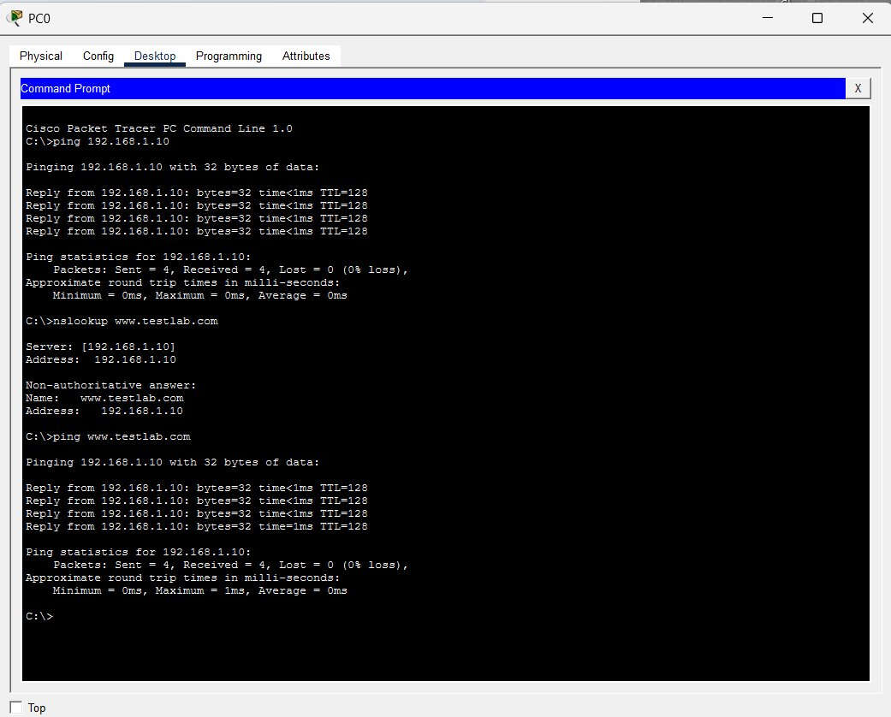
Figure 7: Command Prompt Tests — Ping, nslookup, and ping by domain all successful

5. Test Results Summary
Component | Value | Status
Server Static IP (192.168.1.10) | 192.168.1.10/24 | ✅ Pass
DHCP Pool Active | serverPool | ✅ Pass
PC0 DHCP Assignment | 192.168.1.100 | ✅ Pass
PC1 DHCP Assignment | 192.168.1.101 | ✅ Pass
DNS Record (www.testlab.com) | → 192.168.1.10 | ✅ Pass
Ping by IP (PC0 → Server) | 0% packet loss | ✅ Pass
nslookup www.testlab.com | Resolved 192.168.1.10 | ✅ Pass
Ping by domain name | 0% packet loss | ✅ Pass

6. SOC Analyst Relevance
Understanding DHCP and DNS is essential for SOC analysts. These protocols appear in almost every network security investigation:
- DHCP logs reveal which IP was assigned to which device at a given time — critical for attributing malicious activity to a specific host during incident response.
- DNS logs are one of the most valuable data sources in threat hunting. C2 beacons, data exfiltration, and malware staging often use DNS (as demonstrated in the Wireshark PCAP lab where audienceexposure.com queries indicated a C2 beacon).
- Rogue DHCP servers are a common attack vector in internal network attacks — an attacker can redirect gateway/DNS settings to intercept traffic (DHCP starvation + rogue server).
- DNS spoofing and poisoning attacks manipulate A records to redirect users to malicious IPs — understanding how legitimate DNS works is the baseline for detecting anomalies.

Tools used in real SOC environments to monitor these protocols include Splunk (DHCP/DNS log ingestion), Wazuh (alert on DHCP anomalies), and Wireshark (packet-level DNS/DHCP analysis) — all of which have been covered in previous labs in this series.

7. Conclusion
This lab successfully demonstrated the configuration and verification of DHCP and DNS services in a simulated LAN environment using Cisco Packet Tracer. All objectives were achieved:
- A 2911 router was configured as the default gateway
- A Server-PT was configured with static IP and dual DHCP/DNS services
- Two PCs automatically received IP addresses, gateway, and DNS info via DHCP
- DNS successfully resolved www.testlab.com to 192.168.1.10
- All ping and nslookup tests passed with 0% packet loss

This lab is part of a growing cybersecurity home lab portfolio covering SIEM (Splunk), SOC automation (Wazuh), network forensics (Wireshark), and now network services (Packet Tracer).

