THREAT DETECTION LAB REPORT
Splunk SIEM + MITRE ATT&CK Adversary Emulation

Paulson K Babu (Jude)
SOC L1 Analyst Candidate
MCA Graduate — APJ Abdul Kalam Technological University, Kerala

GitHub | github.com/joseph920744
LinkedIn | linkedin.com/in/paulson-babu-472563215
Report Date | March 2026
Classification | Portfolio — Public

Table of Contents
1. Executive Summary ............ 3
2. Lab Environment & Architecture ............ 3
3. Log Ingestion & Data Sources ............ 4
4. Attack Simulations & Detections ............ 5
4.1 T1059.001 — PowerShell Execution (Mimikatz) ............ 5
4.2 T1053.005 — Scheduled Task Persistence ............ 6
4.3 T1003.001 — LSASS Memory Credential Dump ............ 7
4.4 T1110.001 — Brute Force Password Guessing ............ 8
5. Attack Chain Analysis ............ 9
6. MITRE ATT&CK Detection Coverage ............ 10
7. Splunk Detection Dashboard ............ 10
8. SOC Analyst Relevance ............ 11
9. Analyst Observations & Recommendations ............ 12
10. Conclusion ............ 13

1. Executive Summary
This report documents the design, execution, and findings of a structured adversary emulation exercise conducted within a controlled two-node home lab environment. The objective was to simulate high-frequency attack techniques observed in real-world threat campaigns and validate detection coverage using Splunk Enterprise as the SIEM platform.
Four techniques from the MITRE ATT&CK framework were emulated using the Atomic Red Team library — covering the Execution, Persistence, and Credential Access tactic categories. Each simulation generated observable telemetry captured by Sysmon and Windows Event Logging, ingested into Splunk and queried using purpose-built SPL detection rules.
The exercise achieved a 100% detection rate across all four simulated techniques. Findings indicate that with proper endpoint telemetry (Sysmon v15.15, SwiftOnSecurity configuration) and correctly scoped SPL queries, a SOC team can reliably detect these techniques in near-real-time with minimal false-positive overhead.

Business Impact Context: The four techniques simulated here are consistently observed in ransomware pre-deployment phases (Qilin, LockBit, BlackCat) and APT lateral movement campaigns. Early detection at the Execution tactic stage provides a critical window to contain an incident before credential theft and persistence are established.

Metric | Value
Exercise Period | March 16-21, 2026
SIEM Platform | Splunk Enterprise 10.2.1
Attack Framework | MITRE ATT&CK v14 — Atomic Red Team
Techniques Simulated | 4 (Execution, Persistence, Credential Access)
Detection Rate | 4/4 — 100%
Total Events Analyzed | 11,517+ across 4 sourcetypes

2. Lab Environment & Architecture
The lab uses two virtual machines on VirtualBox connected via an isolated internal network (192.168.50.0/24). All adversary emulation runs locally on the Windows VM using Atomic Red Team — no external connectivity is required. The host machine is fully isolated from the lab network.

VM | Operating System | IP Address | Role
Windows VM | Windows 11 Enterprise (Build 26100) | 192.168.50.2 | Attack Target + Sysmon + Universal Forwarder + Atomic Red Team
Ubuntu VM | Ubuntu 24 LTS | 192.168.50.4 | Splunk Enterprise SIEM Server

2.1 Tools & Versions
Tool | Version | Purpose & Justification
Splunk Enterprise | 10.2.1 | Industry-standard SIEM used by majority of enterprise SOC teams globally. Provides log ingestion, search, alerting and dashboards.
Sysmon (System Monitor) | v15.15 | Provides granular Windows telemetry — process creation, network connections, registry modifications — not captured by native Windows logging.
SwiftOnSecurity Config | Latest | Community-trusted Sysmon configuration that suppresses high-volume benign events while preserving high-fidelity security signals.
Splunk Universal Forwarder | 9.2.1 | Ships Windows Event Logs and Sysmon telemetry from Windows VM to Splunk indexer over TCP 9997.
Atomic Red Team | Latest | Open-source MITRE ATT&CK-mapped adversary emulation library enabling controlled, repeatable technique simulation without live malware.

3. Log Ingestion & Data Sources
Prior to initiating any attack simulation, all four log sources were verified as actively flowing into Splunk. This validation step is critical in a real SOC — a silent forwarder or misconfigured input creates blind spots that attackers can exploit.

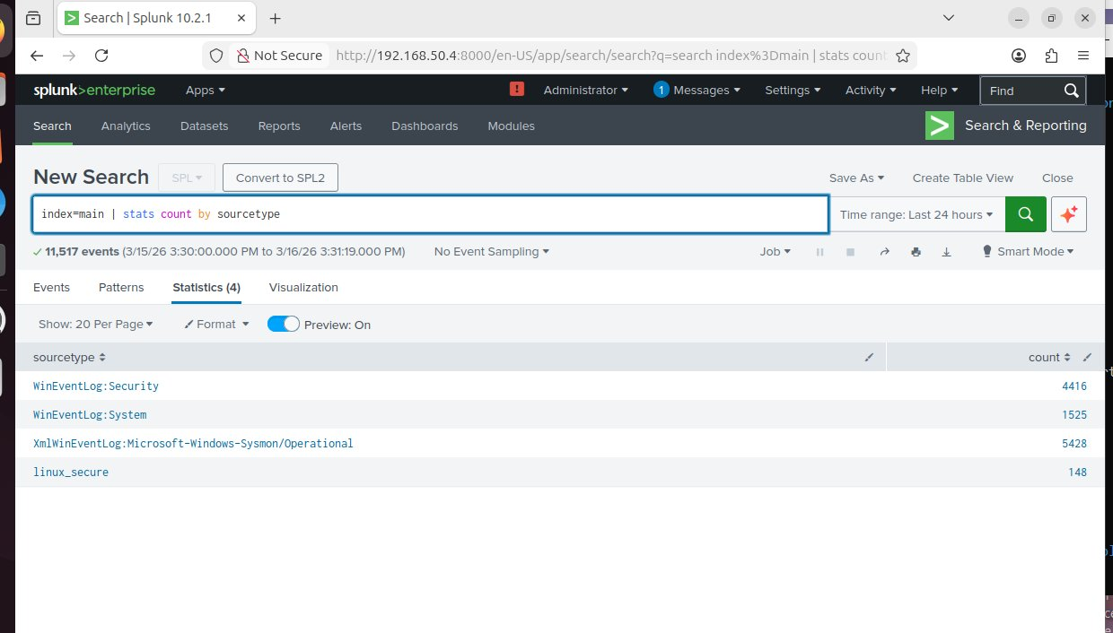
Figure 1: All four log sourcetypes confirmed active in Splunk (index=main | stats count by sourcetype)
Sourcetype | Event Count | SOC Relevance
XmlWinEventLog:Sysmon/Operational | 5,428+ | Primary detection source. Covers process creation, network connections, file events — majority of MITRE ATT&CK technique detections.
WinEventLog:Security | 4,416+ | Authentication events — 4624/4625 logon success/failure, privilege escalation. Essential for brute force and lateral movement detection.
WinEventLog:System | 1,525+ | Service installation (7045), unexpected shutdowns — key persistence and impact indicators.
linux_secure | 148+ | Ubuntu SSH authentication events from prior SSH brute force lab — retained as baseline context.

4. Attack Simulations & Detections
Each technique was executed individually on the Windows VM using Invoke-AtomicTest. After each simulation, Splunk was queried to confirm detection. Detection queries were designed to minimize false positives while maintaining high recall on true positive indicators.

4.1 T1059.001 - PowerShell Execution (Mimikatz)
Attribute | Detail
Tactic | Execution
Technique | T1059.001 - Command and Scripting Interpreter: PowerShell
Atomic Test | Test 1 - Invoke-Mimikatz via IEX download cradle
Log Source | XmlWinEventLog:Microsoft-Windows-Sysmon/Operational
EventCode | 1 - Process Creation
Events Detected | 2 confirmed true positives

What the Attack Does
PowerShell downloads Invoke-Mimikatz directly from GitHub using a Web download cradle (IEX + DownloadString) and executes sekurlsa::logonpasswords to extract credentials from LSASS memory. This is a fileless technique — Mimikatz never touches the disk, bypassing traditional AV file scanning entirely.

SPL Detection Query
index=main sourcetype="XmlWinEventLog:Microsoft-Windows-Sysmon/Operational" EventCode=1
| search CommandLine="*mimikatz*" OR CommandLine="*sekurlsa*"
| table _time, Image, CommandLine, ParentImage, User
| sort - _time

Query Explanation
- EventCode=1 filters to Sysmon Process Creation events only. Every new process spawned generates this event, making it the primary detection source for execution techniques.
- CommandLine="*mimikatz*" OR CommandLine="*sekurlsa*" searches the full command line string. Even in fileless execution, PowerShell captures the entire command including Mimikatz function names in EventCode 1.
- table _time, Image, CommandLine, ParentImage, User extracts the four fields critical for SOC triage: timestamp, executable path, full command, parent process, and user account.
- sort - _time presents newest events first, aligned with incident investigation workflow — analysts want to see the most recent activity immediately.

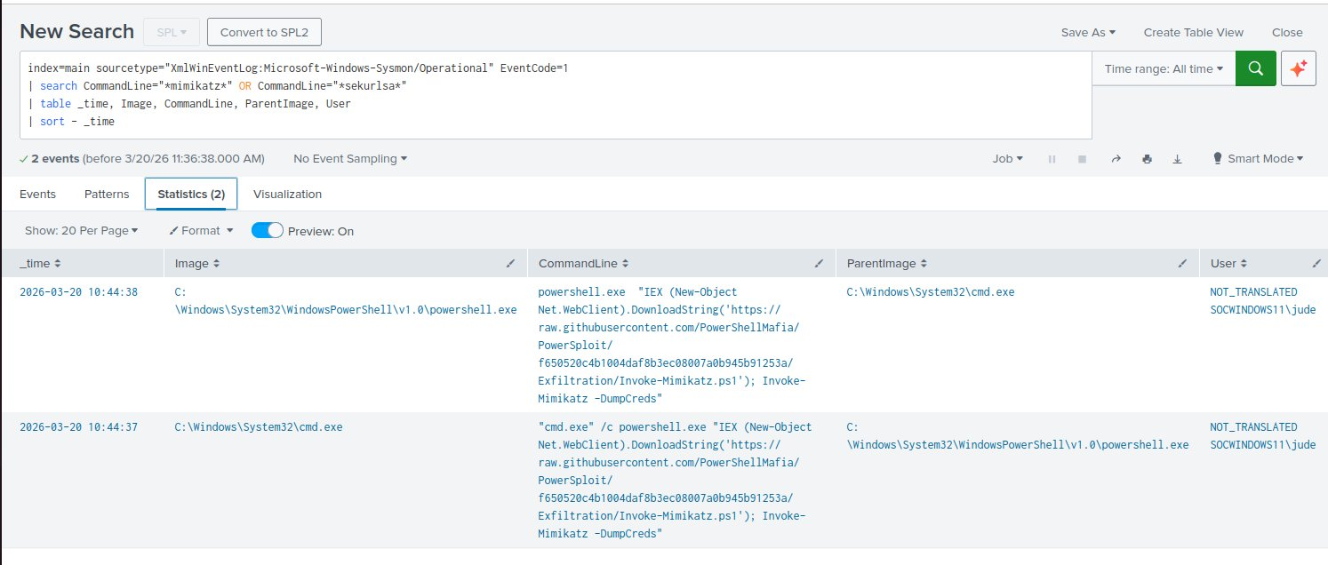
Figure 2: Splunk detects Mimikatz PowerShell execution — cmd.exe spawning powershell.exe with full Invoke-Mimikatz -DumpCreds command visible in CommandLine field

4.2 T1053.005 - Scheduled Task Persistence
Attribute | Detail
Tactic | Persistence
Technique | T1053.005 - Scheduled Task/Job: Scheduled Task
Atomic Test | Test 1 - schtasks /create via PowerShell to cmd chain
Log Source | XmlWinEventLog:Microsoft-Windows-Sysmon/Operational
EventCode | 1 - Process Creation
Events Detected | 3 confirmed true positives

What the Attack Does
Two scheduled tasks are created — T1053_005_OnLogon (runs at every user logon) and T1053_005_OnStartup (runs at every system boot) — both configured to run as SYSTEM. In a real attack, the payload would be a malicious binary or download cradle rather than calc.exe, ensuring persistence across reboots and credential resets.

SPL Detection Query
index=main sourcetype="XmlWinEventLog:Microsoft-Windows-Sysmon/Operational" EventCode=1
| search CommandLine="*schtasks*" OR CommandLine="*T1053*"
| table _time, Image, CommandLine, ParentImage, User
| sort - _time

Query Explanation
- CommandLine="*schtasks*" catches any invocation of the Windows Task Scheduler utility. Legitimate schtasks calls exist but are rarely initiated interactively from PowerShell or cmd.exe.
- ParentImage field is critical for triage. Legitimate task creation originates from software installers or Group Policy — PowerShell as parent is a high-confidence indicator of malicious intent.
- The /ru system flag in CommandLine indicates the task runs as SYSTEM, elevating severity to P1/Critical in most SOC playbooks. The /sc onstart and /sc onlogon triggers confirm persistence intent.

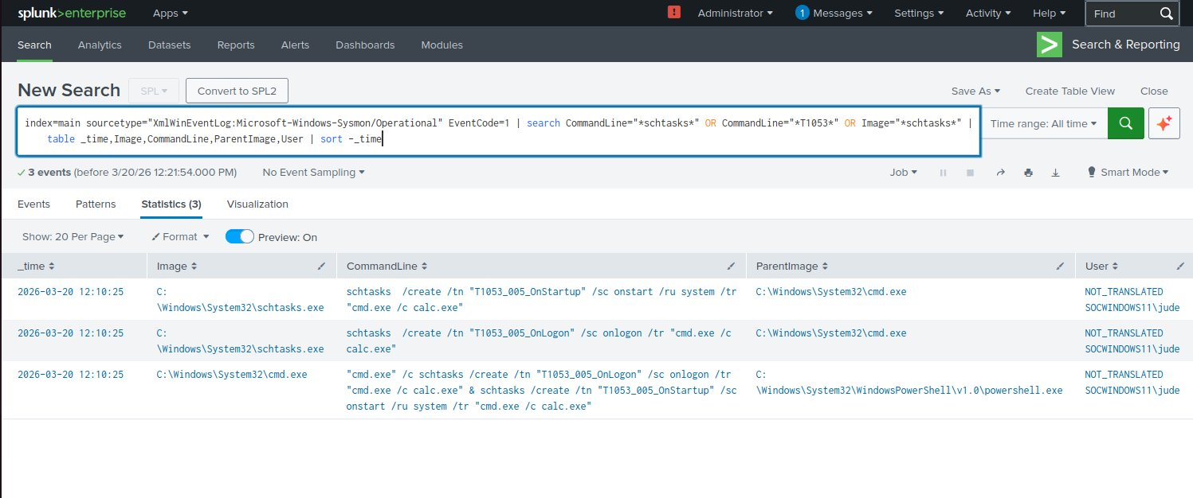
Figure 3: Splunk detects schtasks.exe (spawned by cmd.exe, which was spawned by PowerShell) creating OnLogon and OnStartup persistence tasks running as SYSTEM

4.3 T1003.001 - LSASS Memory Credential Dump
Attribute | Detail
Tactic | Credential Access
Technique | T1003.001 - OS Credential Dumping: LSASS Memory
Atomic Test | Test 2 - rundll32.exe + comsvcs.dll MiniDump (Living off the Land)
Log Source | XmlWinEventLog:Microsoft-Windows-Sysmon/Operational
EventCode | 1 - Process Creation
Events Detected | 5 events (including LSASS baseline for comparison)

What the Attack Does
rundll32.exe invokes the MiniDump export function from comsvcs.dll to dump the LSASS process memory to a file in %TEMP%. This is a Living off the Land (LotL) attack using only Microsoft-signed Windows binaries, bypassing application whitelisting and traditional AV signature detection entirely.

LotL Significance: Because both rundll32.exe and comsvcs.dll are legitimate signed Microsoft binaries, signature-based controls are bypassed. Behavioral detection via Sysmon CommandLine inspection is the only reliable detection method for this technique.

SPL Detection Query
index=main sourcetype="XmlWinEventLog:Microsoft-Windows-Sysmon/Operational" EventCode=1
| search CommandLine="*lsass*" OR CommandLine="*comsvcs*" OR CommandLine="*MiniDump*"
| table _time, Image, CommandLine, ParentImage, User
| sort - _time

Query Explanation
- CommandLine="*comsvcs*" flags any process invoking comsvcs.dll. Combined with MiniDump and lsass as co-occurring terms, confidence in malicious intent approaches near-certainty.
- CommandLine="*MiniDump*" is effectively a definitive IOC — no legitimate administrative tool invokes MiniDump via rundll32 in normal operations.
- CommandLine="*lsass*" catches references to LSASS by process name, whether via Get-Process lsass or direct PID reference, covering multiple attack variants beyond this specific test.

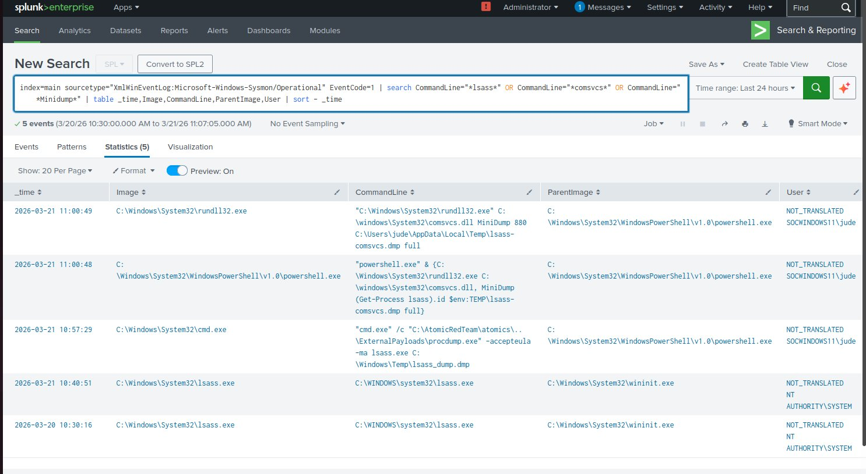
Figure 4: Splunk detects rundll32.exe invoking comsvcs.dll MiniDump against LSASS (PID 880) — saving credential dump to %TEMP%\lsass-comsvcs.dmp via Living off the Land technique

4.4 T1110.001 - Brute Force Password Guessing
Attribute | Detail
Tactic | Credential Access
Technique | T1110.001 - Brute Force: Password Guessing
Atomic Test | Test 2 - LDAP authentication attempts against local account
Log Source | WinEventLog:Security
EventCode | 4625 - An Account Failed to Log On
Events Detected | 5 failed logon events in rapid succession

What the Attack Does
The simulation attempts a password dictionary attack against local account 'jude' via LDAP bind operations, cycling through common passwords (123456, qwerty, password, etc.) in rapid succession. Each failed attempt generates Windows Security EventCode 4625 with Failure Reason: Unknown username or bad password.

SPL Detection Query
index=main sourcetype="WinEventLog:Security" EventCode=4625
| table _time, Account_Name, Failure_Reason, Source_Network_Address, Workstation_Name
| sort - _time

Query Explanation
- sourcetype=WinEventLog:Security uses the Windows Security log rather than Sysmon — brute force is best detected at the authentication layer, not the process layer. EventCode 4625 is generated by the Windows authentication subsystem for every failed logon regardless of protocol.
- Account_Name identifies the targeted account. Repeated 4625 events against the same account within a short window is the definitive brute force indicator. SOC playbooks typically alert on 5+ failures within 60 seconds.
- Source_Network_Address identifies the originating IP. In production this feeds into threat intelligence enrichment and firewall block workflows. In this lab it returns the local IPv6 address as all traffic is local.
- Failure_Reason distinguishes bad password (account exists) from bad username (account does not exist) — helping analysts determine whether the attacker has valid user enumeration data, affecting escalation priority.

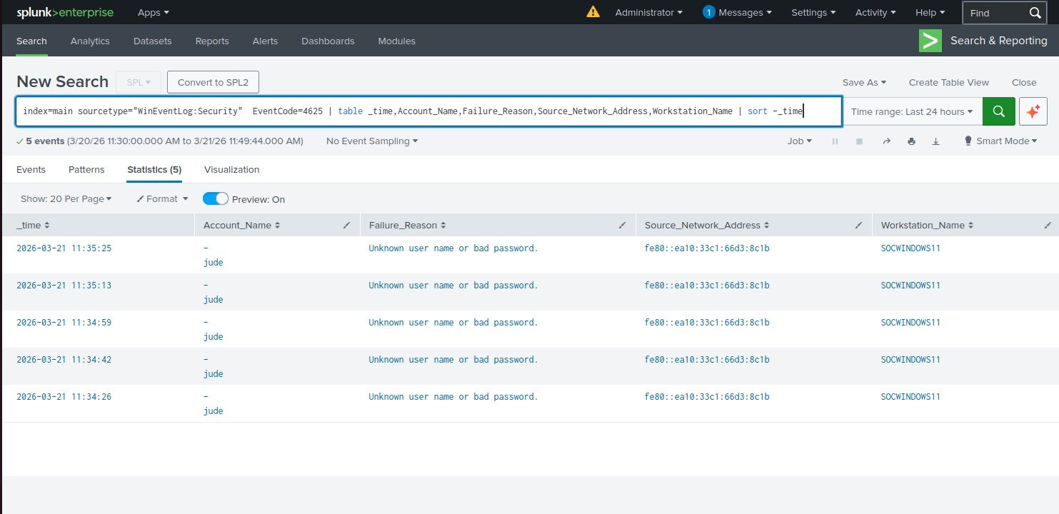
Figure 5: Splunk detects 5 failed logon attempts against account 'jude' within 60 seconds — consistent Failure_Reason and same Source_Network_Address confirm automated brute force

5. Attack Chain Analysis
Understanding process ancestry and tactic sequencing is a core SOC analyst skill. The following kill chains show the parent-child process relationships observed in Splunk for each technique — identical to what a real analyst sees during alert triage.

5.1 T1059.001 — Mimikatz Execution Chain
EXECUTION  PowerShell  T1059.001 | DOWNLOAD  IEX DownloadString  T1059.001 | CRED ACCESS  Invoke-Mimikatz  T1003 | IMPACT  DumpCreds  T1003.001

Observed in Splunk: cmd.exe → powershell.exe → [fileless Mimikatz in memory]. No Mimikatz binary on disk — detection depends entirely on Sysmon CommandLine inspection (EventCode 1). Without Sysmon, this technique is invisible.

5.2 T1053.005 — Scheduled Task Persistence Chain
EXECUTION  powershell.exe  T1059.001 | EXECUTION  cmd.exe /c  T1059.003 | PERSISTENCE  schtasks.exe /create  T1053.005 | PRIVILEGE  /ru SYSTEM onstart  T1053.005

Observed in Splunk: powershell.exe → cmd.exe → schtasks.exe. The /ru system flag means the malicious payload runs at the highest privilege on every reboot — critical severity requiring immediate remediation in production.

5.3 T1003.001 — LSASS Dump Chain (Living off the Land)
EXECUTION  powershell.exe  T1059.001 | LOLBIN  rundll32.exe  T1218.011 | CRED ACCESS  comsvcs.dll MiniDump  T1003.001 | EXFIL PREP  lsass-comsvcs.dmp  T1003.001

Observed in Splunk: powershell.exe → rundll32.exe. Two Microsoft-signed binaries used to dump LSASS — a classic Living off the Land technique favored by APT groups because it bypasses application whitelisting and most AV solutions.

5.4 T1110.001 — Brute Force Chain
RECON  User Enumeration  T1087 | CRED ACCESS  LDAP Bind x5+  T1110.001 | DETECTION  EventCode 4625 x5  T1110.001 | ESCALATION  L1 Analyst Triage  SOC L1

Generates high-volume EventCode 4625 in rapid succession. In production, a SOC analyst would correlate with EventCode 4624 (successful logon) immediately following the failures — indicating successful brute force completion requiring immediate account lockout.

6. MITRE ATT&CK Detection Coverage
# | Technique ID | Name | Tactic | Log Source | EventCode | Result
1 | T1059.001 | PowerShell Execution | Execution | Sysmon | 1 | DETECTED
2 | T1053.005 | Scheduled Task | Persistence | Sysmon | 1 | DETECTED
3 | T1003.001 | LSASS Memory Dump | Cred. Access | Sysmon | 1 | DETECTED
4 | T1110.001 | Password Guessing | Cred. Access | WinSecurity | 4625 | DETECTED

Detection Rate: 4/4 — 100%. All simulated techniques detected via purpose-built SPL queries. No gaps in detection coverage identified for techniques tested.

7. Splunk Detection Dashboard
A unified MITRE ATT&CK Detection Dashboard was built in Splunk Classic Dashboards providing a single-pane-of-glass monitoring view replicating the kind of SOC monitoring screen a Tier 1 analyst would use during a shift.

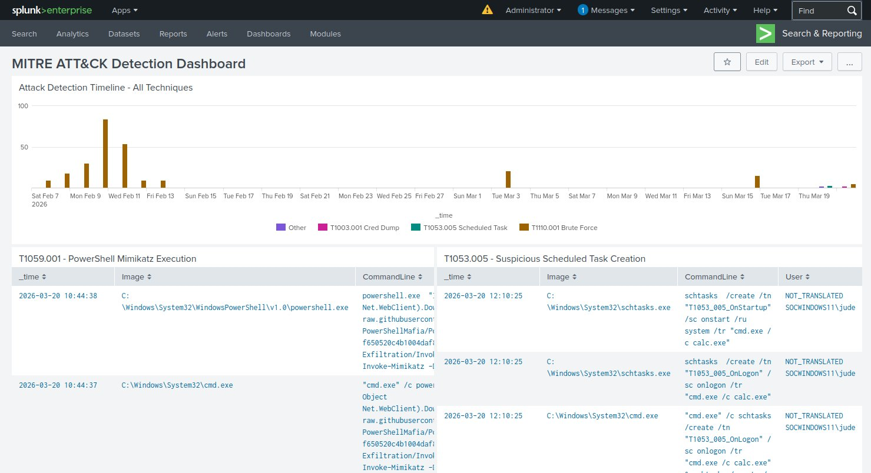
Figure 6: MITRE ATT&CK Detection Dashboard — Attack timeline chart (top) with per-technique detection tables. All panels use earliest=0 for full historical coverage.

7.1 Dashboard Components
- Attack Detection Timeline — Color-coded column chart using timechart SPL. Provides immediate visual identification of attack spikes vs. baseline noise.
- T1059.001 Panel — Table with full CommandLine and User fields for immediate Mimikatz triage.
- T1053.005 Panel — Table with ParentImage field visible to identify unusual PowerShell to cmd to schtasks process ancestry.
- T1003.001 Panel — Table showing rundll32.exe + comsvcs.dll events with dump file path visible for forensic follow-up.
- T1110.001 Panel — Table with Account_Name, Failure_Reason, and Source_Network_Address for rapid attacker identification.

8. SOC Analyst Relevance
The following table maps every technical skill demonstrated in this lab to real SOC L1 daily responsibilities — the operational context that makes this project directly transferable to an entry-level analyst role.

Lab Skill | Real SOC L1 Duty | Why It Matters
Sysmon deployment + config | Endpoint telemetry validation | A SOC is blind without proper endpoint logging. Sysmon configuration is a day-one task in any new environment.
SPL queries with EventCode + CommandLine filters | Alert investigation and log correlation | Every investigation starts with a SIEM query. Targeted SPL reduces investigation time from hours to minutes.
ParentImage anomaly identification | Process tree analysis during triage | Suspicious parent-child process relationships are the primary indicator of malicious execution. Every L1 analyst must read a process tree.
EventCode 4625 brute force detection | Authentication monitoring and account lockout triage | Brute force and credential stuffing are among the most common alerts in any SOC. Rapid identification and escalation prevents account compromise.
MITRE ATT&CK technique mapping | Alert classification and threat intel enrichment | L1 analysts tag alerts with ATT&CK IDs for SIEM enrichment, reporting, and L2/L3 escalation context.
Multi-panel Splunk dashboard creation | SOC monitoring and shift handover reports | Dashboard maintenance is a core L1 responsibility. Analysts must create and modify dashboards without engineering support.
Attack chain and process tree documentation | Incident documentation and runbook creation | Every SOC shift ends with documentation. The ability to write clear technical incident notes is as important as the technical skills.

9. Analyst Observations & Recommendations
The following observations and recommendations are written from the perspective of a SOC L1 analyst reviewing the alerts generated by this detection exercise. In production, these findings would be documented in the incident management system and escalated per the defined playbook.

9.1 Observations

Observation 1 - Fileless Mimikatz bypasses file-based controls
The T1059.001 simulation executed Mimikatz entirely in-memory via a PowerShell download cradle. No Mimikatz binary was written to disk — traditional AV would not trigger. Detection was only possible because Sysmon captured the CommandLine argument containing Invoke-Mimikatz. Without Sysmon and CommandLine logging, this technique would be completely invisible.

Observation 2 - SYSTEM-level scheduled tasks represent critical severity
Both tasks created by T1053.005 run as SYSTEM (/ru system) on every reboot. In a real incident this means the attacker's payload executes with the highest available privilege indefinitely, making remediation significantly more complex and increasing blast radius if the payload is destructive.

Observation 3 - LotL technique evades traditional controls
The comsvcs.dll MiniDump technique uses only Microsoft-signed binaries. Application whitelisting solutions relying on binary signing (AppLocker publisher rules) would not block this. Detection is exclusively behavioral — the combination of rundll32 + comsvcs + MiniDump + lsass is a high-confidence behavioral IOC.

Observation 4 - Brute force requires rate-based correlation
Individual EventCode 4625 events are low-severity and occur in normal operations. The malicious signal is the rate — 5 failures against the same account within 60 seconds. A static alert on 4625 alone generates excessive false positives; effective detection requires threshold-based correlation.

9.2 Recommendations

R1 - Implement Mandatory Sysmon CommandLine Monitoring
All Windows endpoints must have Sysmon deployed with a maintained configuration. Without CommandLine logging (EventCode 1), fileless attacks and LotL techniques are effectively undetectable in a Windows environment.

R2 - Replace Static 4625 Alert with Threshold-Based Correlation
index=main sourcetype="WinEventLog:Security" EventCode=4625
| stats count by Account_Name, Source_Network_Address
-- Alert when count > 5 within 60-second sliding window
| where count > 5

R3 - Add LSASS ProcessAccess Monitoring (EventCode 10)
Supplement CommandLine-based LSASS detection with Sysmon EventCode 10 to catch variants that do not use comsvcs.dll:
index=main sourcetype="XmlWinEventLog:Microsoft-Windows-Sysmon/Operational" EventCode=10
| search TargetImage="*lsass.exe"
| table _time, SourceImage, TargetImage, GrantedAccess, CallTrace

R4 - Escalation Triggers for L2/L3
- CommandLine containing mimikatz, sekurlsa, or Invoke-Mimikatz -> Escalate immediately (P1 Critical)
- Scheduled task created with /ru system by powershell.exe or cmd.exe -> Escalate (P1 Critical)
- rundll32.exe + comsvcs.dll + MiniDump in any CommandLine -> Escalate immediately (P1 Critical)
- 5+ EventCode 4625 events against same account within 60 seconds -> Escalate (P2 High), initiate account lockout

10. Conclusion
This adversary emulation exercise validated detection coverage for four high-frequency MITRE ATT&CK techniques across Execution, Persistence, and Credential Access tactic categories, achieving 100% detection rate using Splunk Enterprise with Sysmon endpoint telemetry.
The exercise demonstrates that effective threat detection does not require expensive commercial tooling. A properly configured open-source stack (Sysmon + Splunk + Atomic Red Team) provides sufficient visibility to detect techniques most commonly observed in ransomware pre-deployment and APT intrusion campaigns.
Key takeaways for SOC operations:
- Endpoint telemetry quality (Sysmon) is more important than SIEM sophistication — garbage in, garbage out
- CommandLine inspection via Sysmon EventCode 1 is the most versatile detection primitive for Windows environments
- Living off the Land techniques require behavioral detection — signature-based controls are insufficient
- Detection rules must be validated against real attack telemetry before production deployment

This report is part of a structured home lab portfolio demonstrating practical SOC L1 analyst capabilities. Complete project including SPL queries, Sysmon configuration and lab documentation available at the GitHub repository below.

Paulson K Babu (Jude) | SOC L1 Analyst Candidate | Kerala, India
github.com/joseph920744 | linkedin.com/in/paulson-babu-472563215

