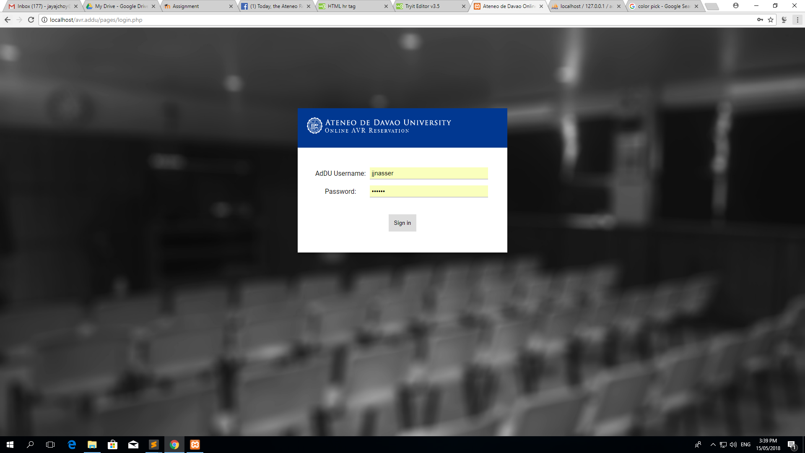

This is the login page. The background is a blurred monochrome image of one of the university’s AVRs. Log-in box’ header is the school’s logo along with the title of the page.

The home page shows the current reservations, as well as two large buttons on what you would like to reserve.

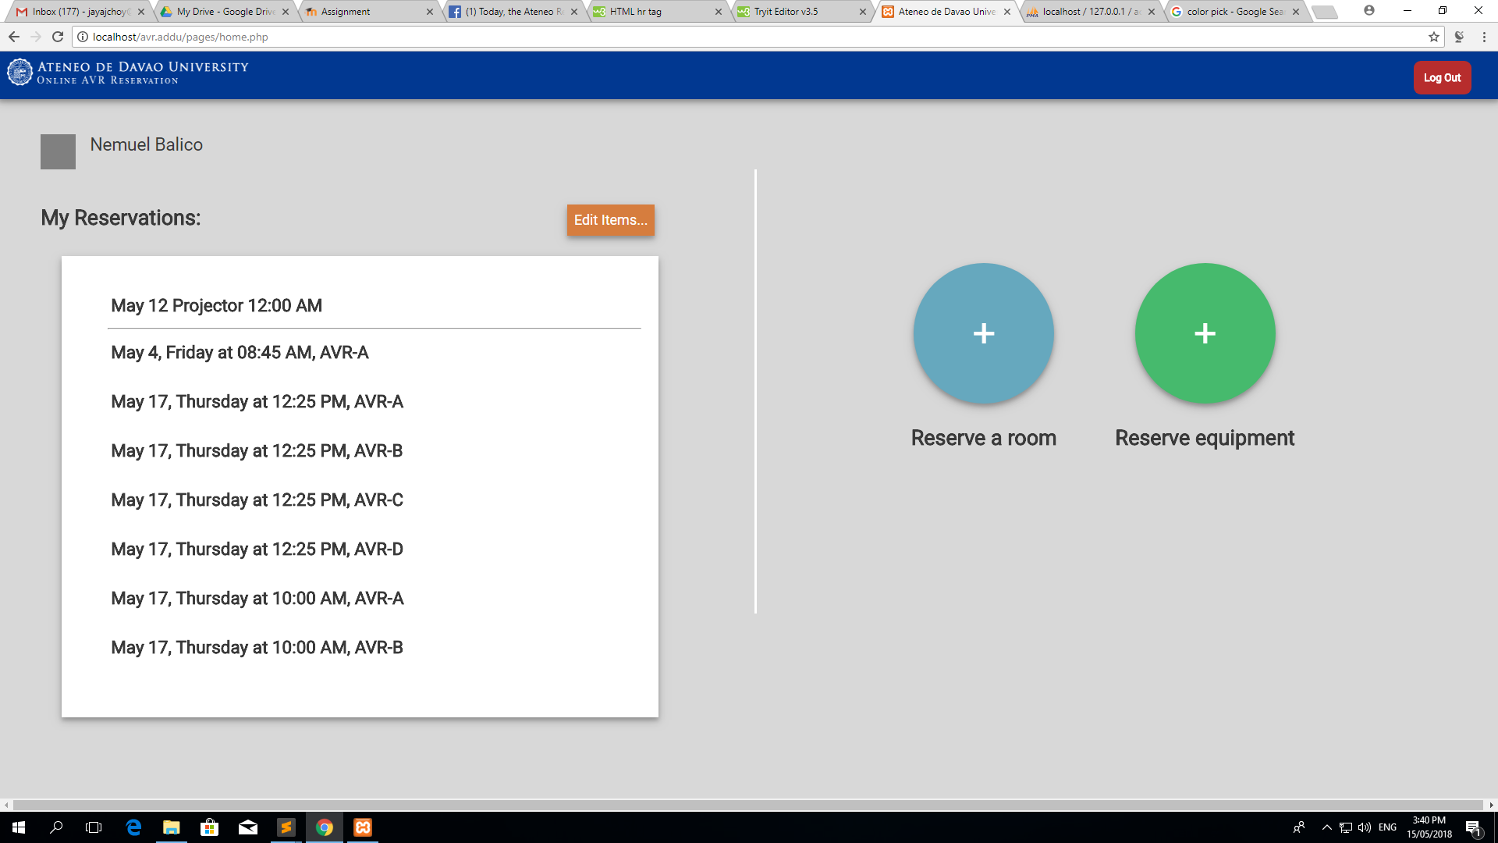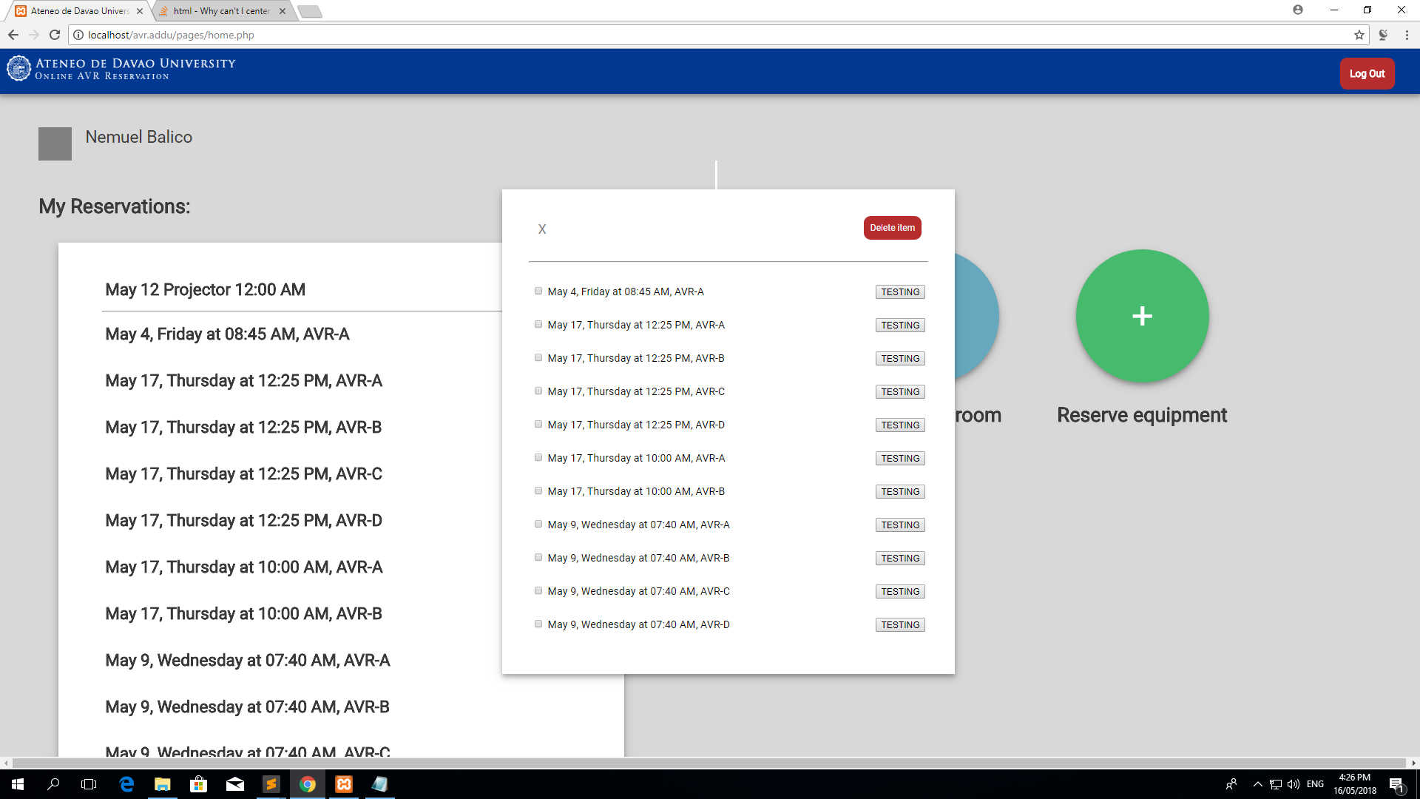

If you click on the edit items button, a pop-up window will appear where you can choose to edit or delete items.

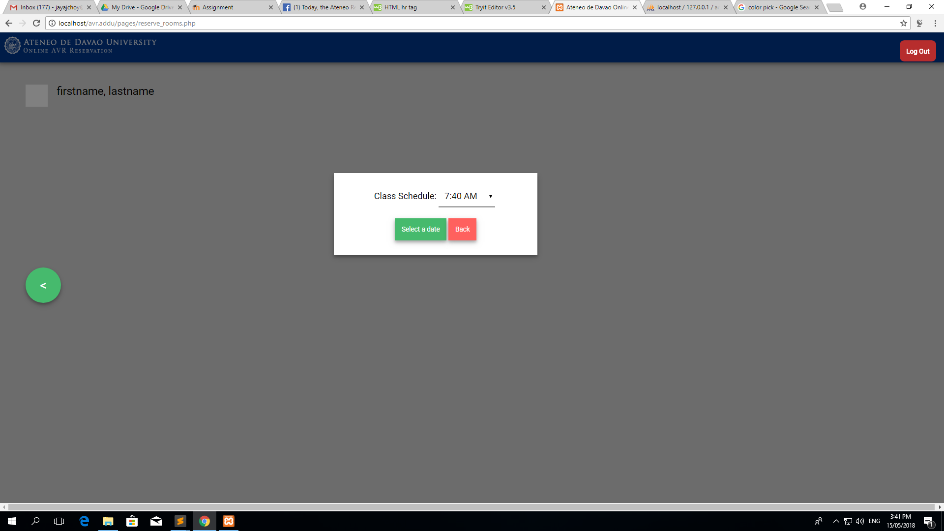

Upon reserving a room, you will be taken to another page where you will be greeted by a pop-up window which prompts you to select the time.

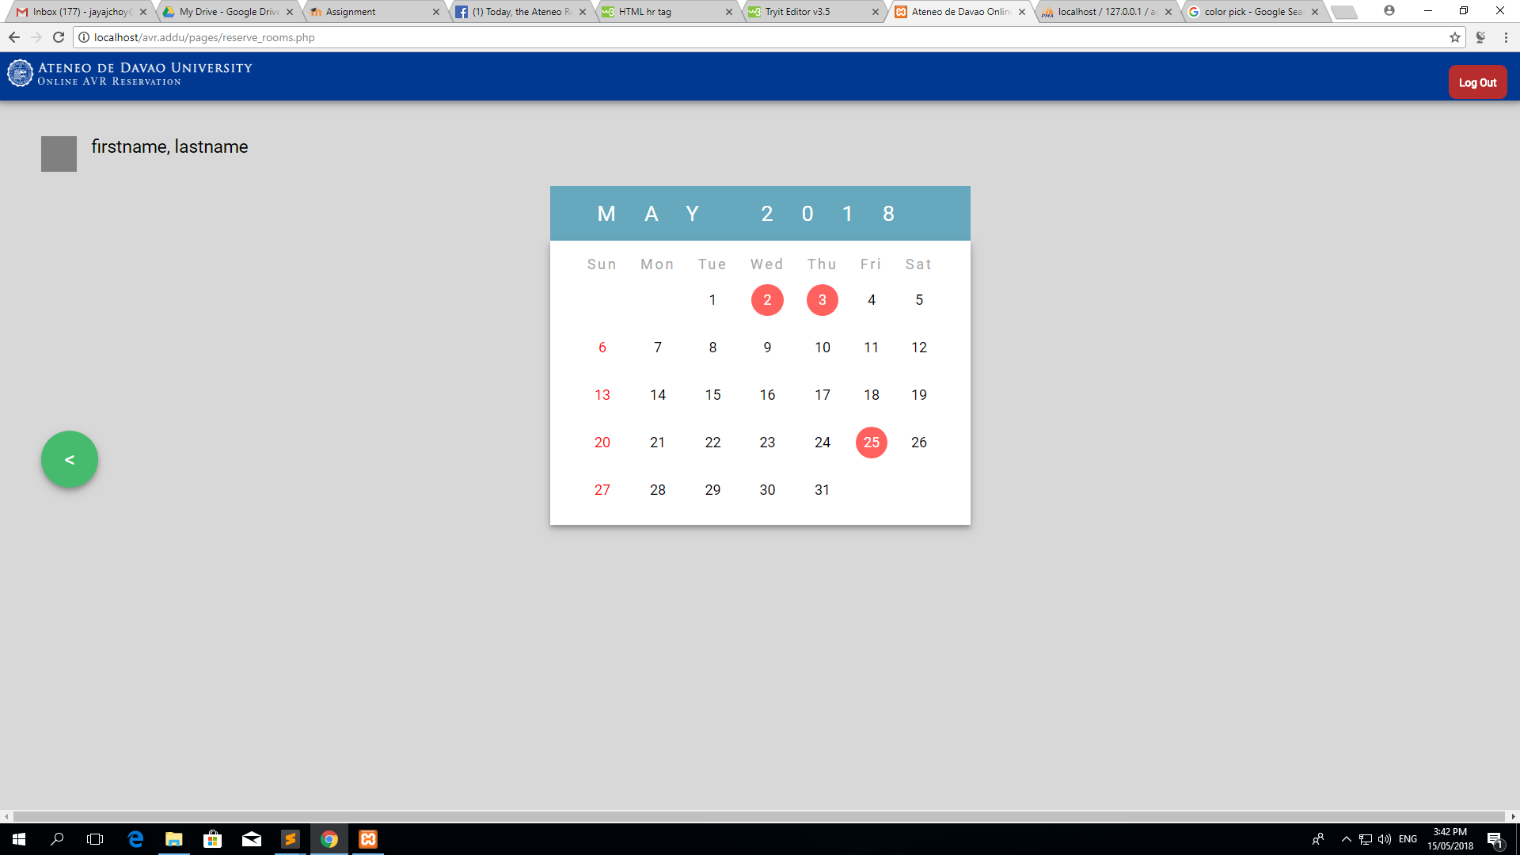

This is the calendar which allows you to select a date. If the dates on your selected schedule are fully booked, the calendar buttons will become red and unclickable.

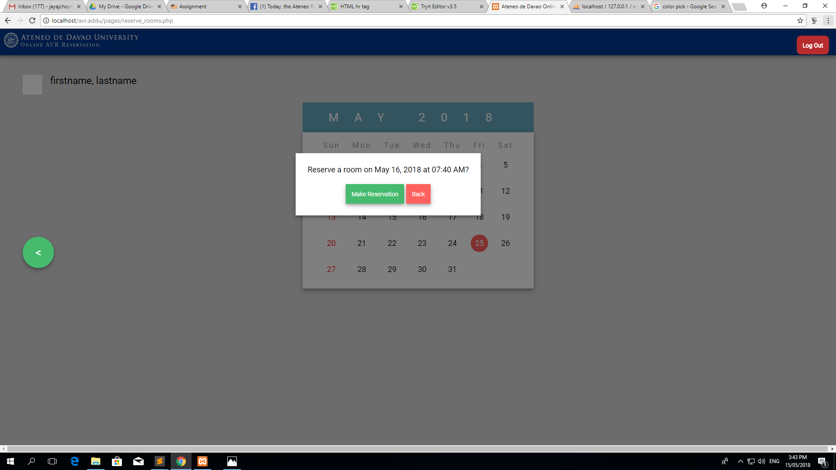

Once you’ve selected a date, a confirmation window will appear.