Standard Business Plan
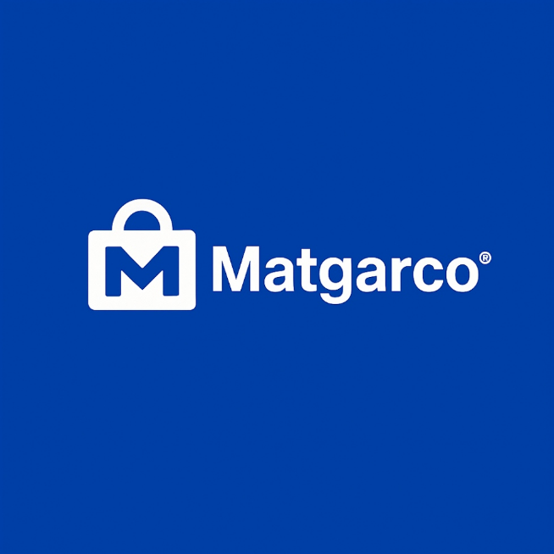

Matgarco Founders Team:
- Salah Elden Haytham (Frontend Development Lead & Project Manager)
- Joseph Adel (Product Strategy & UI/UX Lead)
- Fawzy Khaled (Business Analyst)
- Youssef Diaa Eldeen (Backend & Infrastructure Lead)
- Omar Zakaria (Marketing & Growth Lead)
- Amr Mohamed (Operations & Finance Lead)

Date: March 2026

Content
Page
Executive Summary .................................................... 10
Business Idea and Market ............................................ 12
Marketing Plan Product ................................................ 13
Marketing Plan Price.................................................... 14
Marketing Plan Place .................................................. 15
Marketing Plan Promotion ............................................ 16
Legal Form ................................................................ 17
Start-up Capital.......................................................... 18
Sources of Start-up Capital .......................................... 19
Organization and Staff................................................. 21
Business Operation and Costs....................................... 23
Cash Flow Plan ........................................................... 25
Profit Margin .............................................................. 26
Opening Balance......................................................... 27

- Executive Summary

Name of Business: Matgarco
Legal Form: Limited Liability Company (LLC)
Contact Address: Helwan National University, Faculty of Humanities, Commerce and Business Administration, Business Informatics & Digital Transformation (BIDT) Program, Cairo, Egypt.
Official Contact: Tel: (+2) 01126871779
- E-mail: info@matgarco.io
- Digital Presence: www.matgarco.io

Type of Business: [X] Service Provider (B2B Multi-tenant SaaS E-commerce Platform)
Brief Description of the Business Idea: Matgarco is a specialized SaaS platform engineered to migrate Egyptian small businesses from informal social media selling to structured, professional e-commerce. By offering a "Zero-Code" environment, the platform allows merchants to generate fully functional online stores in under 10 minutes. Matgarco differentiates itself through a hyper-local approach, providing EGP-based pricing, native Arabic AI content generation, and seamless integration with Egypt’s primary payment (Fawry/Paymob) and logistics (Bosta) networks.

Products or Services:
Automated Storefront Generator: A wizard-based system for instant PWA deployment.
- AI-Powered Content Engine: Native Arabic LLM integration for generating product descriptions and marketing copy.
- Integrated Local Ecosystem: Pre-configured APIs for local shipping and payment gateways.
- Advanced Merchant Control Panel: A centralized dashboard for inventory tracking, order management, and business analytics.

Customers:
Social Commerce Sellers: Merchants currently operating exclusively via Facebook, Instagram, and WhatsApp.
- Egyptian SMEs: Small and medium enterprises seeking professional digital transformation.
- Micro-entrepreneurs: Non-technical individuals looking to start an online business with minimal overhead.

Management Team & Ownership:
1. Salah Elden Haytham: Frontend Development Lead & Project Manager (React & Next.js Implementation).
2. Joseph Adel: Product Strategy & UI/UX Lead (Visionary & Strategic Direction).
3. Fawzy Khaled: Business Analyst (BA) (Requirements Engineering & Quality Assurance).
4. Youssef Diaa: Backend & Cloud Infrastructure Lead (Node.js & MongoDB Architecture).
5. Omar Zakaria: Marketing & Growth Lead (User Acquisition & GTM Strategy).
6. Amr Mohamed: Operations & Financial Planning (Budgeting & Resource Management).
- Qualification: Final-year candidates for B.Sc. in Business Informatics & Digital Transformation (BIDT), Helwan National University.

Number of Jobs to be Created: 3 to 5 initial positions focusing on Customer Success and Field Sales Representatives to support merchant onboarding.
Start-up Capital Breakdown: * Fixed Investment: 9,500 EGP (Infrastructure setup, Domain assets, Security protocols).
- Working Capital: 10,500 EGP (Server maintenance, Marketing campaigns, AI API resources).
- Total Initial Capital: 20,000 EGP.
Source of Capital: [X] Personal Savings & Sweat Equity (Bootstrap Funding).

2. Business Idea and Market

2.1 Description of the Business Idea
Identified Market Needs:
Matgarco is engineered to resolve the "Operational Fragmentation" currently hindering the growth of the Egyptian social commerce sector. The platform addresses three critical pain points:
- Technical Complexity: Eliminating the requirement for advanced knowledge in server management, DNS configuration, and API integration.
- Financial Volatility: Providing a stable EGP-based pricing model to shield local SMEs from foreign currency exchange risks associated with global platforms.
- Content Creation Barrier: Solving the difficulty of producing professional, SEO-optimized Arabic marketing copy and product descriptions.

Target Customer Segments:
Our primary audience includes Informal Social Sellers (operating via WhatsApp/Facebook), Traditional Retailers (physical shop owners in commercial clusters like El-Mosky), and Boutique Home-Grown Brands requiring a professional digital storefront.
The Solution (Products and Services):
Matgarco offers a Hyper-Localized SaaS Ecosystem built on modern architecture:
- Zero-Code Onboarding Wizard: A proprietary step-by-step engine that automates store generation in under 10 minutes.
- Native AI Arabic Assistant: An integrated generative AI module designed to produce high-conversion Arabic product descriptions and marketing assets.
- High-Performance PWA Technology: Stores are deployed as Progressive Web Apps, ensuring sub-second load times and offline capabilities, optimized for mobile-first Egyptian consumers.
- Seamless Local Integration: Native connectivity with Bosta for logistics and Paymob/Fawry for local payments, ensuring a frictionless checkout experience.
Customer Acquisition Strategy:
- Educational Content Marketing: Leveraging TikTok and Reels to educate merchants on "Frictionless Digital Transformation."
- Organic Viral Loop: Utilizing the "Powered by Matgarco" attribution on free-tier stores as a high-conversion referral engine.
- Direct Field Onboarding: Physical presence in wholesale hubs to provide live demos and immediate merchant onboarding.

2.2 Description of the Market
Geographical Focus:
- Phase 1: Greater Cairo and Alexandria (Anchor Markets).
- Phase 2: Expansion into the Delta and Upper Egypt regions within the first year of operation.

Market Size and Potential (TAM-SAM-SOM):
- Total Addressable Market (TAM): Approximately 1.5 million informal social sellers currently active in Egypt.
- Serviceable Addressable Market (SAM): 150,000 merchants ready for professional automation and structured e-commerce.
- Serviceable Obtainable Market (SOM): A target of 5,000 to 10,000 active merchants within the first 18 months.

Competitive Strategic Positioning:
- Global Competitors (Shopify): Disadvantaged by USD pricing and high technical entry barriers.
- Regional Competitors (Salla/Zid): Primarily tailored for the GCC logistics and regulatory environment.
- Local Competitors (ExpandCart): Limited by complex user interfaces and a steeper learning curve for basic users.
Market Share Objective:
Matgarco aims to capture approximately 7% of the identified SAM within the first 18 months, positioning itself as the leading "Business Enabler" for the Egyptian micro-SME sector.

