**Concert Connect**

***Joseph Ahrendsen***

***May 14, 2021***

## Project Name:

Concert Connect

## Project Overview:

Concert Connect provides a way to connect with other UNC Charlotte students going to concerts. You can select a genre of music from the available categories and then pick an artist that you are most interested in. From there you can learn more about the specific event and add it to your saved concerts. You can update or delete any events you previously registered for.

The purpose of this web application is to connect UNC Charlotte students going to the same concert. The target market is currently UNC Charlotte students, but with a few additions, it could be utilized by all college students.

## Site Map:

## Page Design:

**Homepage:**

This will be a general overview of the site. It will contain a basic overview of what the website is for and has instructions on how to navigate it. The audience for this page is everyone interacting with the site. There are no page-specific links; Everything is accessed through the navigation bar and footer.

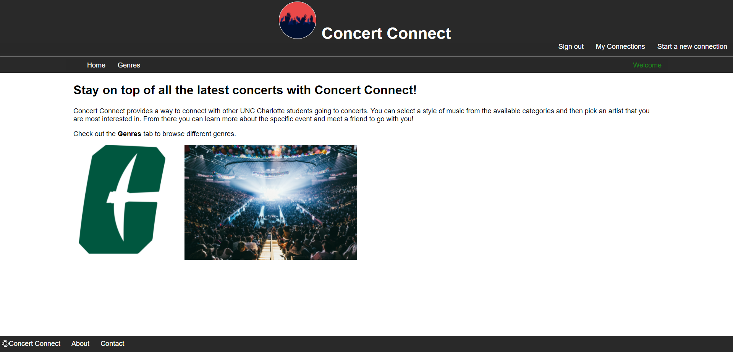

**Genres:**

The purpose of this page is to showcase the available genres a user can choose from. The audience can be general users browsing the site to see upcoming concerts, or it can be registered users who would like to RSVP to an event. This is a statically generated page with a fixed number of available genres to scroll through. Each genre is a hyperlink image that navigates to the specific genre page that the user selected. It sends this data by appending the requested genre to “/genres/”. This page uses a convenient jQuery plugin to allow uses to scroll.

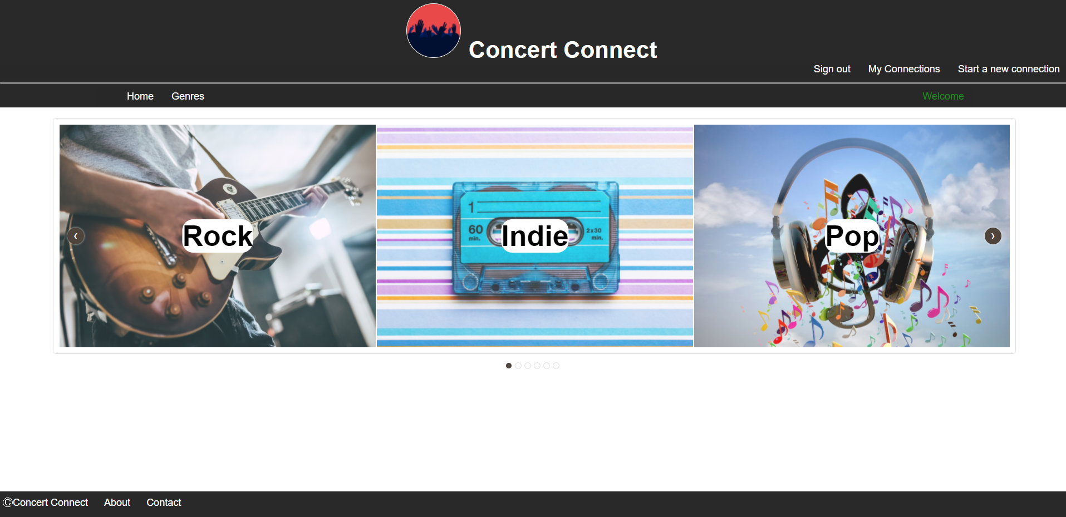

**Specific Genre:**

This page is the direct successor to the “Genres” page. The purpose is to provide the user with a list of bands that have upcoming concerts, within the specific genre requested. The audience can still be general users browsing the site to see upcoming concerts, or it can be registered users who would like to RSVP to an event. The bands that appear on this page are fetched from the “connections” collection within MongoDB. Each of the bands listed appears with a logo that acts as a hyperlink. Similarly, to the previous page, whichever band logo is clicked, the app will route to “genres/(requested genre)/(requested band)”.

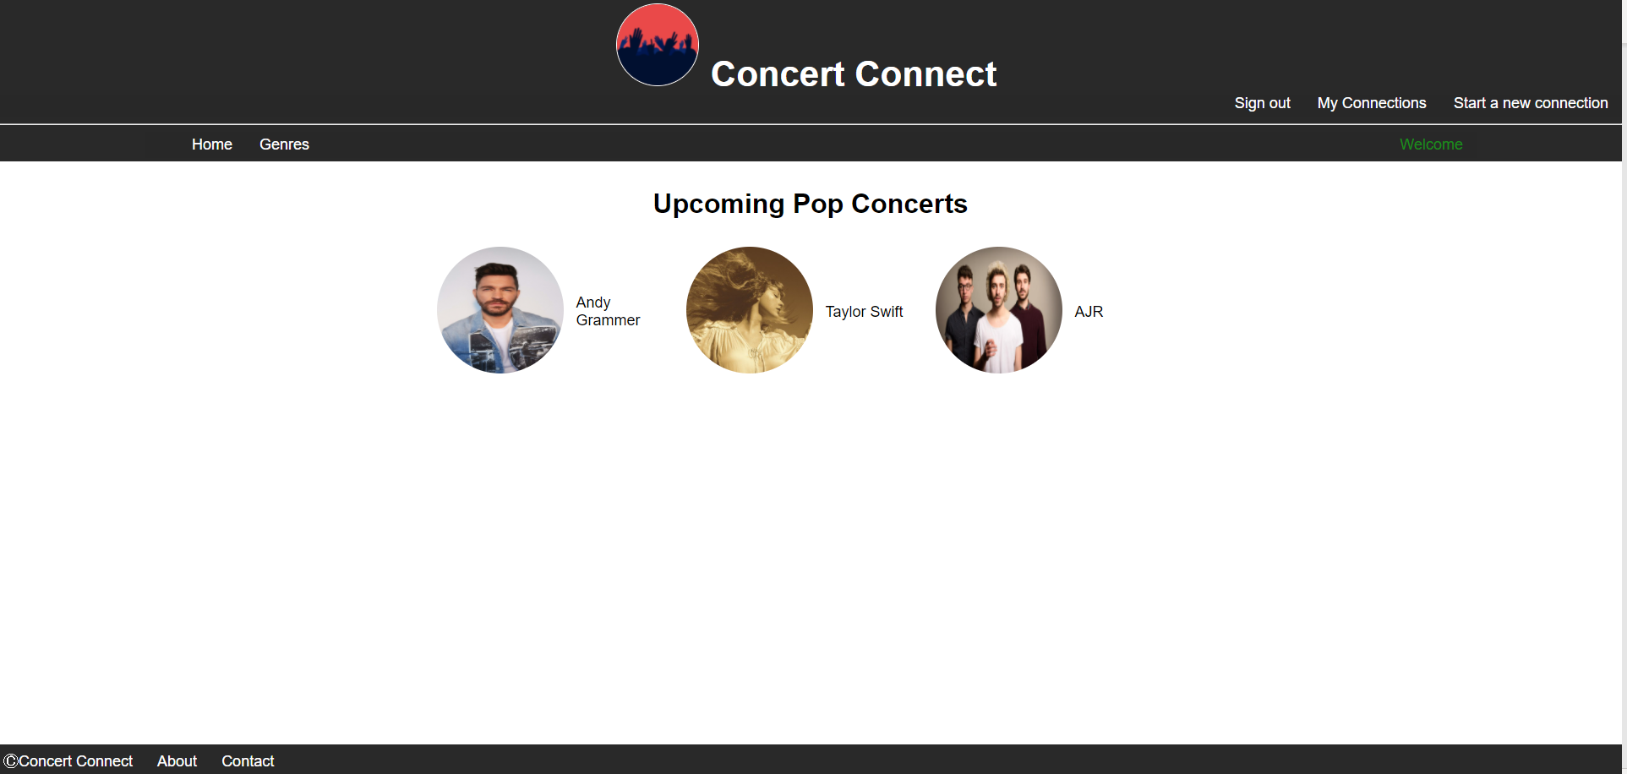

**Concert Details:**

This page is the direct successor to the “Specific Genre” page. The purpose is to provide the user with details about the event they requested on the previous page and give them the opportunity to confirm an event to attend. Once again, the audience can be general users browsing the site to see upcoming concerts, or it can be registered users who would like to RSVP to an event. The data for the page is obtained from the URI. A function will match the event name with the corresponding event in MongoDB. The page will have information the band name, location, date, time, and details; All of which of fetched from the database. There are three hyperlinks on this page: “Yes”, “No”, and “Maybe”. These are the RSVP values a registered user can select. If the user is logged in, it will send the value in a POST request of an HTML form to the controller and the page will be redirected to “Saved Concerts”. If the user is not logged in, they will be redirected to the login page.

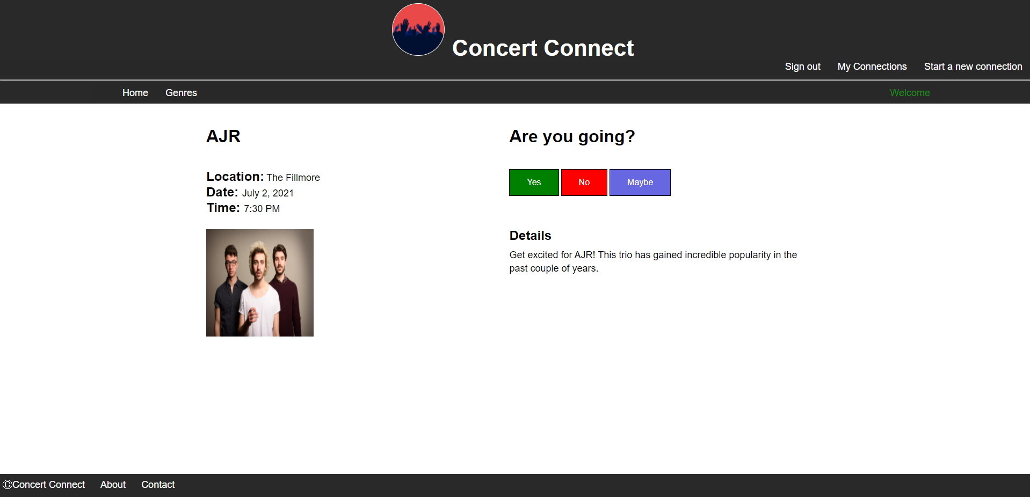

**Login:**

This is a simple page that asks the user for login information. The purpose is to log a user into the website. Once they submit the login form, their session will be created, and they will be routed to “Saved Concerts”. The audience for this page is any user with an account. Within the form, there is a field for username and password. Once the application is designed to support multiple users, these input fields will be validated.

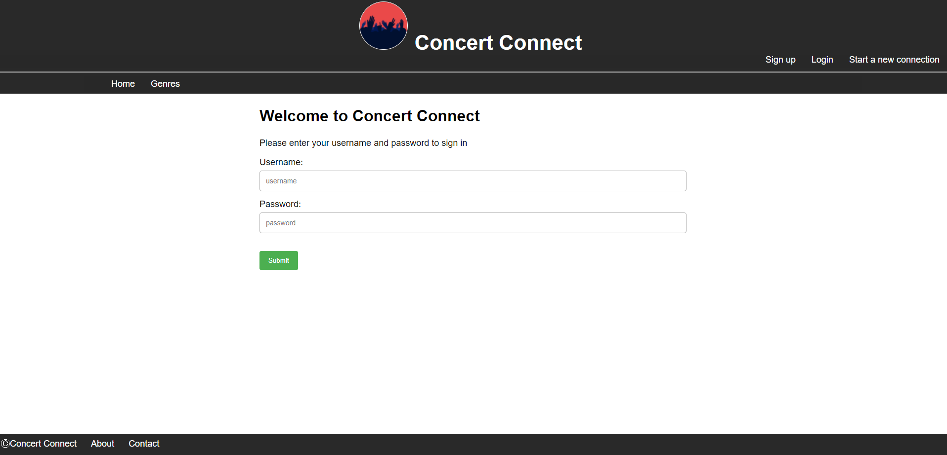

**Saved Concerts**

The “Saved Concerts” page will query the collection “UserProfiles” in MongoDB for all the concerts that the logged in user has RSVP’d to. The audience of this page is only registered users. If they have not responded to any concerts, it will give a message stating that they have no saved concerts. The data is presented in a table format and contains the band title, genre, and RSVP status of all events the user has expressed interest in. For each event in the table, there are two options: Update and delete. If update is clicked, an HTML form will send the ID of the corresponding concert to the controller and it will route to the “Concert Details” page with the requested data. If delete is clicked, the corresponding concert will be removed from the database.

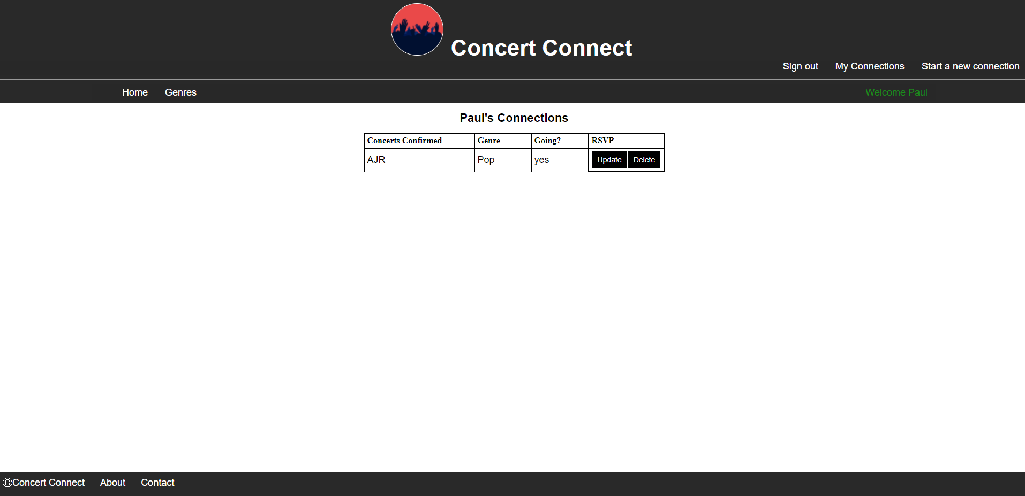

**Create Concert**

The purpose of this page is for a user to create a concert of their own. The audience for this page is only registered users. The page contains a form that has 6 input fields that are all required: Band name, genre, details, location, date, and time. Certain fields are validated as being a specific type. The data in the form is saved to the “Connections” collection within MongoDB and added as a saved concert for the user who created it.

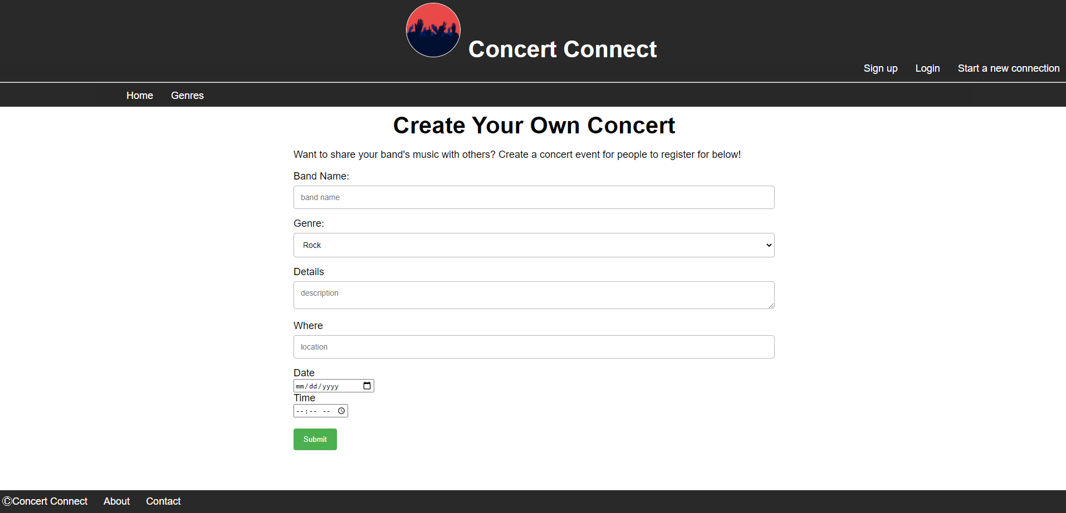

**About**

This is a static page that contains information about the website. The audience is anyone interested in learning about the site.

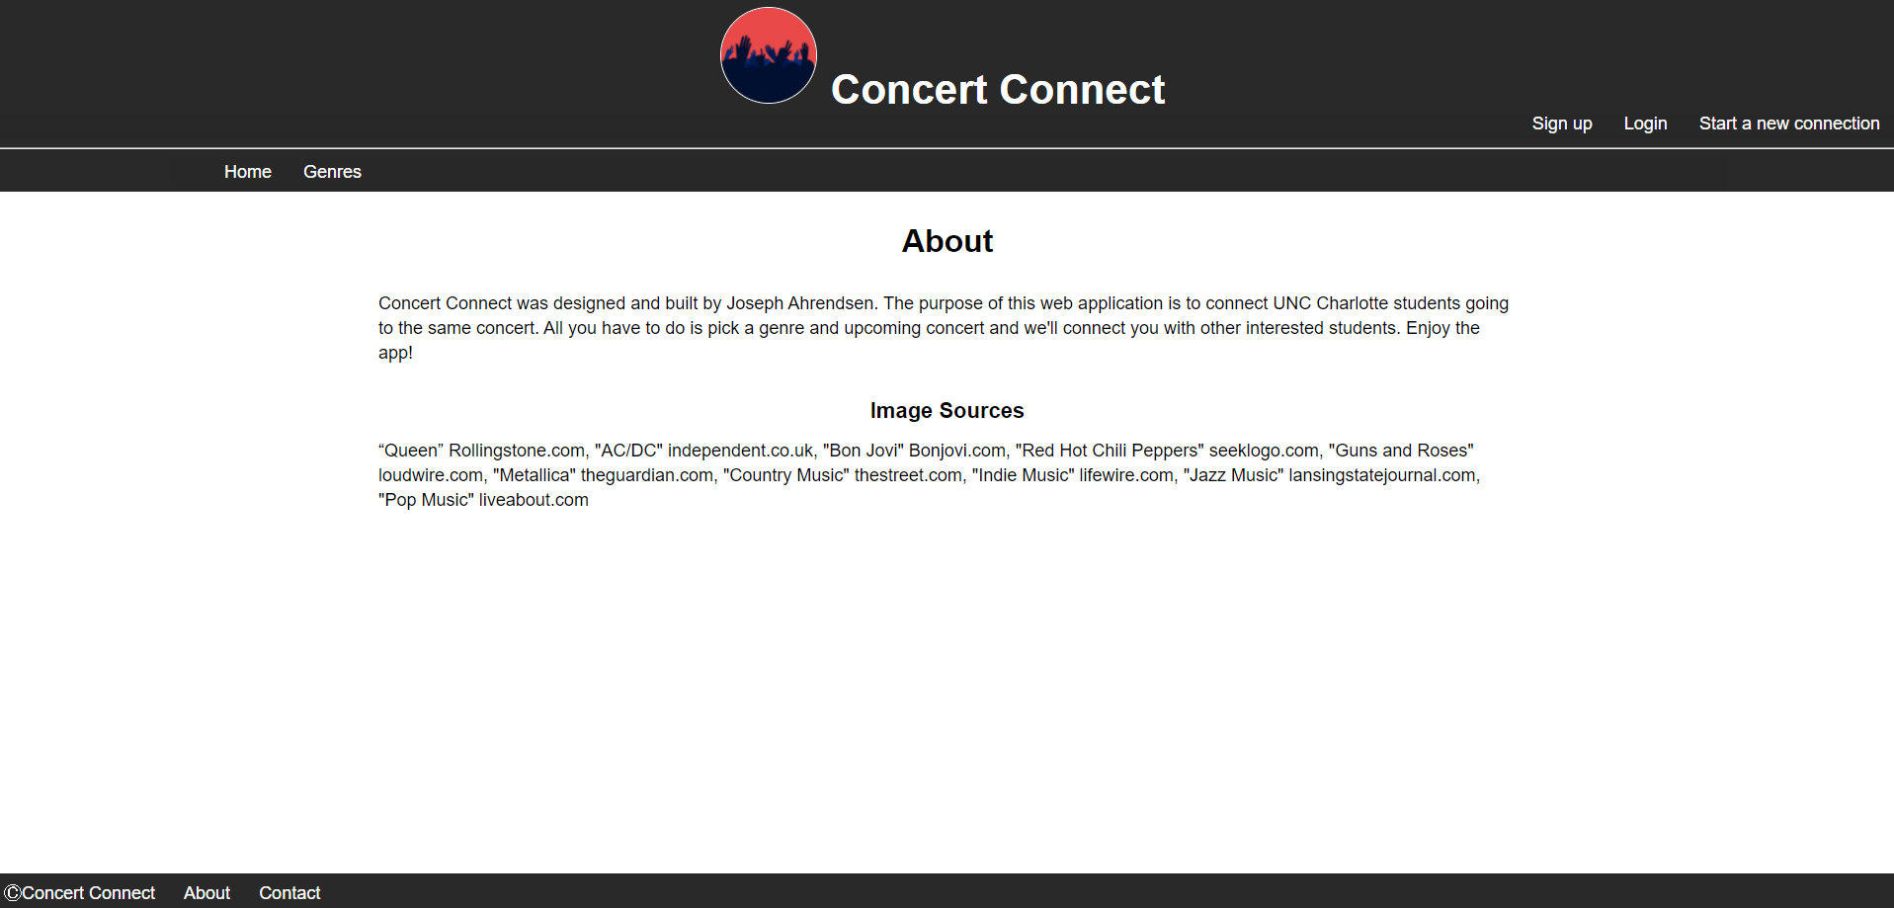

**Contact**

The contact page is very basic. It contains details on how to contact me. The audience is anyone interested in contacting me about the site.

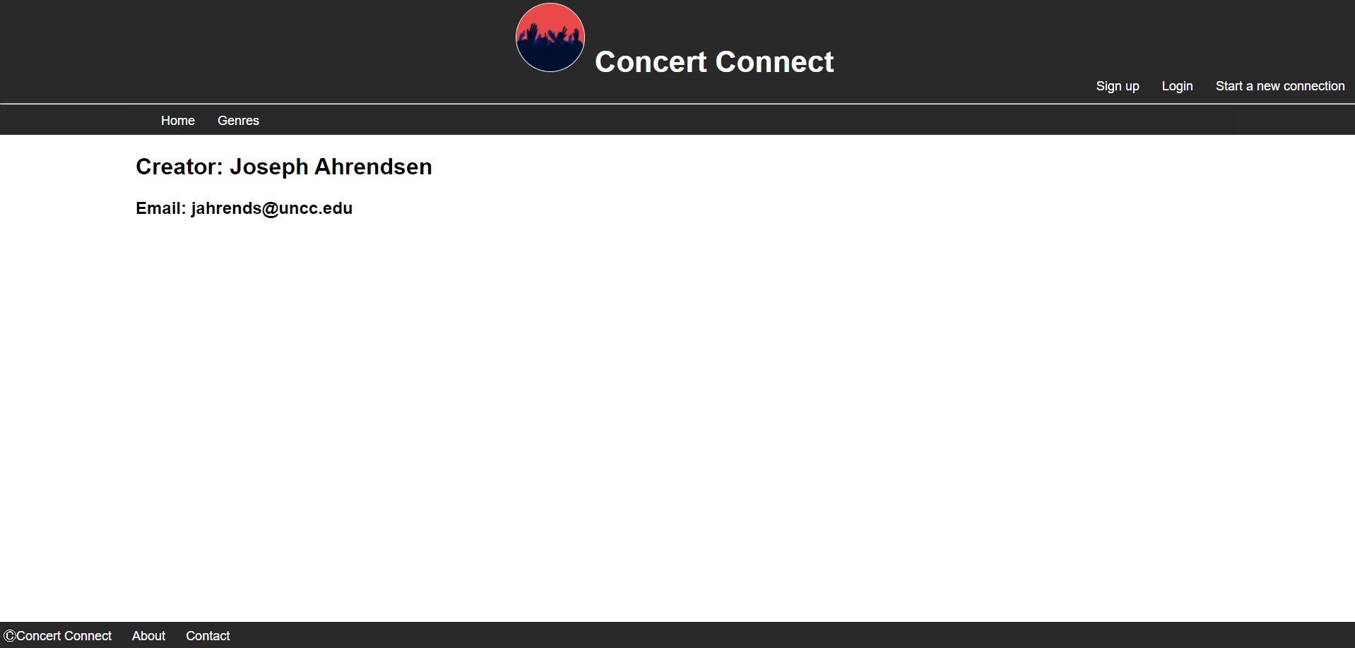

**Header**

The header is a partial view contained in every page on the website. It always contains the title of the website and logo. If a user is logged in, there are three links: Start a new connection, saved connections, and logout. If a user isn’t logged in, these are the three links: Start a new connection, login, and sign up.



**Navigation Bar**

The navigation bar is a partial view contained in every page on the website. It is very simple and links users to either the home page or the “genres” page.



**Footer**

The footer is a partial view contained in every page on the website. It contains a trademark of the website, and a link to the “About” and “Contact” pages.



## Database Design:

