Home page

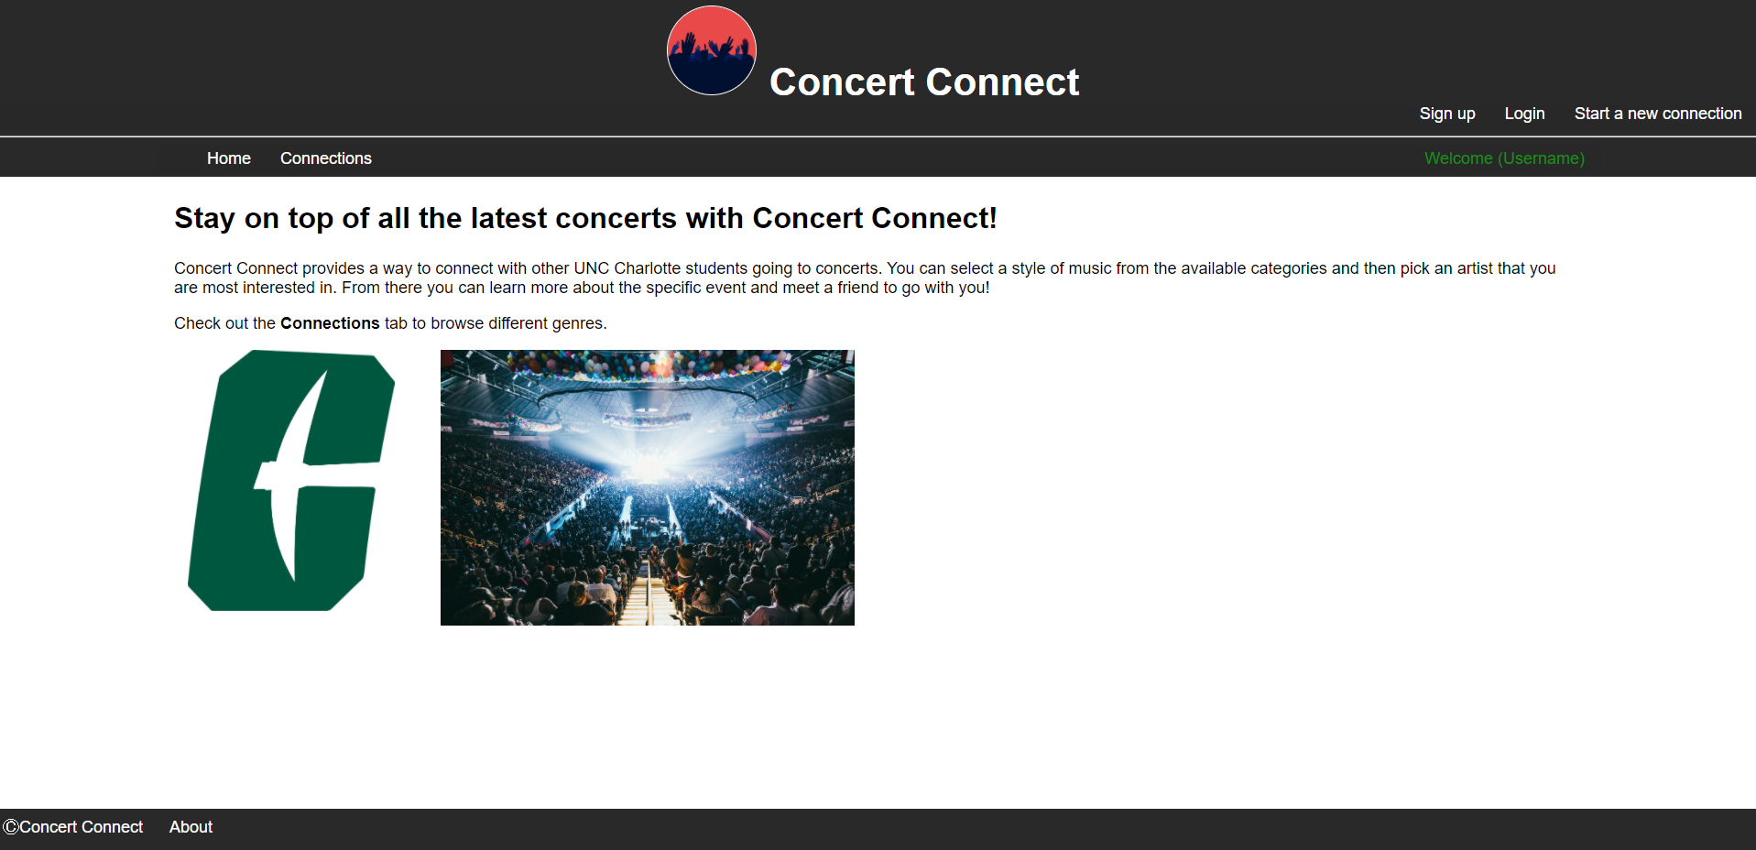

Additional Features:

I added another step in the “connection process”. For my site, I thought it would be more practical if you select a genre and then a band. I used a jQuery plugin to create a slider effect and browse different genres before selecting a specific band.

Project Challenges

I put so much time into this milestone I lost track. By the end, I certainly learned quite a bit about mongoDB and integrating with NodeJS. I spent a lot of time stuck on the insert and update functions and making sure my schemas were set up correctly. It also took me a while to better understand promises and async/await.